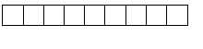
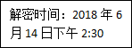
机 密
姓名：_________________ 准考证号：

成都市二○一八年高中阶段教育学校统一招生考试、
（含成都市初中毕业会考）
英 语
注意事项：
1.全卷分A卷和B卷，A满分100分，B卷满分50分；考试时间120分钟。
2.在作答前，考生务必将自己的姓名、准考证号涂写在试卷和答题卡支付宝的位置。考试结束后，监考人员将试卷和答题卡一并收回。
3.选择题部分必须使用2B铅笔填涂；非选择题部分必须使用0.5毫米黑色签字笔书写，字体工整、笔迹清楚。
4.请按照题号在答题卡上各题目对应的答题区域内作答，超出答题区域书写的答案无效；在草稿纸、试卷上答题均无效。
5.保持答题卡清洁，不得折叠、污染、破损等。
A卷 （共100分）
第一部分听力（共30小题；计30分）
一、听句子，根据所听到的内容选择正确答语。每小题念两遍。（共5小题，每小题1分；计5分）
1. A. Thank you B You're kind C. I'm happy.
2. A. No, you can't B. Yes, please, C. You're welcome,
3. A. Good idea B. I think so. C. Enjoy yourself.
4. A. That sounds fun B.I agree with you C. Good luck.
5 A. Oh, I see B. That's right C. Sure, I'd love to
二、听句子，选择与所听句子内容相符的图片，答题卡上只需填涂代表图片的字母。每小题念两遍。（共5小题，每小题1分；计5分）
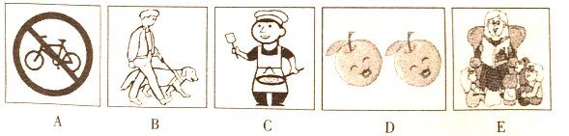
6. 7. 8. 9. 10.
三、听对话，根据对话内容及问题选择正确答案。每小题念两遍。（共10小题，每小题1分；计10分）
11. A. By bus. B. By bike. C. On foot
12.A. He played basketball B. He flew kite. C. He went to the movies
13 A. The music club B. The chess club C. The art club
14 A. Gina. B. Mike. C. Jane.
15. A. At 10:30 pm B. At 11:00 pm C. At 11:30 pm
16. A. Review the lessons B. Go to the concert C. Take an exam.
17 A. Interesting B. Boring C. Enjoyable
18. Teacher and student. B. Nurse and patient C. Mother and son.
19. A. in the park. B. In the restaurant C. At home
20. 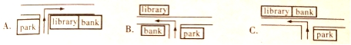
四、听短文，根据短文内容选择正确答案。短文念两遍。（共5小题，每小题1分；计5分）
21. Why does Chris Hughes wear the same clothes for many days?
A. Because he doesn't like washing clothes.
B. Because he can’t use a washing machine.
C. Because he wants to play a joke.
22. Which group of people has the worst basic life skills?
A. Older people. B. Young people. C. Some kids.
23. What problem are young people in the US facing?
A. They have no basic life skills.
B. They can't stop ordering takeaway food.
C. They have less cooking skill than before.
24. Why don't young people learn how to read real maps?
A. Because they needn't do it with smart phones.
B. Because real maps aren't necessary nowadays.
C. Because they are good at using phones and computers.
25. What's the writer's worry?
A. Young people's weak living abilities.
B. Young people's poor living habits.
C. Young people's bad eating habits.
五、听短文，根据短文内容完成图表中所缺信息。短文念三遍。（共5小题，每小题1分；计5分）
Reality Town: the name of 26 in middle schools in Utah, US
its purpose | *to help the students 27 their parents better  * to help the students learn how the real world works
things for students to do | *to get “jobs” with 28 according to their own grades  * to try out to be a husband or wife with maybe a few kids
Jason’s experience | trying out to be a father of a 5-year-old girl, thinking paying taxes(税) was 29 part
30 comments | *It’s a wakeup call for us to learn how much it costs to live.  * Being a parent is not easy. A parent needs to work and care for the kids.  *A parent must provide food, a living place, warmth and love, and take care of the family. And all these take time, work and money.

第二部分 基础知识运用（共30小题；计40分）
六、选择填空（共15小题；计20分）
A. 从以下各题的A、B、C三个选项中选择正确答案。（共10小题，每小题1分；计10分）
31.- Who is boy playing soccer over there?
-He is my classmate, Li Ping.
A. a B. 不填 C. the
32.I got up early this morning my grandma at the airport.
A. to pick up B. picking up C. picked up
33. A smile costs , but gives much, so always keep smiling!
A. something B. anything C. nothing
34.- Wow…another gift! What’s in the box?
-I’m not sure. It be a pair of sports shoes.
A. must B. may C. will
35.- Sally, I heard you’re going to America. Will you stay there?
- Two whole years
A. How soon B. How often C. How long
36. Yesterday, I the subway home when I suddenly found I was on the wrong line.
A. took B. was taking C. had taken
37.- How beautiful your skirt is! Could you please tell me ?
- Thanks. I bought it on Taobao.
A. where you bought it B. when you bought it C. why you bought it
38.- Mary, do you prefer weekdays or weekends?
- Of course weekdays. Because I’m on weekends.
A. busy B. much busier C. the busiest
39.- Is this the new dictionary you got yesterday?
- Yes. Now it’s very convenient for me to look up words.
A. that B. why C. what
40 The opening of the 2018 World Cup in Russia this evening. So after our English exam, let’s go and watch it to relax ourselves!
A. Would be held B. is held C. will be held
B. 补全对话 根据对话内容，从方框中选出适当的选项补全对话，答题卡上只需填涂选项的编号字母。（共5小题，每小题2分；计10分）
Sally: Hello, this is Sally speaking.
Tina: Hi, Sally. It’s Tina here. 41 I don’t know what to do.
Sally: Don’t worry. What’s the matter?
Tina: My best friend doesn’t speak to me.
Sally: 42
Tina: She lent me her pen, but later I lost it. She was very angry.
Sally: 43 You should talk to her and buy one for her.
Tina: No use. 44 But it doesn’t work.
Sally: 45
Tina: No.
Sally: Maybe that’s why.
A. How did it happen?
B. Something worries me now.
C. Did you give her the new pen?
D. I promised to buy her a new one.
E. Well, I don’t think it’s a serious problem.
七、完形填空 阅读下面两篇短文，根据短文内容，从A、B、C三个选项中选出可以填入空白处的正确答案。（共15小题；计20分。A篇每小题2分；B篇每小题1分，计10分）
While many Chinese students go abroad to learn western culture, foreign students come to China. In order to get close to 46 Chinese culture, last July, 55 students and teachers from Germany came to China and joined a(n) 47 camp. They visited several schools in Chengdu, Sichuan. At Huaxin High School, they made dumplings, played tai chi, did paper-cuts and learned calligraphy(书法). To help them 48 more about China, Chinese students led these foreign 49 to some places of interest.
In recent years, there are more cultural exchanges between Germany and China. Almost 400 German schools have Chinese classes. Over 8,000 students study in China. The situation is the same to China. Chinese students are one of the 50 foreign student groups in Germany.
46.A. modern B. traditional C. international
47.A. summer B. autumn C. winter
48.A. write B. read C. know
49.A. guests B. teachers C. artists
50.A. richest B. largest C. smallest
B
There was once a wise old lady who lived on a hill. All the children used to go and ask her questions. She always gave them 51 answers.
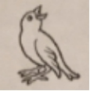
There was a little boy among the children. One day he caught a little bird and held it in his hands without anybody seeing it. Suddenly he had an idea and asked his friends to 52 .
"Let’s 53 the old lady," he said. “I’ll ask her what I’m holding in my hands. Of course, she’ll answer that I have a bird. Then I’ll ask her if the bird is alive or dead. If she says the bird is dead, then I’ll 54 my hands and let the bird fly away. If she says the bird is alive, I’ll quickly 55 it and show her the dead bird. Either way, she’ll be 56 ”
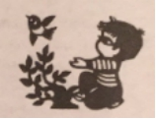
The children agreed this was a clever plan. So 57 the hill they all went to the old lady’s house.
“Granny, we have a 58 for you,” they all shouted.
“What’s in my hands?” the little boy asked.
“Why, of course it must be a bird,” the old lady replied.
“But is it alive or dead?” the boy asked 59 .
All the boys 60 her answer and got ready to laugh at her.
The old lady thought for a moment and then replied, “It’s up to you, my child. If you’re kind enough, it’ll be alive.”
51. A. funny B. perfect C. impolite
52. A. play with it B. go back home C. go with him
53. A. play a trick on B. make friends with C. pay a visit to
54. A. open B raise C. shake
55. A. save B. free C. kill
56. A. right B. wrong C. wise
57. A. up B. down C. across
58. A. question B. bird C. present
59. A.calmly B. worriedly C. excitedly
60. A. listened to B. waited for C. thought of
第三部分 阅读理解 （共15小题； 计30分）
八、阅读下面短文，根据短文内容判断句子正误。正确的涂“A”，错误的涂“B”。（共5小题，每小题2分，计10分）
Professor Lee is talking with a group of students from Yizhou High School. Now Li Hua is asking a question and Professor Lee is answering.
Li Hua: When I hang out with American friends, I’m always afraid to speak. I feel like they will laugh at my accent(口音). What can I do, Professor Lee?
Professor Lee: It’s a good question! This is a typical problem among you students. First, it’s OK to speak English with an accent. It shows who you are and where you’re from. English is an international language. English speakers from the US, the UK, Australia, and South Africa all have different accents. In fact, correct grammar and word choice are much more important. Second, most foreigners are friendly and will not laugh at you. So just relax and be yourself. I always tell my students, “Don’t be shy. Just try!” If you have a chance, take it. Finally, failure is the best teacher. As the saying goes, “Failure is the mother of success.” Michael Jordan, the greatest basketball player of all time, found the secret to success. He said, “I’ve failed over and over again in my life. And that’s why I succeed.”
61. Li Hua tells Professor Lee about his worry.
62. Li Hua is sure foreigners will laugh at his accent when speaking English.
63. Professor Lee encourages Li Hua from three points.
64. People from English-speaking countries all have the same accent.
65. Jordan never gave up in the face of failure and finally he succeeded.
九、阅读下面两篇短文，根据短文内容选择正确答案。（共10小题，每小题2分； 计20分）
Thank you for dining at
Pizza Man
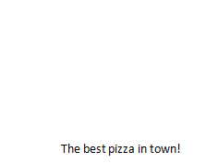
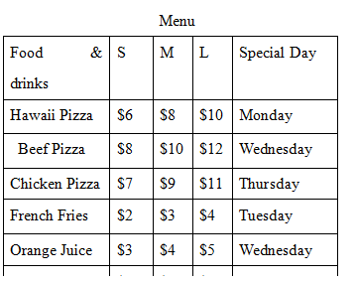

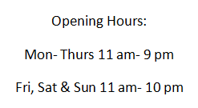
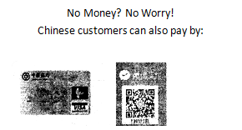
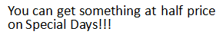





66. What is Pizza Man?
A. It’s a restaurant. B. It’s a supermarket. C. it’s a food factory.
67. How long is Pizza Man open on weekends?
A. 9 hours. B. 10 hours. C.11 hours.
68. If Alice goes there on Wednesday and orders a small Hawaii pizza and a large cola for dinner, how much should she pay?
A. 5 dollars. B. 8 dollars. C. 10 dollars.
69. How many ways at most are there to pay for the meals?
A. Two B. Three. C. Four.
70. What is TRUE according to the poster?
A. We can only order food in Pizza Man.
B. We can have breakfast in Pizza Man.
C. There’s no special day on weekends.
B
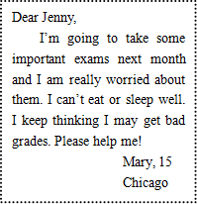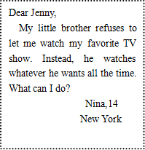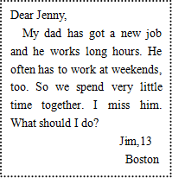
- ② ③
Main parts of the two replies from the editor of the magazine Students’ Life:
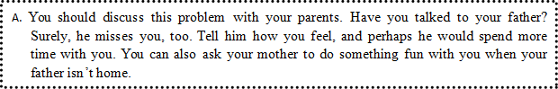
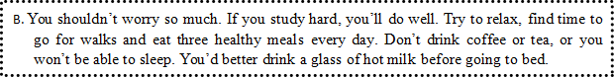
71. What does Jenny do?
A. A teacher. B. A doctor. C. An editor.
72. Match the letters with the replies. Which is right?
A.②-A; ①-B B.③-A;①-B C.③-A; ②-B
73. What problem does Jim have?
A. He misses his dad.
B. He worries about his dad.
C. He has to work at weekends.
74. What may be the proper advice to Nina?
A. Turn off the TV when her brother is watching it.
B. Find programs that they’re both interested in.
C. Ask their parents to punish her brother.
75. Where do the three teenagers probably live?
A. In the US B. In Australia C. In the UK

B卷（共50分）
一、根据首字母填词，请在答题卡上写出完整单词。（共5小题，每小题1分；计5分）
1. I am c wrong for sure. I have to do the research from the very beginning.
2. All the p on the flight 3U 8633 feel thankful for the quick decision made by the pilot.
3. The tour i a visit to the Disneyland, so you needn’t pay for the tickets.
4. At last, Ann o her shyness and gave us a speech in public.
5. “Are you sure you can work out the problem yourself?” Peter asked me in d .
二、完成对话，在空格中填上适当的单词，使对话完整正确。一空一词（含缩写词）。（共10小题，每小题1分；计10分）
A：Johnny, do you know the young man named Frank?
B：Yes. He’s an engineer. Why do you 1 him?
A：I feel strange. Wherever I go, I see people greet him warmly. How long has he been in George Town?
B：He’s been here for only one year, less than half of the time I’ve stayed here.
A：That’s amazing. Why is he so 2 in such a big town?
B：Maybe it’s because of his 3 . He’s fun. To our surprise, he can always 4 find
humorous points in what seems rather usual. And he helps anyone in trouble if he can
5 to. He values the friendship with others.
A：That would 6 it. What about you, my friend? Why do you have so few friends in
the town?
B：It’s probably because I’m the 7 to Frank. And my work is busy, so I have no chance to meet 8 people.
A：I think I can introduce some of my friends to you.
B：Well, thanks, but actually I have many friends on the Internet. I often chat with them online.
A： 9 you can share something with them, you should know that they can never be 10 with the friends around you.
B：You’re so kind. Thank you for your advice.
三、短文填空，从下面方框中选出10个单词，将其正确形式填入短文，使短文意思正确通顺（每词限用一次）。（共10小题，每小题1分；计10分）
but choice color direct fly high important instead it many quick slow
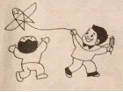
One day, a father and his son went to a kite – flying festival. When they arrived, there were already many adults and their children playing in the park. When the son saw the sky filled with 1 kites in different shapes, he was excited and wanted to get one too. His father agreed to buy one for him. So they went to a kite shop and 2 a beautiful one.
With the string(线) in hand, the son started 3 the kite. Soon, the kite was high up in the sky. After a while, the son said, "Father, it seems that the string is stopping the kite from flying higher. If we cut it, it will be free and fly even higher. Can we cut it?" The father didn't reply, but just cut the string off the reel(线轴). Suddenly, the kite began to go 4 , which made the son much happier.
However, to his surprise, the kite was coming down. They waited for quite some time. 5 , it fell onto the grass. The son felt upset and asked, "I thought that after cutting the string, the kite would fly higher. Why did it fall down?"
The father smiled and said, "The role of the string was not stopping the kite from flying higher, 6 helping it stay in the sky, because the kite 7 can't fly up. By using the string you help the kite go up in the right 8 . When you cut the string, it could not support the kite.
In our life, we may sometimes feel like there are certain things that are holding us back and stopping us from growing. But in fact, these might be the things that support us 9 . We can really grow up and become stronger by realizing the 10 of these things.
四、阅读表达（共10小题；计10分）
A. 补全短文，根据短文内容，从短文后的A～F选项中，选出5个适当的选项补全短文，答题卡上只需填选项的编号字母。（共5小题，每小题1分；计5分）
Have you ever tried to hide your emotions（情感）from someone during a conversation? 1
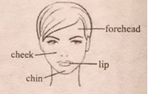
Scientists from the Ohio State University have found that people are able to tell other people’s emotions according to changes in the color of their faces.
Scientists studied pictures of people's facial expressions. 2 For example, happiness makes our faces red around the cheeks and a little blue around the chin. Disgust (厌恶) creates not only a blue-yellow color around the lips, but also a red-green color around the nose and forehead.
"We believe these color patterns are the result of small changes in blood flow triggered (触发) by the central nervous(神经) system. " Lead researcher Alex Martinez said.
3 Does the color alone or also facial expressions help people tell other's emotions?
To figure this out, scientists added color patterns to pictures of faces that showed no facial expressions. 4 They were able to tell the emotions 75 percent of the time without any difficulty.
5 For example, when two people are heatedly arguing over something, we say they are red in the face. When a person is very angry, we'd say he or she is blue in the face.
A. But this raises a question.
B. It is shown that human emotions are influenced by colors on the face.
C. They found that every facial expression is connected to a certain color.
D. It's not always easy, because the colon on your face may tell the truth.
E. Then, volunteers were asked to tell what emotions the faces were showing.
F. This is why there are some Chinese sayings that connect emotions to the color of one’s face.
B. 完成表格，阅读下面短文，根据其内容，完成图表中所缺的信息。（共5小题，每小题1分；计5分）
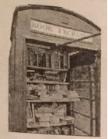
Today almost everyone has a smart phone. So street phone booths are out of date and seem to be useless. But cities like Shanghai are trying to bring the old phone booths to life.
Shanghai will make changes to 263 phone booths in Xuhui District. The Library Booth is one of the six new kinds of booths, offering 60 booths for people to borrow and read. Another kind allows users to listen to audiobooks(有声书)and even record their own voices.
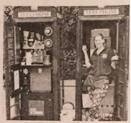
Shanghai is not the only city trying to save the old phone booths. London cares about them even more, because the red phone booths have long been a special scene in London since the 1930s when they were painted all red. In recent years London has come up with many ideas to help phone booths stay useful. The UK company British Telecom has added screens and free WiFi to some booths. Users can use them to surf online and search for maps and weather reports. The company also allows people to rent(租) some booths to change them as they want to. Since 2009, more than 1,500 phone booths have been turned into flower shops, mini-cafes, art museums and even shower rooms.
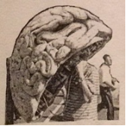
In New York City, three phone booths in Time Square are turned into places for immigrant(移民) voices. When visitors pick up the phone, they can listen to oral(口述) histories of immigration from the newest New Yorkers. They can also open the books inside the booth to know more about the storytellers. Or they can share a part of their own stories if they wish.
Brazil made phone booths works of art. Sao Paulo paired 100 artists with 100 phone booths. Some artists painted on the booths, others made them sculptures- one was shaped like a brain and another wore a pair of shoes.
Phone booths are finding creative ways to live on. Will they succeed? Only time will tell.
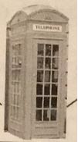
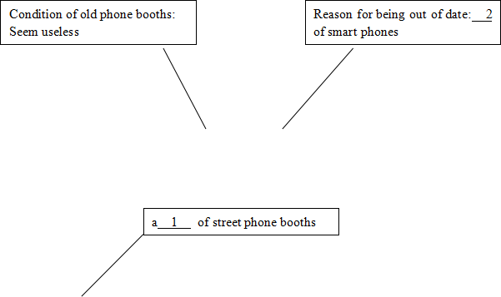
new uses in Shanghai | six new kinds of booths | 60 library booths: Users can borrow& read books.
new uses in Shanghai | six new kinds of booths | Audio booths: Users can listen to audiobooks & record their own voices.
various uses in London | London tried 3 than Shanghai to keep the old phone booths 3 because the red booths are a special scene in the city | Users can search for maps and weather reports online& use 4 in the booths.
various uses in London |  | People renting the booths can turn them into flower shops mini-cafes, art museums and so on.
special use in NY | Three phone booths in Time Square | Visitors can:  ◇listen to oral histories of immigration& read books about these immigrants  ◇share their own stories
new look in Brazil | 5 the 100 artists changed the appearance of one phone booth | Some artists painted on the booths
new look in Brazil | 5 the 100 artists changed the appearance of one phone booth | Others made the booths sculptures.
五、书面表达 请直接在答题卡上写作。（计15分）
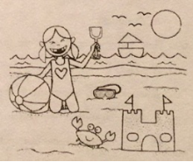
假如你是图中女孩，你与家人于4月29日共度周日。请根据图中所示写一篇英文日记，讲述你当天所见和所做之事。
注意：1.日记应包含图中所有信息
2.日记中须写出当天的一些感受
3.日记应格式正确，语句通顺，句式多样。
4.词数：100左右。
参考词汇：城堡 castle 螃蟹 crab

