试卷类型：A
二〇一三年 初 中 学 业 考 试
英 语 试 题

本试题分第Ⅰ卷和第Ⅱ卷两部分。第Ⅰ卷为选择题，75分；第Ⅱ卷为非选择题，45分；共120分。考试时间为120分钟。
第Ⅰ卷 （选择题， 共75分）
一、听力测试（共20小题，计20分）
(一) 录音中有五个句子，每个句子听一遍，然后从每小题A、B、C中选出能对每个句子做出适当反应的答语。
1. A. How are you? B. Nice to meet you. C. That’s good.
2. A. Hold on, please. B. Who are you? C. What’s the matter?
3. A. Nothing much. B. Don’t worry. C. What a pity!
4. A. You’re welcome. B. My pleasure. C. Sure.
5. A. It’s a good idea. B. No, thanks. C. That’s kind of you.
（二）录音中有五组对话，听对话两遍后，从每小题A、B、C中选出能回答所给问题的正确答案。
6. Where are they talking?
A. In a library. B. In a bookshop. C. In an office.
7. What may Jackie do this afternoon?
A. Work on his lessons. B. Take a test. C. Play baseball.
8. How is Tom now?
A. He’s getting better. B. He doesn’t have a fever. C. He’s getting worse.
9. What do we know about the woman’s new neighborhood?
A. It’s noisy. B. It’s quiet. C. It’s near her office.
10. Why did Ms Brown ask Mary to her office?
A. Mary wasn’t getting on well with Tom.
B. Mary was late for class again.
C. Mary was doing better at school.
（三）录音中有一段对话，听对话两遍后，从每小题A、B、C中选出能回答所给问题的正确答案。
11. What club DOESN’T the centre have?
A. Art club. B. Sports Club. C. Chinese club.
12. What do we know about the man’s kids?
A. They are interested in language learning.
B. They have problems in Chinese.
C. They hate swimming.
13. What language club will the man’s kids join?
A. Chinese club. B. French club. C. English club.
14. What’s the time for the swimming club?
A. 9:00 am to 11:30 am every Sunday.
B. 9:00 am to 11:30 am every Tuesday and Friday.
C. 4:00 pm to 5:30 pm every Sunday.
15. How much will the man pay for his kids each time?
A. 50 yuan. B. 100 yuan. C. 200 yuan.
（四）录音中有一段独白，听独白两遍后，从每小题A、B、C中选出能回答所给问题的正确答案。
16. Who is the speaker?
A. Mr. Jones. B. A student. C. A teacher.
17. What should the designs include?
A. Mr Jones’ advice.
B. The names of their work.
C. The time they set about doing their homework.
18. How will the students do their summer holiday homework?
A. By teamwork. B. By working on it alone. C. With parents’ help.
19. Why are they asked to do the homework?
A. To win a prize.
B. To make them work together.
C. To develop their invention ability.
20. When should the students hand in their designs?
A. By next Saturday. B. In the summer holidays. C. In September. [来源:学_科_网Z_X_X_K]
二、单项选择 （共15小题，计15分）
从每小题A、B、C、D中选出一个能填入句中空白处的最佳答案。
21. —Mum, I want to buy ________ new toy car.
—But ________ old one is still running, isn’t it?
A. the; the B. the; an C. a; the D. a; an
22. The Lushan Earthquake took place ________ about 8 o’clock ________ April 20, when the children are just beginning their first lessons.
A. at; in B. at; on C. in; on D. from; to
23. Young children can easily lose reading skills during the summer vacation without ________.
A. practice B. discussion C. homework D. education
24. Mary is so ________ — she comes to you whenever you’re in trouble.
A. useful B. careful C. thankful D. helpful
25. My twin brothers promised my parents to give up playing computer games, but ________ of them made it.
A. none B. neither C. either D. both
26. The shop manager is quick to ________ any phone calls or emails from her customers, which brings her good business.
A. make B. return C. write D. deal
27. —Why didn’t you answer my phone call, Jack?
—I’m sorry, but I ________ then.
A. drove B. drives C. was driving D. have driven
28. Claude didn’t do much homework, ________ he still passed the exam.
A. for B. or C. and D. but
29. They ________ a notice to tell the students about the changed meeting time.
A. put up B. put on C. put away D. put out
30. Hi, guy! You ________ not park your car here. It’s for our customers only.
A. need B. may C. will D. can
31. Don’t come into the lab ________ you are asked to.
A. unless B. until C. because D. since
32. People who eat breakfast are always in ________ spirits than those who don’t.[来源:学科网ZXXK]
A. good B. nice C. better D. best
33. Teenagers with working experiences know more clearly ________ they will be in the future.
A. who B. why C. where D. what
34. —The paper says Iron Man 3 is on this evening. Let’s go and see it.
—But I ________it.
A. see B. saw C. have seen D. will see
35. —Someone is knocking at the door, dad!
—Go and see ________.
A. who is it B. who it is C. who was it D. who it was
三、完形填空 (共10小题，计10分)
阅读下面的短文，掌握其大意，然后从短文后各题所给的A、B、C、D四个选项中，选择最佳选项。
Twenty years ago, I drove a taxi for a living. One time in the middle of the night, an old lady in her 80s 36 my taxi. She gave me an address, and then asked: “Could you drive through downtown?”
“It’s not the shortest way,” I answered quickly.
“Oh, I don’t 37 ,” she said. “I’m in no hurry. I’m on my way to a hospice (临终关怀医院). I don’t have any family left. The doctor says I don’t have very long.”
I 38 shut off the meter(里程表).
For the next two hours, we drove through the city. She 39 me the building where she had worked, the neighborhood where she and her husband had once lived, the place where she danced as a girl. As the sun was rising, we got to the hospice.
“How much should I pay you?” she asked, reaching into her purse.
“ 40 ,” I said.
“You have to make a living,” she answered.
“There are other 41 .”
“You gave an old woman a little moment of 42 ,” she said. “Thank you.”
I drove into the fine 43 light. Behind me, a door shut. It was the sound of the 44 of a life. I drove aimlessly, lost in thought. For the rest of the day, I could hardly talk. What if that woman had got a(n) 45 driver, or one who was impatient to end his shift(换班)? What if I had refused to take the run?
36. A. found B. took C. called D. chose
37. A. count B. know C. mind D. worry
38. A. quietly B. gladly C. angrily D. usually
39. A. reminded B. introduced C. explained D. showed
40. A. Anything B. Something C. Nothing D. Everything
41. A. passengers B. drivers C. patients D. strangers
42. A. pity B. pain C. joy D. anger
43. A. morning B. afternoon C. evening D. night
44. A. opening B. closing C. beginning D. changing
45. A. careful B. polite C. kind D. unfriendly
四、阅读理解（共15小题，计30分）
阅读下列材料，然后从每小题A、B、C、D四个选项中选出能回答所提问题或完成所给句子的最佳答案。 A
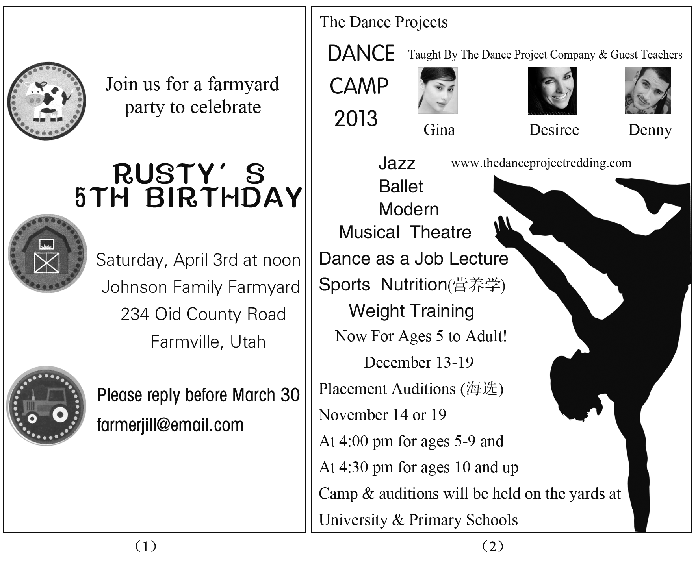

46. Picture 1 is a(n) ________.
A. postcard B. poster C. invitation D. menu
47. You should reply to the Johnson family by ______.
A. writing an email B. making a phone call
C. visiting them in person D. chatting online with them
48. If you want to eat well, you can’t miss the ________.
A. Dance as a Job Lecture
B. Musical Theatre Classes
C. Weight Training Classes
D. Sports Nutrition Classes
49. How long will the camp last?
A. Six days. B. Ten days. C. A week. D. A month

50. If you are a 15-year-old student, what time is your audition?
A. 4:00 pm on Nov 13. B. 4:30 pm on Nov 14.
C. 4:30 pm on Nov 18. D. 4:00 pm on Nov 19.
B
For the first time, Zhang Shengyu, a student from Laiyang Middle School in Shandong, didn’t ask her mother to buy her a new schoolbag or any new pens for the beginning of the school term. “My old schoolbag can still be used, so there is no need to buy a new one,” Zhang said, “I’ve decided to be thrifty from now on.”
As the center of the family’s attention, many of the one-child generation (一代人) do not know about the hardships of life. They sometimes have no idea of the value of things. Many students would throw away pens and erasers that haven’t been used up and buy new ones. Some like to compete with each other to see whose clothes and school things are more expensive.
On its website in January, the Ministry of Education called on students to form good habits such as working hard, being helpful and thrifty, to avoid wasting food and to pay more attention to study and others.
Many schools consider teaching the value of money to be an important lesson and encourage their students to be thrifty.
Students at No. 44 Middle School of Shijiazhuang, Hebei planted many fruit trees in their school. Through taking care of the trees, the students learned how to value things.
At Tie Yi Middle School in Xi’an, students organized a group to collect waste and reuse them. “What we students do are small things, but I think with everyone’s work, we can make a difference,” said Li Dongdong, 16, a student from the group.
51. The underlined word “thrifty” in Paragraph 1 means ______.
A. giving money to the poor B. spending lots of money
C. spending no money at all D. using money carefully and wisely
52. Many of the one-child generation usually ______. [来源:学科网ZXXK]
A. waste things
B. know about the hardships of life
C. don’t know the prices of many things
D. like competition with each other in study
53. In January, the Ministry of Education called on students to do the followings EXCEPT _________.
A. working hard B. being thrifty
C. helping others D. protecting environment
54. We can conclude that Li Dongdong ____________.
A. took care of trees B. planted fruit trees
C. collected waste D. didn’t ask his mother for a new school bag
55. What is the best title of the passage?
A. School activities B. Waste not, want not
C. Make a difference D. The problems of one-child generation

C
Having a teenager at home can be a real headache. Many teenagers smoke, drink and even fight. They often do something dangerous.
Earlier studies have shown that teenagers are more likely (可能) to make irrational decisions than people from any other age group, including children and adults. Is it that teenagers are too young to tell right from wrong? Not really. So what’s the reason?
According to Laurence, a teacher from a US university, the reason is that teenagers care a lot about how their peers (同龄人) view them—that is “peer influence”.
As children enter their teenage years, they spend more time with their friends and classmates, and also they care more about what they think of them. This makes teenagers make decisions without thinking about the costs.
In a test, a group of teenagers were asked to play a video driving game. When they played with their friends watching around them, they took more chances and drove more carelessly because that would increase their possibility of winning. But when they played alone, they drove more safely.
Why do peers have such a big influence on teens’ behavior?
As Laurence sees it, a teenager’s brain is like a car with a good accelerator (油门) but a weak brake (刹车). The “accelerator” is fully developed by teenage years while the “brake” is still not fully developed. When teenagers are watched by their peers, they usually push hard on the accelerator. With their weak brake, it is likely that they are going to end up in an accident.
But the good news is that a violent (暴力的)teenager doesn’t necessarily become a violent adult. About two-thirds to three-quarters of violent youth grow out of it. “They get more self-controlled.”
56. What does the underlined word “irrational” in the 2nd paragraph mean?
A. Quick. B. Crazy. C. Careful. D. Correct.
57. Why are teenagers likely to make wrong decisions according to the text?
A. They like difficult tasks.
B. They don’t care about costs.
C. They are too young to tell right from wrong.
D. They care a lot about what their peers think of them.
58. How does Laurence explain the influence of peer pressure on teens’ behavior?
A. By comparing it with how a car works.
B. By comparing it with an accident.
C. By showing research findings.
D. By giving examples.
59. According to the text, with peers around them, teenagers are more likely to _______ .
A. use more self-control
B. perform better than when they are alone
C. become more careful about what they do
D. care about winning without thinking about danger
60. What can we conclude from the text?
A. Teenagers are easy to have traffic accidents.
B. Peer influence is bad on teenagers.
C. Most of the teenagers become less violent when they grow up.
D. Teenagers shouldn’t spend all the free time with their friends.
第Ⅱ卷 （非选择题， 共45分）
五、 词汇运用（共两节，计20分）
第一节 单词拼写 根据首字母或汉语提示，在答题卡上写出下列句子中单词的完全形式。（共10小题，计10分）
61. The old man felt a bit l_______ with his wife gone.
62. We are secretly preparing a birthday party to give Mum a s_________.
63. My busy work made it i______ for me to visit my old mother quite often.
64. The company o_____ the young man a job, but he didn’t take it.
65. We got up early and c______ the early train back.
66. Doing more exercise will ______(改善) your health.
67. December is the ________(十二) month of a year.
68. The garbage _______ (短信) on cell phones are polluting the teens.
69. I never like long walks, _______(尤其) in winter.
70. The fisherman made a fire and _______(悬挂) his wet clothes up to dry.
第二节 用方框内所给单词的适当形式填空。（共10小题，计10分）
beside, loud, soft, think, so, get, answer, happen, say, shout
A wise man was visiting a village with his students. He found a group of family members 71 in anger at each other. He turned to his students and asked, “Why do people shout in anger at each other?”
His students 72 for a while, and one of them said, “Because when we lose our calm, we shout.”
“But, why should you shout when the other person is just 73 you? You can just as well tell him what you have to say in a soft manner.”
Students gave some other 74 but none were any good.
“When two people are angry at each other, their hearts became distanced (疏远的),” the wise man explained. “To cover the distance they must shout to be able to hear each other. The angrier they are, the 75 they will have to shout to hear each other.”
“What 76 when two people fall in love? They don’t shout at each other but talk 77 because their hearts are very close.” The wise man said.
He looked at his students and said, “So when you argue, do not let your hearts 78 distant. Stop 79 words that distance you from others. Otherwise, there will come a day when the distance is 80 great that you will not find the way back.”
六、阅读表达 (共5小题，计5分)
阅读短文，根据要求完成下面各小题。
If I can give up coffee, anyone can! I was completely addicted (上瘾). I drank coffee all day. I depended on it for everything. Without coffee, I became sad and anxious. I would feel nervous if I couldn’t get some coffee before an important event like giving a speech or taking an exam.
It took countless tries before I realized how to give up coffee. Between each try, I learned a little bit more. Here’s how I did it.
Coffee Addiction Knowledge
The first step is to learn about what you are dealing with. Caffeine is a drug. The human body gets addicted to it easily. That’s why you feel good when you get your first cup of coffee in the morning and it’s why you feel bad when you try to give it up. There are emotional addictions to the caffeine as well. Some people believe that with the caffeine you will perform better and have more confidence.
Gradually Cut the Amount and Then Replace (替代)It with Green Tea
You can give up coffee suddenly, but why put yourself through that unless you need an unpleasant experience? You can follow these two steps.
1) Gradually cut the amount of coffee you drink according to a plan. Let’s say, you normally drink 5 cups of coffee a day. Over a one-week period, cut out one cup ________ so that by the sixth day you’re at zero.
2) On your first day without coffee replace it with green tea. Green tea has the lowest amount of caffeine of most teas, but don’t expect any similar coffee taste.
81. How would the writer feel without coffee before giving it up?
82. What is caffeine according to the passage?
83. Put the underlined sentence into Chinese.
84. Fill in the blank with proper words (no more than 5 words).
85. Give a proper title (题目) to the passage.

七、 写作（共两节，计20分）
第一节 根据所给汉语完成句子(每空一词)。（共5小题，计10分）
86. 钓鱼岛属于中国。
The Diaoyu Islands _____ ______ China.
87. 写这部小说你用了多长时间？
How long does ____ ____ you to write this novel?
88. 她父母太忙了，很少有时间陪她。
Her parents were ______ busy _______ they spent little time with her.
89. 史密斯一家来青岛已经一年了，逐渐爱上了这座城市。
_______ is a year ________ the Smiths came to Qingdao and they are falling in love with it.
90. 研究表明五分之一的学生在11岁之前有阅读困难。
Studies show that one fifth of the pupils have difficulty ______ _______ by the age of 11.
第二节 书面表达 （共1题，计10分）
假如你是Tom，上周日下午和朋友在小区(neighborhood)空地踢球，请根据图片提示写一篇90词左右的日记。
要求：1. 根据前三幅图片所描述的情景，发挥想象，写出事情的结局；
2. 内容合乎情理，故事完整；
3. 文中不要出现你的真实姓名和学校名称；
4. 文章的开头已给出，不计入总词数。
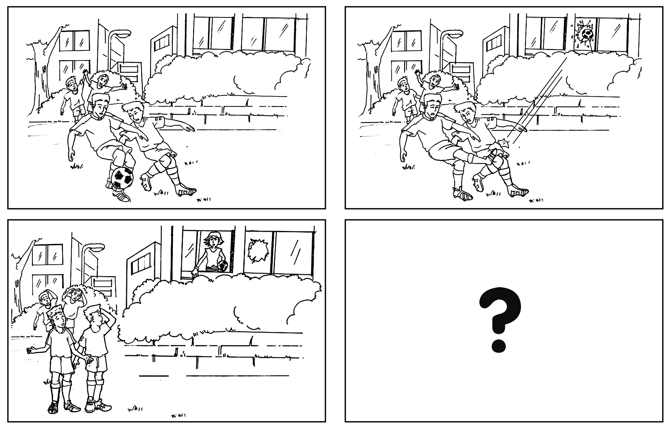
Wednesday, June 12, Sunny

[来源:Zxxk.Com]

二〇一 三年 初 中 学 业 考 试
英语试题参考答案及评分说明
第 I 卷 （选择题, 共75 分）
一至四题：
（一）参考答案：
1---5 BACCA 6----10BACBC 11---15CBCAB 16---20CBACA
21---25 CBADB 26---30BCDAD 31---35ACDCB 36---40BCADC
41---45ACABD 46---50CADCB 51---55DADCB 56---60BDADC
（二）评分说明：[来源:Zxxk.Com]
1. 1---45小题，每小题1分； 46--60小题，每小题2分；
2. 凡与答案不符者, 不得分。
第 II 卷 （非选择题, 共45分）
五、词汇运用
（一）参考答案：
61. lonely 62. surprise 63. impossible 64. offered 65. caught 66. improve 67. twelfth
68. messages 69. especially 70. hung 71. shouting 72. thought 73. beside 74. answers 75. louder 76. happens 77. softly 78. get 79. saying 80.so
（二）评分说明:
1. 本题共20分，每小题1分。
2. 凡与答案不符者，不得分。
六、阅读表达
（一）参考答案:
81. Sad and anxious/Nervous.
82. It is a drug/A drug.
83.无数次的尝试后我才认识到怎样戒掉咖啡。
84. a day/per day/every day
85. How to give up coffee./Giving up coffee.
（二）评分说明：
1. 本题共5分，每小题1分。
2. 虽与参考答案表达方式不同，但与所给参考答案意思一致，无语言错误，即可得分。
3. 81题只要写出参考答案中的其中一个即可得分。
七、写作
第一节
（一）参考答案：
86. belong to 87. it take 88. so; that 89. It; since 90. in reading
（二）评分说明:
1. 本题共10分，每空1分。
2. 与答案不符者不得分。
第二节
（一）One possible version：
Wednesday, June 12, Sunny
Last Sunday afternoon，some of my best friends and I went to play football in the open ground inside our neighborhood. We really had a good time! Suddenly I kicked the ball so hard that it flew at a window. It was broken! An angry woman looked out of a window, shouting at us. We were all too frightened! She asked who did that. I went up and said sorry to her. The woman told us not to play football around next time. A bad day!
（二）评分说明：
1. 文章要体现图画信息，结局只要合理均可接受。
2. 要求考生用适当的时态、语态、句式和词语，完整准确地表述所提示的内容，情节合乎逻辑书写工整。
请按下列五个档次评分：
1. 短文通顺完整，能包含所有要点，表达清楚流畅, 语言基本无误，9－10分;
2. 短文较通顺完整，表达基本清楚，语言有少量错误，7－8分;
3. 能写明基本要点，短文不够通顺完整，语言有较多错误，但尚能达意，5－6分;
4. 仅能写明部分要点，短文不完整，语言错误多，影响意思表达，3－4分。
5. 仅能写出与文章有关的单词或片语，0—2分。

