绝密★启用前 试卷类型：A
泰安市二〇一〇年初中学生学业考试
英 语 试 题
本试卷分第I卷（选择题）和第II卷（非选择题）两部分。第I卷1 至 8页，第II卷9至11页，共120分。考试时间120分钟。
第I卷（选择题，共80分）
第一部分 听 力（共25小题；每小题1分，满分25分）
（一）听句子，选择适当的应答语。每个句子读两遍。
1. A. It’s new. B. It’s fine. C. It’s black.
2. A. No, I can’t. B. Yes, I do. C. Yes, I am.
3. A. They are good. B. Good idea. C. We like hot dogs.
4. A. He is swimming. B. I’m reading. C. She is singing.
5. A. It’s my pleasure. B. I’m afraid I can’t. C. Yes, please.
（二）听对话及问题，选择相对应的图画。每段对话及问题读两遍。
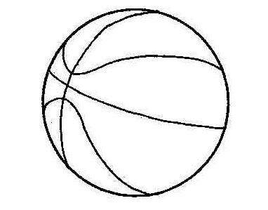
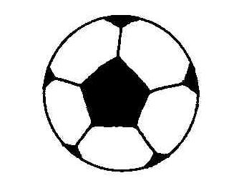
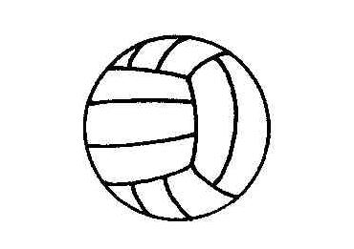
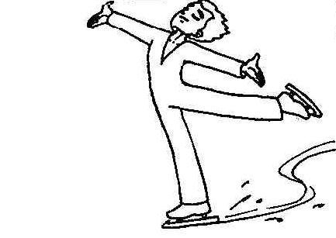
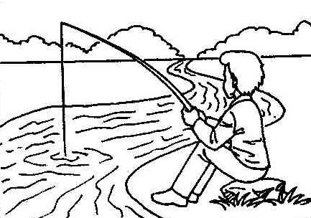

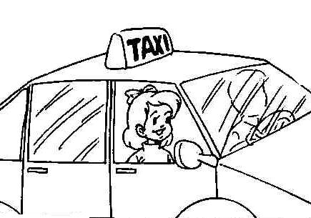
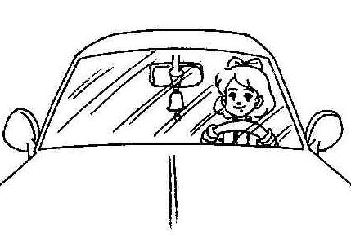
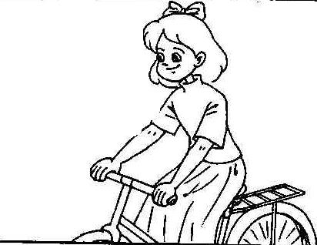
6. A. B. C.

7. A. B. C.

8. A. B. C.

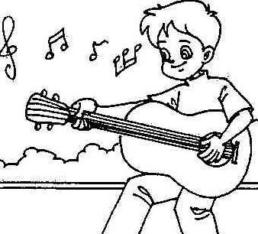
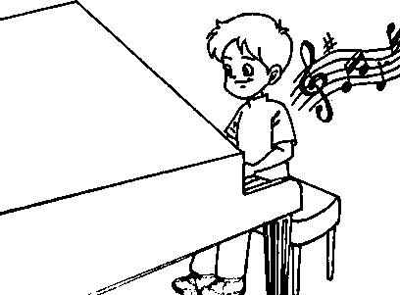
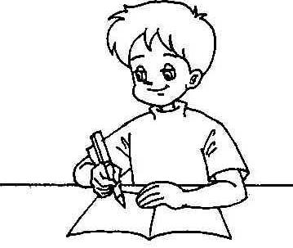
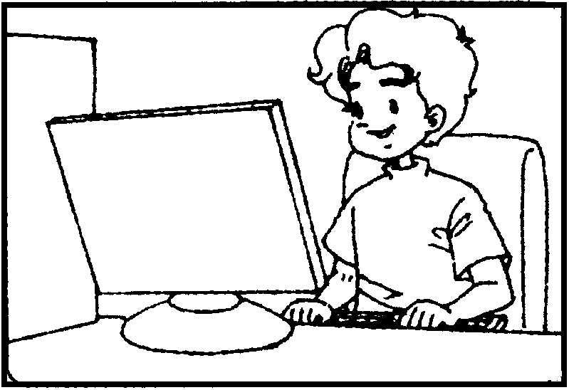
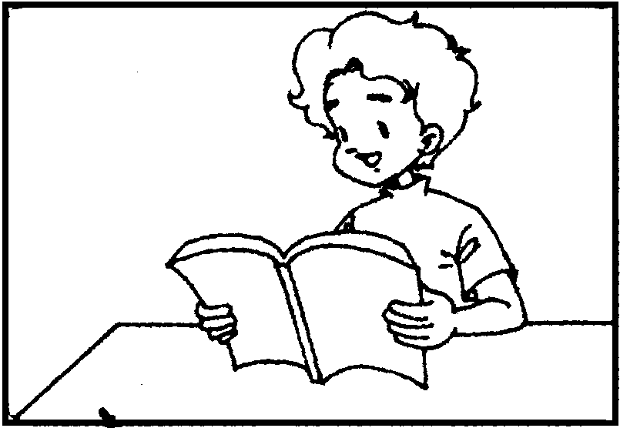
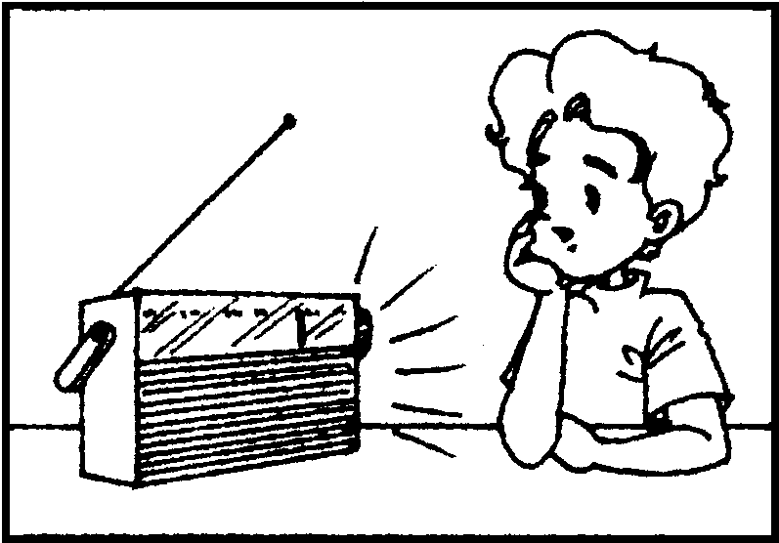
9. A. B. C.

10. A. B. C.
（三）听五段对话和五个问题，选择每个问题的正确答案。每段对话及问题读两遍。你将有15秒钟的时间阅读下面5个小题。
11. A. In 1953. B. In 1965. C. In 1955.
12. A. Went to a picnic. B. Did her homework. C. Had a party.
13. A. Every day. B. Sometimes. C. Never.
14. A. Country music. B. Pop music. C. Classical music.
15. A. $ 100. B. $ 200. C. $ 300.
（四）听两段长对话，选择每个问题的正确答案。每段对话读两遍。你将有20秒钟的时间阅读下面5个小题。
听第一段对话，完成第16—18小题。
16. Where does the woman go?
A. The hotel. B. The hospital. C. The station.
17. Where is the station?
A. At the end of the road. B. In the middle of the road. C. Near the factory.
18. How far is the station?
A. Three kilometers. B. Two kilometers. C. Ten kilometers.
听第二段对话，完成第19、20小题。
19. What are they getting ready for?
A. Teachers’ Day. B. Children’s Day. C. Women’s Day.
20. Where will they hold the party?
A. In the office. B. In the library. C. In the classroom.
（五）听短文，选择每个问题的正确答案。短文读两遍。你将有20秒钟的时间阅读下面5个小题。
21. What does the mother do?
A. A teacher. B. A farmer. C. A worker.
22. What is the mother like?
A. She is tall and beautiful. B. She is tall and fat. C. Her hair is brown.
23. What does the mother like doing?
A. Fishing. B. Swimming. C. Planting flowers.
24. Who does she often give flowers to?
A. Her friends. B. The teacher. C. The father.
25. What is important to a student from the passage?
A. Playing. B. Studying. C. Surfing the Internet.
第二部分 语言知识运用（共两节, 满分25分）
第一节 语法和词汇（共15小题；每小题1分, 满分15分）
从每小题A、B、C、D四个选项中, 选出能填入相应空白处的最佳选项, 并在答题卡上将该项涂黑。
26. —What’s ______ most useful invention in the 20th century?
—______ computer, I think.
A. the, A B. a, A C. the, The D. /, The
27. —Lucy, do you like ______?
—Yes. Most of my clothes are ______.
A. an orange, an orange B. orange, orange
C. oranges, oranges D. orange, an orange
28. —Jim, Tom is looking for his English book. Is this ______?
—No, that is ______. I don’t know where his is.
A. his, mine B. he, mine C. him, mine D. his, my
29. —Why do you always watch Channel 10 instead of Channel 5, Grandpa?
—The programs on Channel 10 are ______ better.
A. more much B. much more C. more D. much
30. —I can’t decide ______.
—You mean the purple sweater or the blue one?
A. how to go there B. who to go with C. where to visit D. which to choose
31. —Where is Mr. Lee? I have something important to tell him.
—You ______ find him. He ______ Japan.
A. won’t, has gone to B. may not, has been to
C. may, has gone to D. can’t, has been to
32. —Which of these two English books will you borrow?
—I’ll borrow ______ of them. Because they are very interesting.
A. either B. all C. neither D. both
33. —Lots of trees and flowers ______ on both sides of Huanshan Road last year.
—Oh, that’s beautiful.
A. are planted B. were planting C. were planted D. have planted
34. —Hi, Daming. It’s said the famous singer will come to Tai’an. Do you know ______?
—Next month.
A. when does he come B. when he comes
C. when will he come D. when he will come
35. —Tom, your books should be in right order.
—OK. I’ll ______ right now.
A. put them down B. put them away C. put them up D. put them on
36. —How about going shopping this weekend, Peter?
—Sorry. I prefer ______ rather than ______.
A. to stay at home, go out B. to go out, stay at home
C. staying at home, go out D. going out, stay at home
37. —______ will you come back, Mum?
—In ten minutes.
A. How long B. How soon C. How often D. How far
38. —______ kind girl Nancy is!
—Yes, she is always ready to help others.
A. What B. What a C. How D. How a
39. —Hello! Is that Kate speaking?
—Yes, ______.
A. it’s Kate B. I’m Kate C. this is Kate D. Kate is me
40. —My mother and I will go to Shanghai this summer.
—______. Shall we go together?
A. So do I B. So can I C. So am I D. So will I
第二节 完形填空（共10小题；每小题1分, 满分10分）
阅读下面短文，掌握其大意，然后从每题所给的A、B、C、D四个选项中，选出能填入短文相应空白处的最佳选项，并在答题卡上将该项涂黑。
Stuart and Steve were twin brothers. Stuart loved to play basketball. But Steve loved to read books.
One day Stuart was playing basketball 41 he fell and broke his leg. When they took him to the hospital, the doctor said he wouldn’t be able to play for six months. Steve went 42 him and brought him books on basketball. At first Stuart wasn’t going to read them. Then he began to read them and 43 that there were ways he could play basketball better. He began to think that books weren’t that 44 .
When Stuart’s leg started getting better, Steve would help him by going for walks with him. 45 Stuart’s doctor said he could start playing basketball again. Then Stuart showed Steve how to toss (投) for baskets. Steve found that he enjoyed it.
Then Stuart was ready to 46 the basketball games. Steve went to games and enjoyed himself. They then 47 practiced basketball and read books together.
So you can see, when 48 happens, something good may also happen. Steve showed Stuart about books and Stuart showed Steve about basketball. So you can also 49 showing others something that you like to do and they can show you something that they like to do. 50 you can find new things to do.
41. A. until B. when C. after D. where
42. A. on seeing B. to call C. to visit D. to look
43. A. saw B. looked C. read D. found
44. A. good B. bad C. better D. worse
45. A. But B. However C. Finally D. So
46. A. take part B. win C. lose D. join in
47. A. always B. never C. seldom D. much
48. A. anything good B. something nice C. something bad D. anything wrong
49. A. try B. practice C. enjoy D. like
50. A. On the way B. By the way C. All the way D. In this way
第三部分 阅读理解（共20小题；每小题1.5分, 满分30分）
阅读下列短文，从每题所给的A、B、C、D四个选项中, 选出能回答所提问题或完成所给句子的最佳选项, 并在答题卡上将该项涂黑。
A
Sixteen years ago a boy gave me an important gift. It was a smile.
It was the early autumn of my first year at a middle school, and my old school was far away. As a result, no one knew who I was. I was very lonely, and afraid to speak to anyone.
Every time I heard the other students talking and laughing, I felt my heart break. I couldn’t talk with anyone about my problems.
Then one day, when my classmates were talking happily with their friends, I was sitting at my desk unhappily as usual. At that moment, a boy entered the classroom. I didn’t know who he was. He passed by me and then turned back. He looked at me, with a smile.
Suddenly, I felt the touch of something bright and friendly. It made me feel happy and warm. That smile changed my life. I started to talk with other students and made friends. Day by day, I became closer to everyone in my class. The boy with the lucky smile has become my best friend now.
One day I asked him why he had smiled, but he couldn’t remember doing so!
It doesn’t matter because all the dark days have gone. I believe that the world is what you think it is. If you think it is lonely, you might always be alone. So smile at the world and it will smile back.
51. When did the writer get the gift?
A. At the age of 16.
B. After making friends with the boy.
C. In the first year at a middle school.
D. After becoming closer to everyone in the class.
52. Why was the smile an important gift?
A. Because the writer’s old school was far away.
B. Because the writer didn’t know who the boy was.
C. Because the smile didn’t mean anything to the boy.
D. Because the writer felt lonely and had no friends and it made her feel happy and warm.
53. Why didn’t the writer talk to anyone in her new school about her problems?
A. Because she was always unhappy.
B. Because she didn’t know anyone at the time.
C. Because she was in the first year at the junior high school.
D. Because she didn’t want her parents to worry about her.
54. How did the smile change her life?
A. She started to make friends.
B. She became the best friend of the boy.
C. Her parents didn’t worry about her any more.
D. She realized that she was lonely.
55. Where does she now think her feeling of unhappiness came from?
A. From her old school. B. From her parents.
C. From herself. D. From her classmates at the new school.
B
Almost every day, we discuss the topic of health, especially for kids. But what is health? “Health” means eating well, getting enough exercise, and having a healthy weight. Let’s read the following rules. They can help you stay healthy.
1. Eat a variety of food, especially fruit and vegetables. We all know that eating fruit and vegetables can help us stay healthy, but many of us only eat our favorite food. Remember that we can only get the nutrition (营养) we need by eating different kinds of food, especially fruit and vegetables.
2. Drink water and milk most often. Everyone knows that water is important. Besides that, kids need plenty of calcium (钙) to grow strong bones, and milk is rich in it. Every day, you should drink at least three cups of milk, when you are 9 years old or older. You should also try to have less sugary drinks, like soda and coca. They include a lot of sugar. Sugar only includes calories (热量), not important nutrition.
3. Listen to your body. When you are eating, notice how your body feels. When your stomach feels comfortably full, stop eating. Eating too much makes you feel uncomfortable. If you do it too often, it can make you unhealthy and fat.
4. Limit screen time. What’s screen time? It’s the amount of time you spend watching TV, movies and playing computer games. The more time you spend on these sitting-down activities, the less time you spend playing sports, like basketball, and doing other activities like riding and swimming. Try to spend no more than 2 hours a day on screen time.
56. In this passage, “health” includes all of the following EXCEPT ______.
A. eating well B. doing more exercise
C. having a healthy weight D. wearing comfortable clothes
57. The underlined phrase “a variety of” means ______.
A. plenty of B. all kinds of C. the rest of D. a lot of
58. Which of the following is NOT true?
A. Eating more fruit and vegetables is good for people.
B. We should eat and drink things with little sugar.
C. We should spend the same time on both sitting-down activities and sports.
D. When we are full, we should stop eating, no matter how delicious the food is.
59. Screen time is the time that you spend ______.
A. playing computer games B. watching movies
C. watching TV D. All of above
60. What’s the main idea of the passage?
A. How to eat healthy food. B. Eating and playing are both important.
C. Suggestions for staying healthy. D. Health is very important.
C
In Britain you may often hear “Drop in any time” or “Come to see me soon”, but you can’t really do that. People just say those things to make you feel welcome. It is better to telephone before visiting someone at home. If you receive a written invitation to an event that says “RSVP”, you should reply to let the person who sent the invitation know whether or not you plan to go.
You should never accept an invitation unless you really plan to go. You may refuse by saying, “Thank you for inviting me, but I will not be able to come.” If, after accepting, you are unable to go, be sure to tell those who are expecting you as soon as possible that you will not be there. Although it is not necessarily expected that you give a gift to your host, it is considered polite to do so, especially if you have been invited for a meal. Flowers, chocolate, or a small gift are all appropriate(合适的). A thank-you note or telephone call after the visit is also considered polite and is an appropriate way to express your appreciation for the invitation.
61. What can you do when a British friend says, “Drop in anytime”?
A. Visit him or her at any time.
B. Say no time to him or her seriously.
C. Telephone him or her before visiting.
D. Visit him or her soon.
62. What does the underlined word “RSVP” probably mean in Chinese?
A. 请自便 B. 请回复 C. 请审阅 D. 请来访
63. What should you do if your British friend sends you an invitation but you do not want to go?
A. Do not give him or her an answer.
B. Tell another friend to go instead of you.
C. Tell him or her that you can’t be there for some reason.
D. Tell him or her that you don’t want to go there.
64. Which of the following is considered impolite in Britain?
A. Buy small presents when invited.
B. Refuse the invitation without telling anyone.
C. Write a thank-you note after a visit.
D. Give a telephone call after a visit.
65. Where would you probably see this passage?
A. In an invitation. B. In a guidebook. C. On a poster. D. In a newspaper.
D
At the World Expo Shanghai 2010, you will be able to see the world in just one day.
The World Expo (short for “exposition”) is the third largest world event after the Olympics and the FIFA World Cup. Countries build pavilions(展示馆) at the Expo, showing off technologies and cultures with colorful exhibitions and performances.
People can experience the most advanced technologies at the World Expo. Throughout history, many new inventions have made their debuts(样品) at the World Expo, including the TV, telephone and even the ice cream cone.
But the Expo is not just a trade fair(商品交易会). It’s a platform(平台) for cultural exchange, bringing people closer to the rest of the world.
For example, at the Shanghai Expo, couples may be able to marry in French-style weddings at the France Pavilion. Thailand will let visitors walk into its emperor’s palace. Visitors to the Austria Pavilion will have the chance to experience the snow-capped mountains of the country.
Many countries have also decided to bring their national treasures to the event.
Since the 1993 Expo in Chicago, the World Expo began to focus on one theme. It changed from a show into a community event. Visitors are invited to help solve global issues, such as environmental problems.
The theme of the Shanghai Expo is “Better city, better life”. It will call on the world to solve the problems human beings face as a result of urbanization(城市化). In the future, more and more people may care about protecting the places they live in.
66. Countries build pavilions to show us ______ with colorful exhibitions and performances.
A. the Olympic games B. the FIFA World Cup
C. technologies and cultures D. many cities
67. What’s the meaning of “cultural exchange” in this passage?
A. 科技展示 B. 文化交流 C. 科技交流 D. 自由买卖
68. Which of the following is NOT true at the World Expo in this passage?
A. People can experience the most advanced technologies.
B. Couples may be able to marry in French-style weddings at the France Pavilion.
C. Visitors can walk into the emperor’s palace of Thailand.
D. Australia Pavilion will let the visitors experience the snow-capped mountains of the country.
69. When did the World Expo begin to focus on one theme?
A. In 1990. B. In 1993. C. In 1998. D. In 2010.
70. What is the theme of the Shanghai Expo?
A. One world, one dream. B. Better world, better life.
C. Better city, better life. D. One world, one family.

绝密★启用前 试卷类型：A
泰安市二〇一〇年初中学生学业考试
英 语 试 题

第II卷（非选择题 共40分）
注意事项：
1. 答卷前将密封线内的项目和答题纸上的座号填写清楚。
2. 在试题上、草稿纸上答题无效，答案必须写在答题纸的相应位置。
3. 考试结束后，试题和答题纸一并收回。

第四部分 书面表达（共三节，满分40分）
第一节 词汇运用（共两题，满分15分）
（一）单词拼写（共5小题；每小题1分，满分5分）
根据句意和首字母或汉语提示，将单词的正确形式写在相应的横线上。
71. You must stop s____________, nicotine (尼古丁) is bad for your health.
72. The girl s____________ a lot of time collecting stamps last year.
73. We were glad to celebrate our motherland, China’s s__________ birthday on October 1st, 2009.
74. I like ____________ (土豆) a lot, and my mother usually cooks it in different ways.
75. Which are __________ (重的), elephants or sheep?
（二）综合填空（共10小题；每小题1分，满分10分）
根据短文内容，用方框中所给词语的适当形式填空，使文章通顺、完整。（每词限用一次）
In a happy town there lived a little, beautiful and smart girl, and (76)______________ name was Rose. (77)______________ in the town liked her. She was so brave, but one thing she was scared of was the doctor.
turn, better, give, she, scared, visit, close, open, but, everyone
One day her tooth was moving. Her mum saw it. She said, “Your tooth is moving, and you need to (78)______________ Doctor Tim.”
Rose said, “No! I am not going to the doctor.” Mum said, “Don’t worry. It’s not so wobbly (摆动的) now.” That made Rose feel (79)______________.
After five weeks, Rose forgot about her tooth (80)_______________ her mum didn’t. She checked her tooth again and it was wobbly, so she said, “It’s time to see the doctor.”
Rose was (81)______________ but she had to do what her mum told her, so they went to see Doctor Tim. They had to wait in the waiting room.
When it was her (82)_______________, her heart was bumping(碰撞) very fast. She went into Doctor Tim’s room. He was smiling. She sat on the chair.
Doctor Tim said, “(83)______________ your eyes.”
Rose closed her eyes, but just before Doctor Tim started, tears started coming down her eyes. But when she (84)______________ her eyes, she saw Doctor Tim holding her tooth.
Rose smiled. Then Doctor Tim (85)______________ her a teddy bear(泰迪熊) and from that time Rose wasn’t scared of doctors any more.
第二节 任务型阅读 (共5小题；每小题2分，满分10分)
阅读下面的短文，完成文后的任务。
Disneyland is the name of the theme parks around the world. There are Disneyland Park in Anaheim, California, Disney Orlando in Florida, Disneyland Paris in France, Tokyo Disneyland in Japan, and Hong Kong Disneyland in Hong Kong. But do you know its history? OK! Let me tell you.
Walt Disney was born in 1901. The Mickey Mouse created in 1927 made him very famous. He died in 1966, but his work and his dreams did not die. Now people all over the world enjoy his Mickey Mouse and other cartoon characters.
Later in his life, Mr. Disney had a dream, that is, to build a new kind of amusement park. It would be clean and beautiful. There would be rides for children and nice hotels for adults. It would be fun for people of all ages. Mr. Disney drew a plan for this park. It was called Disneyland. The engineer told him it was an impossible dream. His family and friends thought he was mad. But Mr. Disney did not give up his idea. In 1955, (90)Disneyland opened to the public and became the most successful amusement park in the USA. Walt Disney’s dream came true.
The Walt Disney Company confirmed that Disney had been talking to the government in Shanghai about opening a park that would open by 2014.
任务一：根据短文内容回答下列问题。
86. When did Walt Disney create Mickey Mouse?
__________________________________________________________________
87. What was Walt Disney’s dream?
__________________________________________________________________
88. Whom would the amusement park be fun for?
__________________________________________________________________
89. Where is the first Disneyland?
__________________________________________________________________
任务二：将文中划线的句子翻译成汉语。
90. __________________________________________________________________
第三节 写 作（共1题，满分15分）
今年6月5日世界环境日的主题是倡导“低碳生活”，老师就“节能减排”问题组织了一场主题讨论：日常生活中，我们能为保护环境、减少污染做些什么？请用英语写一篇不少于80词的短文，谈谈自己的想法。
参考词汇：discussion, protect the environment, be caused by, ordinary people, instead of driving cars, use plastic bags, cut down on, recycle, natural food, save energy, reduce pollutions
_______________________________________________________________________________

泰安市二〇一〇年初中学生学业考试
英语试题参考答案及评分标准

第一部分：听 力（共25小题；每小题1分，满分25分）
1—5 BABCA 6—10 BBCAC 11—15 CBBCA 16—20 CABAC
21—25 CACAB
第二部分：语言知识运用（共两节，满分25分）
第一节：语法和词汇 (共15小题；每小题1分，满分15分)
26—30 CBABD 31—35 ADCDB 36—40 ABBCD
第二节：完形填空 (共10小题；每小题1分，满分10分)
41—45 BCDBC 46—50 DACAD
第三部分：阅读理解（共20小题；每小题1.5分，满分30分）
51—55 CDBAC 56—60 DBCDC 61—65 CBCBB
66—70 CBDBC
第四部分：书面表达（共三节，满分40分）
第一节：词汇运用（共两题，满分15分）
（一）单词拼写（共5小题；每小题1分，满分5分）
71. smoking 72. spent 73. sixtieth 74. potatoes 75. heavier
（评分要求：所填单词只要符合题意，语法正确，拼写无误，都可得分；否则不得分。）
（二）综合填空（共10小题；每小题1分，满分10分）
76. her 77. Everyone 78. visit 79. better 80. but
81. scared 82. turn 83. Close 84. opened 85. gave
（评分要求：所填词语只要符合题意，语法正确，拼写无误，都可得分；否则不得分。）
第二节：任务型阅读（共5小题；每小题2分，满分10分）
86. In 1927.
87. Build a new kind of amusement park.
88. People of all ages.
89. In America.
（评分要求：要求与参考答案的意思相近。）
90. 迪士尼乐园对公众开放了并且成为美国最成功的游乐园。
（评分要求：要求在准确、全面的基础上，翻译成较为通顺的汉语。）
第三节：写 作（共1题，满分15分）
（一）One possible version：
Our class had a discussion about protecting the environment. Here is my opinion. I think the environment is one of our biggest worries. It was found out that a lot of air pollution is actually caused by ordinary people, not just by big factories. There are so many things each one of us can do every day. It’s best for people to take buses or walk instead of driving cars. We should stop to use plastic bags for shopping. We can cut down on waste, recycle trash and eat more natural food. In these ways we can save energy and reduce pollutions.
（二）评分说明：
1、评分原则
（1）评分时，先根据文章的内容和语言初步确定其所属档次，然后以该档次的要求来衡量，确定或调整档次，最后给分。
（2）评分时，应注意的主要内容为：内容要点、应用词汇和语法结构的数量和准确性及上下文的连贯性。
（3）拼写与标点符号是语言准确性的一个方面，评分时，应视其对交际的影响程度予以考虑。
（4）如果书写较差，以至影响交际，将分数降低一个档次。
2、各档次的给分范围和要求
第一档（13—15分） 很好地完成了试题规定的任务。
覆盖所有内容要点；应用了较丰富的语法结构和词汇；用词准确、句子通顺、行文连贯、表达清楚，没有或基本没有语言错误；书写工整；字数符合要求。完全达到了预期的写作目的。
第二挡（10—12分） 较好地完成了试题规定的任务。
虽漏掉1、2个次重点，但覆盖所有主要内容；应用的语言结构和词汇虽不太丰富，但能满足任务的要求；句子较通顺、表达较清楚；有少量语言错误；书写工整；字数基本符合要求。达到了预期的写作目的。
第三档（7—9分）基本完成了试题规定的任务。
虽漏掉一些内容，但覆盖所有主要内容；应用的语言结构单一；句子不够通顺，行文不够连贯；语言错误较多；书写不够工整，字数较少。整体而言，基本达到了预期的写作目的。
第四档（0—6分）未恰当完成试题规定的任务。
漏掉或未描述清楚一些主要内容，写了一些无关内容；应用的语言结构单一且不规范；句子不通顺，行文不连贯；语言错误多；书写潦草，字数不足50。信息未能清楚地传达给读者。

听力录音材料
（一）听句子，选择适当的应答语。每个句子读两遍。
1. What’s the weather like?
2. Can you speak Japanese?
3. Let’s go to the zoo.
4. What is she doing?
5. Thanks for your help.
（二）听对话及问题，选择相对应的图画。每段对话及问题读两遍。
6. M: Lucy, what’s your favorite sport?
W: Football. I like playing football best.
Q: What’s Lucy’s favorite sport?
7. M: Did you go hiking last Sunday?
W: Yes, what about you?
M: I went fishing. That’s my hobby, you know.
Q: What’s the man’s hobby?
8. M: Linda, how are you going to the library today?
W: Oh, I’m going there by bike.
Q: How is Linda going to the library today?
9. M: When is your birthday?
W: Tomorrow. Can you come to my party, Bob?
M: I’d love to. But I’m afraid I will be a little late. I must have a guitar lesson first.
Q: Why will the boy be late for the party?
10. W: Your English is pretty good, Tom. How do you usually study it?
M: There’re many ways of learning. I study it by listening to the radio. It really helps.
Q: How does Tom learn English?
（三）听五段对话和五个问题，选择每个问题的正确答案。每段对话及问题读两遍。你将有15秒钟的时间阅读下面5个小题。
11. M: When was Bill Gates born?
W: He was born in 1955.
Q: When was Bill Gates born?
12. M: Hi, Alice! What did you do last weekend?
W: I went to a picnic with my friends on Saturday and I did my homework on Sunday.
Q: What did Alice do last Sunday?
13. M: How often do you exercise?
W: I keep running every day, sometimes I go swimming, but I never play ball games.
Q: How often does the woman swimming?
14. M: Lucy, are you a pop music fan?
W: No, I like classical music best.
Q: What is Lucy’s favorite kind of music?
15. M: Look! I’ve just bought a new T-shirt on sale. I paid only 200 dollars for it.
W: Oh, it’s nice. But my daughter bought the same thing for half the price.
Q: How much did the woman’s daughter pay for her T-shirt?
（四）听两段长对话，选择每个问题的正确答案。每段对话读两遍。你将有20秒钟的时间阅读下面5个小题。
听第一段对话，完成第16—18小题。
W: Excuse me, sir.
M: Yes? What can I do for you?
W: Could you tell me the way to the station?
M: Yes. Go down the road. Turn left at the second traffic light. At the end of the road you’ll find it.
W: Is it far from here?
M: Yes, it’s about two kilometers away.
W: Oh, that’s too long. Is there a bus?
M: Yes. The No. 4 bus will take you there.
W: Thanks a lot.
M: You are welcome.
听第二段对话，完成第19、20小题。
W: Tomorrow is teachers’ Day.
M: Yes, I know. And we are getting ready for it.
W: What are you going to do?
M: We are going to have a party together with our teachers.
W: When and where?
M: Tomorrow afternoon in our classroom.
W: What time?
M: At two o’clock.
W: Did you tell all your teachers to come?
M: Yes, and they’ll come on time.
（五）听短文，选择每个问题的正确答案。短文读两遍。你将有20秒钟的时间阅读下面5个小题。
Every mother is great, so is my mother. My mother is a common worker. But I love her very much. She is tall and of medium build. She has two big eyes. Her hair is black and curly. I think she is very beautiful.
My mother is hard-working like many other mothers. Whenever she is at home or at work, she is always busy. On weekends, she often cleans our house and she likes planting flowers, too. She often says, “Flowers can make the air fresh and keep the house beautiful.” She often gives flowers to her friends.
She is strict in my study. She often says to me, “Study is the most important thing to a student. You must study hard. Then you can do more and better for others and yourself.” And she is also kind to me. When I have trouble, I’d like to ask her for help.

