邵阳市2016年初中毕业学业考试试题卷
英 语
温馨提示：
(1)本学科试卷分试题卷和答题卡两部分，考试时量为90分钟，满分为120分。
(2)请你将姓名、准考证号等相关信息按要求填涂在答题卡上。
(3)请你在答题卡上作答，答在本试题卷上无效。
I．听力技能(三部分，共20小题，计25分)
A)反应 根据你所听到的内容，选择正确答语完成对话。(共5小题，每小题1分)
1．A．Nice to meet you，too． B．I＇m happy． C．The same to you．
2．A．I’m Li Ming． B．This is li Mel C．Lily is me．
3．A．Yes，I’d love to． B．Yes，I can． C．Yes，I do．
4．A．9 days． B． 8 kilos． C． 10 yuan．
5．A．I’ll chat with you． B．Sure，it's 542851369． C．QQ is useful．
B)理解 根据你听到的对话，选择最佳答案回答问题。(共10小题，每小题1分)
听下面的对话，回答第6至7小题。
6．Which sport does Rose 1ike best，swimming，football Or basketball？
A． Swimming． B． Football． C． Basketball．
7．What is Jim’s favorite sport?
A． Football． B. Skating． C． Swimming．
听下面的对话，回答第8至9小题。
8． HOW is the man going to Changsha?
A． By car． B． By train， C， By bus．
9．What time is it now?
A．7：00． B. 7：15， C．7：45．
听下面的对话，回答第10至12小题。
10．What will John plan to do?
A． Go traveling． B． Go shopping。 C． Go swimming．
11． Where are they going to spend their ho1idays?
A．Langshan． B．Huangsang． C．Nanshan．
12． Who is going there with John?
A．Alice． B.Mary． C．Helen．[来源:Zxxk.Com]
听下面的对话，回答第13至15小题。
13. Is Jack reading Yu Gong Moves a Mountain?
A. Yes, he is. B. No, he isn't. C. Yes, he does.
14. What does the woman think of the story?
A. It's interesting. B. It's a little silly. C. It's boring.
15. What does the story show us?
A. Anything is possible. B. Anything is impossible. C. Nothing is possible.
C)笔录要点 根据你所听到的内容，填写下面的表格。(每空不超过3个单词，共5小题，每小题2分)
Weather Report
Cities | ____16_______ | Temperature
_____17________ | Fine | 25 to 31
Shaodong | ______18_____ | 26 to 33℃
Longhui | _____19______ | 24 to 30 ℃
Wugang | Sunny and windy | ____20_____ ℃

Ⅱ．知识运用(两部分，共20小题，每小题1分，计20分)
A)语法填空填空 从A、B、C三个选项中选择最佳答案填空。(共10小题，每小题1分)
21. —Uncle is coming by __________ train tomorrow.
—Let's go to railway station to meet him.
A. a; the B. /; a C. /; the
22. There are __________ students in our school.
A. hundreds B. hundreds of C. hundred of
23. —David, is that __________ English dictionary?
—Yes, it is __________ . It is new.
A. yours; my B. your; my C. your; mine
24. We__________ for a picnic if it rain this Sunday.
A. will go; doesn't B. will go; won't C. go; doesn't
25. —_______ do you visit your grandfather?[来源:学*科*网Z*X*X*K]
—Once a week.
A. How many B. How soon C. How often
26. She said she hoped her daughter.
A. to see B. you to see C. seeing
27. —Must I clean the room now, Mom?
—No, .
A. you mustn't B. you needn't C. you can't
28. One of my friends moved to America, I miss her so much.
A. has B. have C. are
29. —A new bridge in our hometown last year.
— Really? Our hometown must be more beautiful.
A. is built B. was built C. built
30. I have only two tickets of Kong Fu. you he can go With me.
A. Either; or B. Neither; nor C: Both; and

B)词语填空 阅读短文，掌握其大意，从每题所给的A、B、C三个选项中选择最佳答案填
空。(共10小题，每小题1分)
Last year Jeff left school. He came to Guangzhou to find a 31 . He ,went to one
company after another company. But no one wanted him. Then he had 32 money. He
had to go back to his small town. 33 he came to the station. He 34 Very sad and
tired. It was very late at night and the station was 35 of people. They were waiting to
buy tickets of the last train. He bought the 36 ticket, so he was very happy.
At that time, a woman 37 a crying baby walked to him. She asked him to 38
her the ticket. He gave her the ticket. He thought they needed it more than he. After the
train left, he sat on the bench and didn't know 39 to go. Just then an old man came and
said, "Young man, I saw what you did to help the woman. I have a big company. I need a
good young man like you. Would you like to 40 for me?"
31. A. school B. work C. job
32. A. a little B. little C. few
33. A. Because B. So C. But
34. A. felt B. thought C. saw
35. A. filled B. some C. full
36. A. second B. last C. first
37. A. with B. in C. inside
38. A. lend B. buy C. sell
39. A. what B. where C. when
40. A. work B. study C. learn
Ⅲ．阅读技能(五部分，共25小题，每小题2分，计50分)
A)阅读短文，根据短文内容判断所给句子正(T)误(F)。(共5小题，每小题2分)

Reading is a good hobby for all kinds of reasons. First, reading is fun. You can always
keep yourself happy if you like reading. If you like reading, you will never feel bored or
tired.
Next, you can read a book almost anywhere: in a car, on a plane, or even in the
bathroom. All you need is a book!
Another good reason for reading is that it is useful. If you read as a hobby, you will get
better and better at it. And you will read faster and find it easier to understand what you
read. As your reading skills improve, you will probably find your schoolwork becomes much
better.
Some people say that reading is out of date. This is not true. You can read on
computers, and the better you read, the better your computer skills will be.
Good readers may become writers, too. They always have more things to write about.
Reading is a wonderful hobby. Why not start reading right now?
41. According to the passage, reading can keep you bored and tired.
42. You can read a book almost everywhere.[来源:学_科_网Z_X_X_K]
43. If your reading skills improve, your schoolwork will become much better.
44. It is true that reading is out of date.
45. Good readers may become writers.

B)阅读短文，从每题所给的A、B、c三个选项中选出最佳答案回答问题或完成句子。
(共5小题，每小题2分)

China is a large country. The population is over 1.3 billion. It has a special culture with
a very long history.
Chinese food plays an important role for Chinese families. Different foods have special
meanings. The main difference is that Chinese people eat their meals with chopsticks. One of
the main foods in Chinese culture is rice. Tea is a favorite drink and it is popular in the
market.
Chinese calendar is different from the one used in western countries. New Year's Day is
in late winter. It is also called the Spring Festival. It has a big celebration of tinging out the
old and ringing in the new. It has special foods and traditions. For example, sweeping the
floor before New Year's Day sweeps away all the old year's bad luck.
The Chinese zodiac( 生肖 ), known as Sheng Xiao, follows a twelve-year cycle. Each[来源:学科网]
year is named for an animal. These animal signs are the rat, ox, tiger, rabbit, dragon,
snake, horse, sheep, monkey, rooster, dog and pig. For example, the year that begins in
2016 is the year of the monkey.
Chinese is a complex (复杂的) language. Chinese writing developed almost 4,000
years ago and may even be older. Chinese writing has thousands of characters. A character
stands for a word and also a meaning. Besides Putonghua, Chinese people speak six other
forms of the language, and there are many kinds of dialects.
46. What's the population of China?
A. Almost 4,000. B. More than 1.3 billion. C. 12 million.[来源:学科网ZXXK]
47. The underlined "dialects" probably means" "in Chinese.
A.交际 B．对话 C方言
48. According to the passage, what's one of the main foods in China?
A. Tea. B. Rice. C. Meat.
49. The year that begins in 2016 isn't the year of the monkey, is it?
A. Yes, it is. B. No, it isn't. C. I don't know.
50. What's the main idea of the passage?
A. Different foods have special meanings in Chinese culture.
B. Chinese is a popular language.
C. Chinese culture.

C)阅读图表，从每题所给的A、B、C三个选项中，选择最佳答案回答问题或完成句子o
阅读下面图表，回答51-52题。
(共5小题，每小题2分)
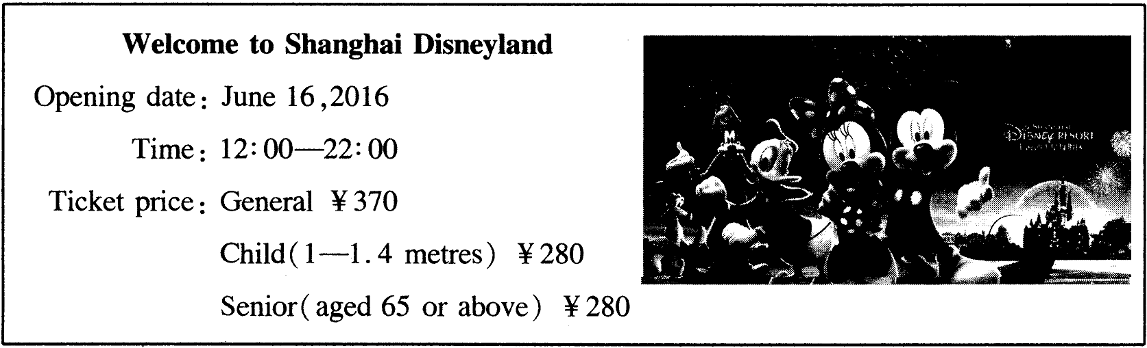

51. When will Shanghai Disneyland start to open?
A. On June 16,2016. B. On June 22,2016. C. On June 12,2016.
52. If Mr Li, Mrs Li and their 6-year-old son go to Shanghai Disneyland, they need to pay
____________
A. 930 yuan B. 1020 yuan C. 650 yuan
阅读下面图表，回答53-55题。

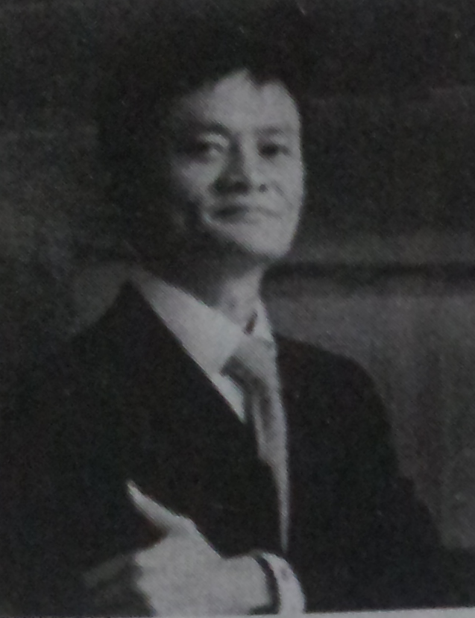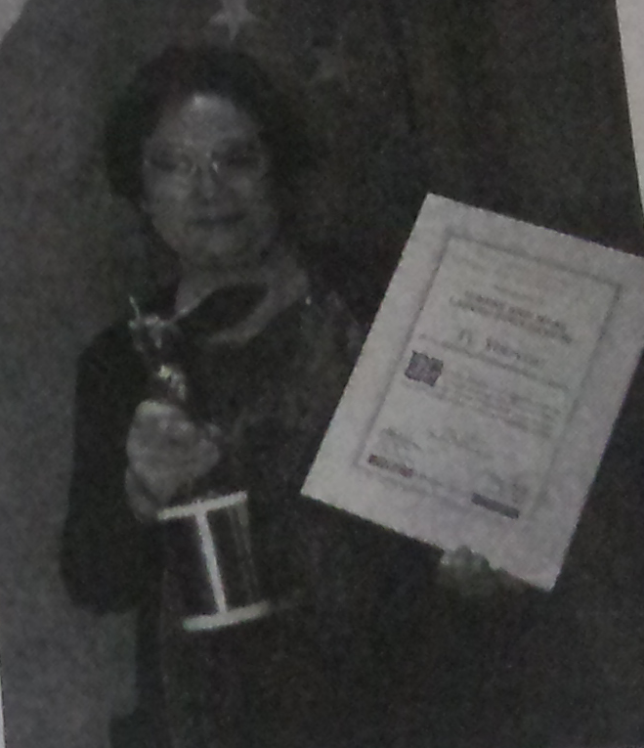
Ma Yun Tu Youyou
Bom-in 1964, Hangzhou Zhejiang 85 years old, China
The Chairman of Alibaba Group The 2015 Nobel Prize in Medicine

53. Who is the Chairman of Alibaba Group?
A. Lang Lang. B. Li Yundi. C. Ma Yun.
54. What kind of the Nobel Prize did Tu Youyou receive? ~
A. Medicine. B. Literature. C. Physics.
55. Where is Tu Youyou from?
A. America. B. Japan. C. China.

D)阅读短文，根据短文内容回答问题. (共5小题，每小题2分)
Long long ago, there was a man living in a village with his wife and two children. They
had a hen. It laid a golden egg every day. The man sold the golden egg and the family lived
a rich and comfortable life.
But the man was very greedy (~:~). He wanted to get all the golden eggs from his
hen at a time. So, he thought hard every day about how to achieve it and he got a plan at
last. He decided to kill the hen and get all the eggs. He didn't want oto tell his wife about the
plan because he wanted to give her a big surprise. He was so excited about his great plan.
He even started to sing when he thought of the plan.
The next day when the hen laid a golden egg, the man couldn't wait to take a knife and
cut its body open. However, there was nothing but blood(i~) all around. There weren't
any eggs at all. He was very sad because he would not get even one egg now.
Their life used to be comfortable with one egg a day, but now their life changed a lot.
How silly he was!
56. How many children did the man have?
57. Had the man's family lived a rich and comfortable life before he killed the hen?
58. Why did the man kill the hen?
59. What did the man getfrom the hen at last?
60. What do you think of the man in the passage?
E)阅读短文，根据短文内容，在表格中填入相应信息. (每空不超过三个单词，共5小题，每小题2分)
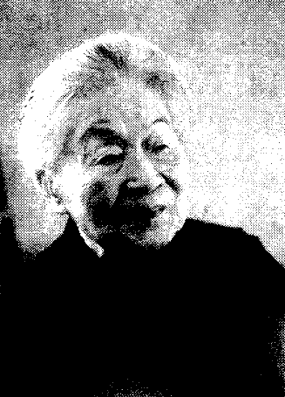
Yang Jiang, the famous woman writer and translator, is well-known
to us all.
She was bom in Beijing in 1911, originally named Yang Jikang.
As a baby she likes laughing. Her parents let every daughter develop
their character freely, which is rare at that time and even at present.
Jikang, therefor, had a happy childhood in 1920s.
She graduated from university and went to Tsinghua University as a
postgraduate( 研究生) in 1930s. There she met Qian Zhongshu, they fell in love and
married.
In 1940s, she started to use the name Yang Jiang as her pen name. Since then, she was
commonly known as Madam Yang Jiang.
In 1950s, she worked for Peking University, and started to learn Spanish. She was the
first to translate Don Quixote 《唐吉诃德》 into Chinese.
She began to write short novels in 1980s. The novel The Old Wan《老王》 written in
1984 was selected as the passage in our middle school text book.
Besides, her famous works After Baptism《洗澡之后》 and We Three《我们仨》 also
became a househould name in China.
Sorry to hear that Madam Yang died at Peking Union Medical College Hospital in
Beijing, on May 25, 2016.
Such was Madam Yang, the best wife and the talentest woman! Her legend is still
continuing!

Yang Jiang
Introduction | Bom: in Beijing in 1911  Original name: Yang Jikang  61. Yang Jiang  Her husband: 62.
Experiences | In 1930s, graduated from university  In 1950s, worked for Peking University, started to. learn 63.  In 1980s, began to write 64.
Famous works | The Old Wang; After Baptism, 65.

Ⅳ．写作技能(三部分，共11小题，计25分)
A)完成对话 通读对话，根据上下文补全对话内容。(共5小题，每小题1分)

Jane: 66.__________________
Doctor: Good afternoon, Jane. 67. ______________？
Jane: I'm not feeling well and I have a headache.
Doctor: 68. ______________？
Jane: It started this morning.
Doctor: Let me see. Oh, there's nothing serious. You have a cold.
Jane: 69. ______________？
Doctor: You'd better take these pills and drink more hot water.
Jane: I'll follow your advice, Thank you.
Doctor: 70. ______________.

B)英汉互译 阅读短文，将文中划线的句子翻译成汉语或英语。(共5小题，每小题2分)
71. The Intemet is becoming more and more popular. It brings us a lot of fun and
convenience, 72. 但它也引起一些新的问题。 Children like the Intemet. They would rather
communicate with others online than talk with their parents.
On the one hand, in my opinion, the Intemet brings people closer. On the other hand,
73. 如果我们花太多的时间在网络上, we will have less time with our families and friends
in the real world.
74. Parents are always staying with us. So why not talk to them face to face when we
have problems. If so, 75. I'm sure that we can get on well with our parents.

C)情景作文(计10分)
近来，中小学生的健康问题日益引起人们的关注。其中垃圾食品、电子游戏等是影响健康的重要因素，请以“Keep Healthy”为题谈谈你的看法o ，
要求：1．列举中小学生面临的健康问题。
2．谈谈怎样才能保持健康。
3．80词左右，开头已给出，不计人词数o
4．语法正确，文理通顺、流畅，并适当发挥。
提示词：junk food,be bad for, computer games,suggestions,stay away from
Keep Healthy
Today, some students have several health problems.
____________________________________________________________________________________________________________________________________________________________________________________________________________________________________________________________________________________________________________________

