2016年浙江省初中毕业升学考试（嘉兴卷）
英语试题
考生须知：
- 本试题卷分卷I（选择题）和卷II（非选择题）两部分，请考生使用规定用笔，将所有试题的答案涂、写在答题纸上。做在试题卷上无效。
- 全卷共8页，7大题。满分为120分。考试时间为100分钟。
温馨提示：答题前请仔细阅读答题纸上的“注意事项”。
卷 I
注意：每小题选出答案后，用2B铅笔把答题纸上对应题目的答案标号涂黑，如需改动，用橡皮干净后，再选涂其他答案标号。

一、听力（本题有15小题，第一节每小题1分，第二、三节每小题2分；共计25分）
第一节：听小对话，从题中所给的A、B、C三个选项中选出最佳选项，回答问题。
- What fruit does Susan like best?
A.Apples. B. Oranges. C.Bananas.
2.What is the weather going to be like?
A.Rainy. B.Sunny. C.Cloudy.
3.Whose is the notebook?
A.Tina’s B.Eric’s. C.Tony’s
4.What does Julia want to be?
A.A teacher B.A driver. C.A doctor.
5.When does the school bus leave?
A.At4:00. B.At 4:20 C.At 4:40
第二节：听较长对话，从题中所给的A、B、C三个选项中选出最佳选项，回答问题。
~听下面一段对话，回答第6~7两个小题。
6.Where does the conversation probably take place?
A.In a cinema. B.In a bookstore. C. In a restaurant.
7.How much should the man pay?
A.20 yuan. B.23 yuan C.26 yuan.
听下面一段对话，回答第8~10三个小题。
8.Why is Jack going to Los Angeles?
A.To visit some of his friends.
B.To have a businese meeting.
C.To watch a basketball match.
9.How will Jack go to Los Angeles?
A.By car. B.By bus. C.By subway.
10.What will Jack probably do in a traffic jam?
A.Listen to music. B.Chat with friends. C.Send text messages.
第三节：听独白，从题中所给的A、B、C三个选项中选出最佳选项，完成信息表。
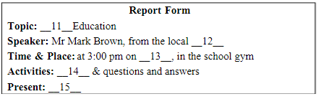
11. A. Law B. Health C. Safety
12. A. sports club B. police station C.medical centre
13. A. Wednesday B. Thursday C. Friday
14. A. idea sharing B. role playing C. video watching
15. A. a movie ticket B. a cartoon book C. a set of postcards

卷II 笔试部分
二、完型填空 （本题有15小题，每小题1分；共计15分）
阅读下面短文，掌握大意，然后从A、B、C、D四个选项中选出最佳选项。
Brittany Amano wants to make sure every child in the US has enough to eat.
Brittany Amano, now 18, knew how it felt to go hungry. Her mother tried to find a ___16__ in Honolulu, Hawaii to support the family. Her grandmother helped out as much as she could. But the family ___17__ had to depend on a local food bank to live on, and for that she was ___18__.
When they lost their home, Amano’s family had to live in a friend’s basement （地下室）. “I could feel how hunger and homelessness__19___ my family.” Amano told a reporter from TFK. “The experience made me want to give ___20__ to others in the same situation.”
In fourth grade, she and some of her friends started a good project. They __21___ $ 700 and collected 800 pounds of food. __22___ twelve, Amano set up the un profit （非营利的）group Hawaii’s Future Isn’t Hungry. She hoped to raise $ 10,000 __23___ she finished high school. She ended up raising more than $ 500,000 in four years.
With the ___24__ collected, the nonprofit group, now called The Future Isn’t Hungry, can offer fresh fruits, vegetables, and other ___25__ foods to school kids on Fridays. This is to make sure that the kids and ____26___ families have enough food to get them ____27___ the weekend. So far, the effort has helped more than 750,000 people.
In the fall of this year, Amano will ___28__ Duck University, in North Carolina on a full scholarship. After that, she plans to return to ___29__ the city that gave her so much. “It doesn’t matter if you help one million people ___30__ just one person,” she says. “The smallest action can make a huge difference.”
16. A. job | B. club | C. house | D. school
17. A. yet | B. still | C. just | D. never
18. A. careful | B. helpful | C. hopeful | D. thankful
19. A. satisfied | B. influenced | C. developed | D. managed
20. A. hope | B. choice | C. surprise | D. pleasure
21. A. paid | B. saved | C. raised | D. borrowed
22. A. By | B. At | C. Until | D. Below
23. A. if | B. since | C. when | D. because
24. A. food | B. clothes | C. books | D. money
25. A. sweet | B. healthy | C. cheap [来源:学科网] | D. delicious
26. A. his | B. her | C. their | D. our
27. A. into | B. across | C. along | D. through
28. A. enter | B. visit | C. drop | D. leave
29. A. set off | B. club | C. give back | D. come up
30. A. or | B. as | C. but | D. and
【参考答案】1-5 ABDBA 5-10 CBCDB 10-15CDACA
【考查内容】完型填空，考查英语中各语法知识点
【解题思路】
16. 考查名词辨析，妈妈在夏威夷的火奴鲁鲁找到了一份工作来支撑家庭，所以选A。
17. 考查副词辨析，yet意为“还，但是，已经”，still意为“仍然，更，静止地”，just意为“只是，仅仅；刚刚，刚才”，never意为“从未，决不”，妈妈找了份工作，奶奶也尽自己所能地帮忙，但是这个家仍然不得不依靠食物银行为生。所以选B。
18. 考查形容词辨析，careful意为“仔细的”，helpful意为“有益的，愿意帮忙的”，hopeful意为“有希望的， thankful意为“感恩的”，得到天野小姐食物银行的帮助，所以对于它，天野小姐是感恩的。
19. 考查动词辨析，satisfy意为“使……满意”，influence意为“影响”，develop意为“发展”，manage意为“管理”。饥饿和无家可归是一种不好的感觉，在这里选“influence影响”显然更好一些。
20. 考查名词辨析，联系上下文，天野在生活窘困的时候得到了帮助，心怀感恩的她也想给别人，那些跟她一样处境的人，带来希望，所以选A。
21. 考查动词辨析，pay意为“支付”，save意为“节约，节省”，raise意为“筹集”，borrow意为“借”。在这里，那些钱和食物是天野和她的同学筹集所得，所以选C。
22. 考查介词，“at twelve”在某人12岁的时候，at后面跟数字，可表示在某人几岁时。
23. 考查连词，if意为“如果”，since意为“从……起”when意为“当……时”，because意为“因为”，当她结束高中的时候，她筹集了100000美元，所以选C。
24. 考查名词，联系上下文，上文中大篇幅地描写了她所筹到的钱，而后面的食物也是要钱买的，所以这里选“money”。
25. 考查形容词，上文提到的新鲜的瓜果蔬菜的共同特点是健康的，在列举时，后面的食物应该符合这个共同特点，所以选B。
26. 考查形容词性物主代词，那些得到帮助的家庭是孩子们的家庭，所以选C。
27. 考查介词辨析，through the weekend是“持续到周末”的意思，选D。
28. 考查动词辨析，联系上下文可知，天野结束了她的高中，要去上杜克大学了，所以选A，意为“进入”。
29. 考查动词短语，set off意为“出发动身”，get down意为“下来；吞下；使沮丧”，give back意为“归还；回馈；恢复”，come up意为“走进；发生；开始；上升；发芽；被提出”，天野计划回到火奴鲁鲁是为了回馈那个给了她很多的城市，所以选C。
30. 考查连词，你帮一百万个人或只帮了一个人都没有关系，一个小小的行动就能产生巨大的不同，只有or有选择意义，所以选A，as 是“因为；当……时；依照”的意思。

三、阅读理解 （本题由15小题，每小题2两分；共计30分）
阅读下面材料，从每题所给的A、B、C、D四个选项选出最佳选项。
A
Leon was a postman. Every day wake up and feed his 37 cats. Leon didn’t really want 37 cats, but one by one they had appeared on his doorstep, and Leon had taken them in.
Every day, after feeding the cats, Leon would collect the mail from the red postboxes in the village and take it home. “If only I had 37 helpers instead of 37 cats, my job would be so much easier, ” Leon thought. Just then, the cats started meowing for their dinner. That gave Leon an idea. That night, Leon worked late making 37 cat-sized postal backpacks. Then, he went around to each postbox, putting up signs that read: postbox closed! Please use the postal cat service.
The next day, Leon put a backpack on each cat and dropped off the cats around the village. Leon knew that the cats would be happy walking around all day. He also knew that they would always come home for dinner. Leon spent the day relaxing, waiting for his helpers to return. Leon was right. The cats did return, but they did not bring home many letters. Some got the letters wet. Some bit off the corners of the letters. Some even lost their backpacks. “”Cats are just too unreliable（不可靠的）,” Leon thought.
Just then, a strange sound came from the outside of Leon’s door. A dirty dog was waiting to be invited inside. That gave Leon an idea.
31. In Paragraph 2, Leon _______ that night.
A. made postal backpacks B. put up a sign on each cat
C. had dinner with the cats D. collected letters in the village
32. According to the last paragraph, we can infer（推断） that Leon would _______.
A. let the dog take a shower B. invite the dog to dinner
C. make the dog work for him D. walk the dog around the village
33. From the passage we know Leon was ______.
A. honest B. brave C. strict D. funny
【参考答案】 31-33ACD
【考查内容】 体裁：选择型阅读理解——记叙文 题型：细节理解题，推理判断题和主旨大意题
【解析思路】
- 细节理解题，文章第二段一开始写到每天Leon疲于每天出去到村庄里收集村民们寄的信，后来就想出了一个让他的37只猫帮他收信的办法，从第二段的倒数第三句话“That night, Leon worked late making 37 cat-sized postal backpacks.”可以这题选择A 。
- 推理判断题，从最后一段的文意可以推断出C项的内容就是本题的答案，由于之前的37只猫都unreliable（不可靠的），所以作者将会请狗进家门，开始做他的得力助手。
- 主旨大意题，通过全文得出文章的作者属于很幽默滑稽的性格，而且A,B,C的选项都不是文章要表现的作者的性格。
B
Luca Gramberini has been scuba diving since he was a kid. His family owns a scuba company. For the past three summers, Luca has added gardening to his underwater activities. He helps run Nemo’s Garden, a project to grow plants in the sea.
From May through September, Luca and other divers are working on Nemo’s Garden in the Mediterranean Sea, 150 feet from the coast of Noli, Italy. Five large balloon-like objects, called biospheres（生物圈）, hold plants such as beans and strawberries. The biospheres are filled with air and placed 20 feet below the surface. “My father came up with the idea because he loves gardening very much,” Luca said.
According to Luca, the sea is a good place to grow plants because underwater temperatures remain stable, changing little from day to night. The biospheres act like greenhouses. Inside the air-filled biospheres, fresh water keeps evaporating（蒸发）, providing the plants with a good environment to grow in. “We have already seen the plants, grow faster and better,” Luca says. “And there are fewer storms that can knock down the biospheres during the summer.”
Luca hopes Nemo’s Garden will provide a new way of growing crops. “There is not enough land on the Earth,” he says. “And in many developing countries, bad conditions make it difficult for crops to grow.”
Though the project has just started, Nemo’s Garden has achieved success and is moving to different areas. “We’re going to try growing other plants.” Luca says. “We hope to set up biospheres in other countries. There are many possibilities.”
34. Nemo’s Garden is a project to ______.
A. do scuba diving in the sea B. stop storms in the sea
C. make fresh water from the sea D. grow plants under the water
35. The underlined word “stable” in paragraph 3 means ______ I Chinese.
A. 平衡的 B. 正常的 C. 稳定的 D. 合适的
36. The passage is probably taken from the _______ part of a newspaper.
A. travel B. science C. health D. sports
37. The best title for this passage is _______.
A. Gardens in the sea B. Projects for summer activities
C. Plants in greenhouses D. Conditions for crop growing

【参考答案】DCBA
【考查内容】体裁：选择型阅读——记叙文；题型：细节理解题，词义猜测题，推理判断题，主旨大意题。
【解题思路】
- 细节理解题。定位于第一段最后一句话：He helps run Nemo’s Garden, a project to grow plants in the sea. 得出答案D。
- 词义猜测题。根据下文得出答案：changing little from day to night，说明改变得很少，得出“稳定”的意思。
- 推理判断题。根据全文判断，文章讲了在海底种植植物的事情，比较可能出现在科技部分。
- 主旨大意题。文章主要围绕海底花园展开。

C
Some English words have more than one meaning. These are called multi-meaning words.
Multi-meaning words have the same pronunciation with different meanings. For example, let’s look at the word “ball”. You could have a “ball” which means you would have a good time. You could toss a “ball” which means you throw an object. You could be on the “ball” which means you know what is happening. You could go to a “ball” which means a dance.
______Take the word “can”. You “can” ride a bike which means you are able to ride a bike. You have a “can” of soup which means the soup is in a round-shaped holder. You can do the “can-can” which is a dance from the 1920s. And you might get “canned” if you do a poor job at work, which means you might lose your job.
How about “fly”? You can “fly” an airplane or you can hit a “fly” that is on your food in your house. Or, you can “fly by the seat of your pants” which means you don’t make a plan before taking an action. And, you know that the “fly” of a zipper（拉链）is the top part of the zipper.
There are hundreds of words that are multi-meaning words. The word “set” has more meanings than any other word in the English language. When you have time, why don’t you try to think of all the ways the word “set” is used?
If you look at the title of this book Can a Fly, Fly? ... you know that the answer is “Yes” because you have seen an insect named a “fly” go up in the air and move around through the air…which is what “fly” means. Can a Fly, Fly? Of course, it can!
38. If Tom is often late for work and fails to finish his tasks, he will_______
A. do the can-can B. get canned C. be on the ball D. go to a ball
39. According to the passage, the word “______” has the most meanings in the English language.
A. ball B. can C. set D. fly
40. Which of the following is the best sentence to fill in the blank in paragraph 3?
A. Let’s try another word. B. Let’s make a word list.
C. Here’s a survey report. D. Here’s the guessing game.
41. The writer writes the passage in order to _______.
A. tell a story about learning English words
B. introduce a book on learning English words
C. share an experience in learning English words
D. present different pronunciations of the same word
【参考答案】BCAB
【考查内容】体裁：选择型阅读理解——说明文 题型：细节理解题，推理判断题，主旨大意题
【解题思路】
- 第38小题属于细节理解题，在文中第三段最后一句话有所提及。
- 第39小题属于细节理解题，在文中第五段第二句有所提及“the word “set” has more meanings than any other word即the word “set” has the most meanings”。
- 第40小题属于推理判断题，文章第二、三段都在介绍单词的多种意思，故中间缺一衔接句，A项符合。
- 第41小题属于主旨大意题，通过全文得出文章介绍的是一本关于学习英语词汇的书，ACD三项的内容都没有提及。

D
Once, Louis the Twelfth, the King of France, happened to walk into the kitchen of his palace. There he found a small boy busy at work and singing happily.
The boy had bright eyes, and a happy, sunny face, and his looks and manners pleased the king. With a smile Louis asked him his name. He replied that his name was Simon. In answer to further questions, the king learnt that the boy was an orphan; both his father and mother were dead.
“Are you content（满足的）to do this kind of work?” the king asked, pointing at the bowls which the boy was washing. “Are you willing to spend your time in the kitchen when so many of the others work upstairs?”
“Why not?” answered the boy, with a twinkle in his eye. “I am doing as well as the best of them. The king himself can do no better.”[来源:学_科_网Z_X_X_K]
“Indeed!” said the king, no little surprised at the boy’s words. “How do you know that?”
“Well, sir, the king lives, and so do I. I am content with my life. Can the king say that he is content with his life?”
Louis walked away, his mind full of strange, sad thoughts. No one knew better than he did that kings seldom feel content.
The next day, much to Simon’s surprise, he was called before the king. He was still more surprised when he found that his visitor of the day before was Louis himself. The king talked with him about many things, and found him to be a very quick and clever boy.
After that Simon was made to serve the king directly. Step by step, he rose from one important task to another, until he became one of the best soldiers of that time. He is known in his history as General La Roche, and considered as one of the greatest men of France.
If Simon had not, early in life, learnt to be content with his life, he might never have been given those chances. The king did not want people who were always unhappy because they did not have as good a place as some others. You cannot too soon learn that only those who are content are happy.
42. What did Simon do before he met the king?
A. He sang in the king’s kitchen. B. He served in the king’s army.
C. He worked in the king’s kitchen. D. He guarded the king’s palace.
43. Simon was made to serve the king directly because he ______.
A. was content with his life B. knew what the king thought
C. did as well as the best of others D. had bright eyes, and a happy, sunny face
44. Which of the following is the correct order about Simon?
① He served the king directly. ② He found the visitor was the king.
③ He became one of the best soldiers. ④ He had a chat with a visitor in the kitchen.
⑤ He is a well-known man in French history.
A. ①②⑤③④ B. ④②⑤①③ C. ③④②①⑤ D. ④②①③⑤
45. We can learn from the story that ______.
A. being content makes us happy B. working hard can lead to success
C. it is important to believe yourself D. Children are always more honest
【答案】CADA
【考查内容】体裁：选择型阅读——记叙文 题型：细节理解题，推理判断题
【解题思路】
- 第42小题属于细节理解题，可从文章第一段“there he found a small boy busy at work”得出正确选项C。
- 第43题属于推理判断题，可从文章第十段首句“If Simon had not, early in life, learnt to be content with his life, he might never have been given those chances.”推断出正确选项A。
- 第44小题属于细节理解题，每一点都可从原文直接找到，故正确选项为D。
- 第45小题属于推理判断题，通过全文可以得出小孩知足常乐，他也因此获得了很多机会，综上所述，正确选项为A。

四、词汇运用（本题有15小题，每小题1分；共计15分）
A. 用方框中所给单词的适当形式填空。每词仅用一次，每空一词。
among jacket discover main necessary

46. It is ______to have a good diet to stay healthy.
47. David bought his father a ______on Father’s Day.
48. Jiaxing is ______the most beautiful cities in Zhejiang Province.
49. The book, New Exploring, is ______written for young students.
50. Scientists are working to______ a better way to fight air pollution.
【答案】
46. necessary
47. jacket
48. among
49. mainly
50. discover
【考查内容】正确使用词汇
【解题思路】从方框中选出正确单词后，代入句中，判断应用该词的何种词性。
【考点】
- 形容词
- 名词单复数[来源:学|科|网Z|X|X|K]
- 介词
- 形容词副词的转化
- 动词不定式

B. 根据短文内容和所给中文提示，在空白处写出单词的正确形式。每空限填一词。
Alison Lapper, a very unusual painter, paints pictures for a living. She doesn’t use her __51____（手）when she paints. She uses her mouth! Alison was born ___52___ （没有）any arms. Her physical problem caused her to spend the first ___53___ （十七）years of her life in a hospital. But this didn’t stop her from making her dreams in life come true. She ___54___（认识到）that even though she was disabled, she could express herself as freely as __55____ （正常的）people. This was what got her to start drawing paintings.
Although Alison lives ___56___ （十分）a different life from others, she believes that she can ___57___（成功）as others. Her paintings are excellent and they do not look like they were drawn by ___58___（某人）who used her mouth. Alison has become a symbol of __59____（勇气）. Her active way of living has encouraged many disabled people around the __60____（世界）and will continue to do so in the future.
【答案】
51. hands
52. without
53. seventeen
54. realized / realised
55. normal
56. quite
57. succeed
58. someone / somebody
59. courage
60. world
【考查内容】根据中文提示写出正确单词
【解题思路】填词是要注意动词的时态以及主谓一致，和名词的单复数。
【考点】
- 名词单复数
- 介词
- 基数词的用法[来源:学科网]
- 动词的时态（一般过去时）
- 形容词
- 副词
- 动词
- 不定代词
- 名词
- 动词词组

五、语法填空（本题有10小题，每小题1分；共计10分）
阅读下面短文，在空白处填入一个适当的词，或填入括号中所给单词的正确形式。
Dear Auntie Em,
Great news! Mrs Mumford just told me I had been chosen as one of the school ______ (student) to visit the University of Cape Town in South Africa this summer! She said the program ______ (design) for some of the brighter teenagers to experience a different culture. ______ a good chance!
The only problem is: mom and dad ______ (simple) won’t let me go. They said it was dangerous for me, a girl, ______ (travel) alone. But my guess is that they think it too expensive. I ______ (keep) telling them I had been on a plane on my own before. They needn’t worry about ______ (I) because this trio would be almost the same as that time when I had visited you in Texas. ______ they just won’t listen!
Will you help, Auntie Em? It will be ______ very important experience to my personal growth.
Love, (and love you even ______ (much) if you manage to make mom & dad agree with me.
【答案】
61. students
62. was designed
63. What
64. simply
65. to travel
66. kept
67. me
68. But
69. a
70. more
【考查内容】词汇语法填空
【解题思路】填词时需留意单词的正确词性，时态，单复数，句首时注意大小写等。
【考点】
- 名词单复数
- 动词的被动语态
- 感叹句
- 形容词副词转化
- 动词不定式
- 动词的过去时态
- 人称代词
- 转折连词
- 不定冠词
- 形容词的比较级

六、任务型阅读（本题有5小题，每小题1分；共计5分）
阅读下面有关企鹅活动的周期表，在短文的空白处填入或选择恰当的词，完成对其活动的介绍。
The Penguin Calendar
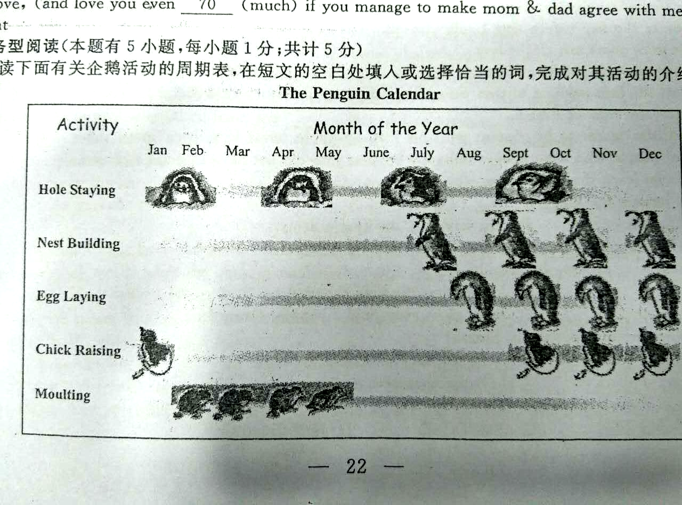
The chart above shows five activities of penguins over a period of one year, month by month. They are hole staying, nest building, 71 , chick raising and moulting. The penguins stay in the 72 most of the year, from January to October. In July, they begin to build nests, just 73 (before/ after) they lay eggs. Chick raising lasts five months, from September to the next 74 . After chicks come out of the eggs, they begin to lose their baby hair, which is called moulting. It usually takes about 75 months, from February to May.
【参考答案】
- egg laying
- hole(s)
- before
- January
- four/4
【考查内容】 任务型阅读，根据图上信息进行短文填空。[来源:学§科§网Z§X§X§K]
【考点】图片型任务型阅读
【解题思路】在短文中找到图片里包括的activities信息，进行配对填空即可。
七、书面表达（本题有1小题；共计20分）
- 英语课上，你们开展了一次以”What can we do to make home a happier place?”为主题的讨论，同学们把自己的想法写在卡片上。请结合卡片信息，用英语写一篇短文，向校刊Englihsh Learning 投稿。
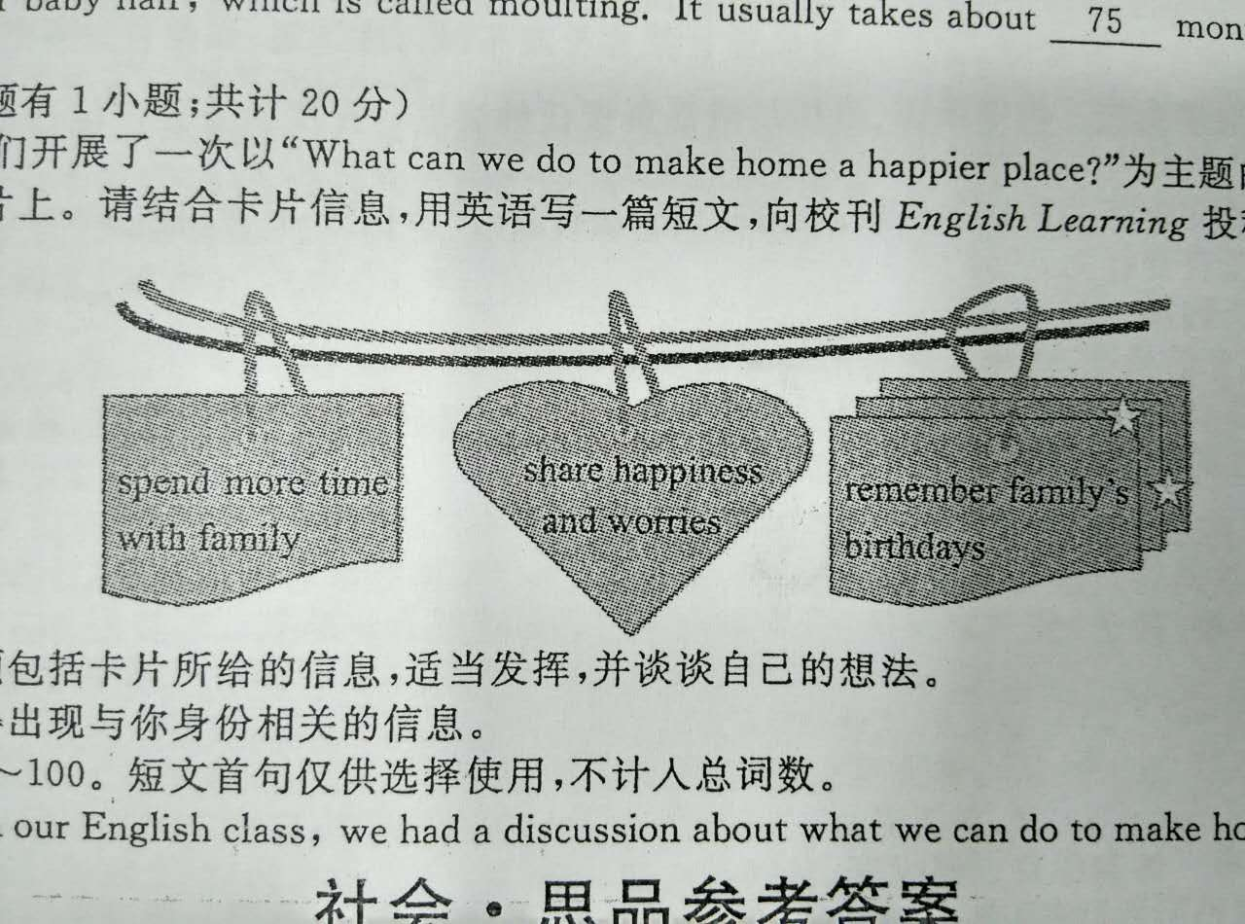
注意：（1）短文必须包括卡片所给的信息，适当发挥，并谈谈自己的想法。
（2）文中不得出现与你身份相关的信息。
（3）词数：80~100。短文首句仅供选择使用，不计入总词数。
短文首句：In our English class, we had a discussion about what we can do to make home a happier place.

【参考答案】
Possible version：
In our English class, we had a discussion about what we can do to make home a happier place. We shared different ideas.
Some say it’s better to spend more time with family. The more we get together, the better we understand each other. Family members should share happiness and worries. For example, when they have problems, we should try to cheer them up. Others believe it’s important to give small presents to our family on their birthdays.
I think, showing love for family is necessary. If we help with housework, they may feel warmer. Sometimes, even the smallest thing like walking with family makes them happier. Though we’re young, we can do much to make a happier home.
【考查内容】书面表达
【考点】书面表达——议论文
【解题思路】1. 确定主题——根据给出的主题进行作文。
2. 确定写作顺序——分三段，以总分总结构进行。
3. 确定每段内容：第一段，总起，介绍背景，使用给出的首句即可；第二段，根据给出的信息进行组织，并加上自己的内容；第三段，总结全文。

