2012年上海市初中毕业统一学业考试
英 语
（满分150分，考试时间100分钟）
Part 1 Listening (第一部分 听力)
- Listening comprehension (听力理解) (共30分)
- Listen and choose the right picture (根据你听到的内容，选出相应的图片) (6分)
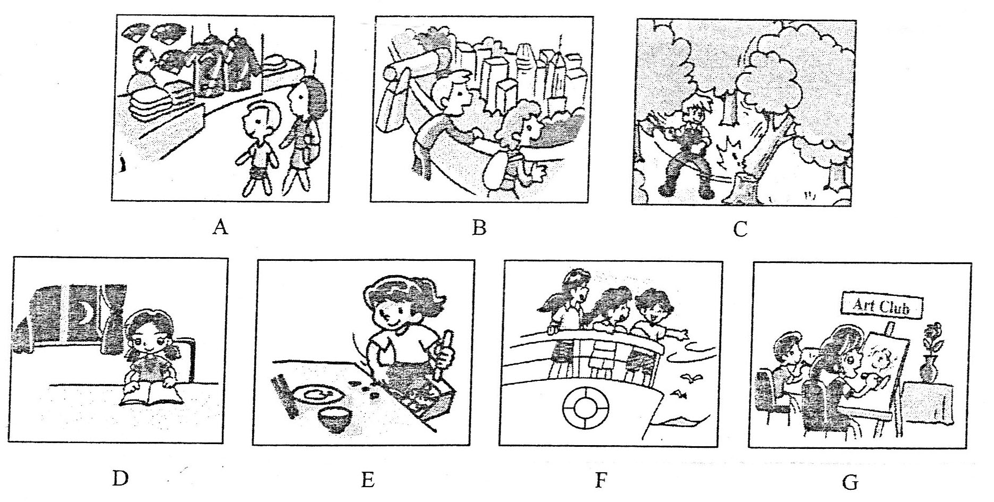
1. _______ 2. _______ 3. _______ 4. _______ 5. _______ 6. _______

- Listen to the dialogue and choose the best answer to the question you hear (根据你听到的对话和问题，选出最恰当的答案) (10分)
- A) In March. B) In April. C) In May. D) In June.
- A) Once a week. B) Twice a week. C) Once a month. D) Twice a month.
- A) By bus. B) By underground. C) On foot. D) By taxi.
- A) The brown one. B) The blue one. C) The red one. D) The green one.
- A) To watch TV. B) To play football. C) To see a film. D) To hold a match.
- A) In a car park. B) In a post office. C) In a coffee bar. D) In a school hall.
- A) A librarian. B) A shop assistant. C) A secretary. D) A tour guide.
- A) A film. B) A novel. C) A game. D) A person.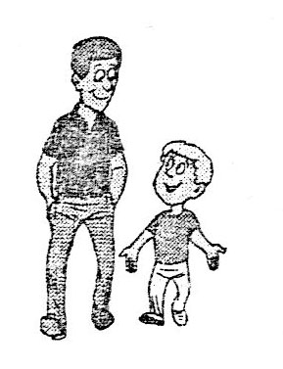
- A) Jane should change a bus. B) Jane stayed up too late last night.
C) Jane always gets up early. D) Jane used the same excuse again.
- A) Because painting is fun to her. B) Because she is good at painting.
C) Because her parents are artists. D) Because she wants to be an artist.

- Listen to the passage and tell whether the following statements are true or false (判断下列句子是否符合你听到的内容, 符合的用“T”表示，不符合的用“F”表示) (7分)
- Jack was in charge of the sales department in a big company.
- Jack took some work home to complete for a meeting one day.
- While Jack was working, he took several breaks as he was tired.
- In order to make Tim busy, Jack gave Nm a newspaper to read.
- It took Tim only about four minutes to finish the task from his dad.
- When Tim said he had completed his task, Jack was excited.
- Tim was familiar with the world map so he put it together quickly.

- Listen to the passage and complete the following sentences (听短文，完成下列内容。每空格限填一词) (7分)
- Charlie found that he had the same watch as the ________.
- Charlie didn't ________ the sign until his father called him back.
- There was a beautiful ________ on the top of the hill in the park.
- It was ________ for Charlie to sit on the grass with his parents.
- All afternoon, Charlie was playing with his toy car ________.
- It was ________ o'clock and Charlie's parents wanted to return home.
- Charlie told his parents to ________ the sign on the bus.

Part 2 Vocabulary and Grammar (第二部分 词汇和语法)
- Choose the best answer (选择最恰当的答案) (共20分)
- Could I have an early morning call ______ six o'clock tomorrow?
A) on B) to C) at D) in
- We have decided to try ______ best to raise more money for the local charity.
A) us B) our C) we D) ours
- You really don't have to worry ______ your weight. You look just right.
A) for B) from C) with D) about
- I can't connect my computer to the Internet. There must be ______ wrong with it.
A) something B) everything C) anything D) nothing
- The baby feels ______ while his mother holds him in her arms.
A) save B) safe C) safely D) safety
- Pudong International Airport is one of ______ airports in the world.
A) big B) bigger C) biggest D) the biggest
- Martin and his friends didn't eat up all the food they ordered, ______ they took the rest away.
A) for B) or C) so D) as
- Peter will cook for his parents ______ the International Day of Families comes.
A) unless B) when C) until D) though
- With the help of the new technology, you ______ e-mail your friends by mobile phone.
A) can B) must C) need D) should
- ______ Tony ______ Frank likes the CD. They think the music is too noisy.
A) Neither...nor B) Either...or C) Both...and D) Not only...but also
- Stop ______ about the traffic. Just think about what we can do to improve it.
A) complain B) to complain C) complaining D) complained
- Don't jump to a conclusion! Let's ______ the problem first.
A) to discuss B) discuss C) discussed D) discussing
- —______do millions of online users visit the home page of the government?
—To read the news and search for the information they need.
A) When B) Where C) Why D) What
- The volunteers ______ a lot of help to the community for nearly ten years.
A) offered B) will offer C) are offering D) have offered
- The students ______ the Art Festival when I passed by their school.
A) celebrate B) were celebrating C) will celebrate D) have celebrated
- Jenny told me that she ______ an English Speech Contest the next month.
A) takes part in B) is taking part in C) took part in D) would take part in
- ______ wonderful concert they are putting on in the city square!
A) How B) What C) What a D) What an
- I'm sure that stricter rules to control cigarette smoking ______ very soon.
A) made B) will make C) were made D) will be made
- —Shall we join in the Green World Summer Camp?
—______
A) Good idea. B) You're welcome. C) Not at all. D) Never mind.
- —Congratulations! You've got a chance to be an exchange student!
—______
A) Thank you. B) I agree. C) Of course. D) Good luck.

- Complete the following passage with the words or phrases in the box. Each can only be used once (将下列单词或词组填入空格。每空限填一词，每词只能填一次) (共8分)
A. weak B. break C. confident D. at the end of
E. possibly F. breath G. do well in H. hobbies I. politely
A headmaster is giving a speech about how to perform successfully in an interview to a
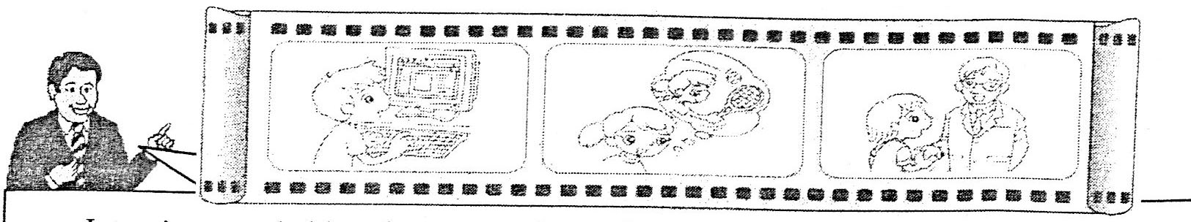
new school.
Interviews are held so that you can learn about the school and the school can learn about you. You should spend a couple of hours getting ready for the interview carefully. Then you will 51 understand your questions better and get right answers on the day of the interview.
First find out about the school. Read the school introductions and look at the school websites. Then think about yourself—your strong points and 52 ones. Try to find a few examples you could give the interviewers.
What else you want to tell the interviewer about yourself? For example, you might want to speak about your interests and 53 outside school. These tell the interviewer what kind of person you are. Be ready to talk about why you enjoy them.
Dress properly on the day. Arrive a few minutes early. When you first meet the interviewer, greet him or her 54 . Don't forget to smile and make eye contact. First impressions (印象) are very important. You want the interviewer to think you are 55 and friendly.
If you get nervous, take a deep 56 to calm yourself down. Listen to the interviewer with great care. If you don't understand the question, ask the interviewer to repeat it. Last but not least, 57 the interview, don't forget to thank the interviewer and say goodbye.
I'm sure that you will 58 your interviews. Best of luck, boys and girls!

- Complete the sentences with the given words in their proper forms（用括号中所给单词的适当形式完成下列句子。每空格限填一词) (共8分)
- The students took the PISA test in ________ subjects—reading, maths and science. (third)
- Board games are more and more popular among ________. (teenager)
- I liked to walk in fields on ________ days and to see my footprints left behind. (snow)
- ________ people often begin their conversations by talking about the weather. (Britain)
- The news about education has attracted the public attention ________. (recent)
- The World Chocolate Park showed a ________ of many kinds of chocolates. (collect)
- To improve your writing skills, you'd better ________ a habit of reading. (development)
- Don't tell lies. Nobody likes those ________ people. (honest)

- Rewrite the following sentences as required (根据所给要求，改写下列句子。每空格限填一词) (共14分)
- The new product consists of four main parts inside. (改为一般疑问句)
________ the new product ________ of four main parts inside?
- Jessica solved the physics problems without any help. (保持句意基本不变)
Jessica ________ ________ the physics problems without any help.
- Susan followed Ben's advice to design smart shoes. (就划线部分提问)
________ advice ________ Susan follow to design smart shoes?
- Lin Dan played badminton very well. He won the Thomas Cup again. (合并为一句)
Lin Dan played badminton well ________ ________ win the Thomas Cup again.
- My students always share ideas in class. (改为被动语态)
Ideas ________ always ________ by my students in class.
- Choose the perfect grapes only, or you won't be able to make the best wine. (保持句意基本不变)
You ________ be able to make the best wine ________ you choose the perfect grapes only.
- "Is it the first boys-only school in the city?" asked a parent. (改为宾语从句)
A parent asked ________ it ________ the first boys-only school in the city.

Part 3 Reading and Writing (第三部分 读写)
- Reading comprehension (阅读理解) (共50分)
- Choose the best answer（根据短文内容，选择最恰当的答案) ( 12分)
Dear Disney,
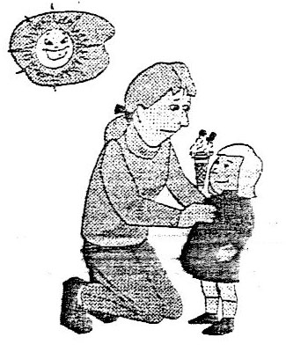
Last weekend, the four members of my family spent an enjoyable holiday at the Magic Kingdom—Disneyland. And one event made our visit seem truly magical.
We got to the front of the line at Space Mountain, only to find out that our little daughter Gloria couldn't take her ice-cream on the ride. We were so excited that we all forgot ice-cream was not allowed on the ride.
Gloria broke into tears and we all had no idea what to do. Then Murphy, one of the staff (员工) members, came over. She bent down and told Gloria that she would hold the ice-cream for her and give it to her when she finished the ride. Gloria said, "Promise?" Then she gave Murphy her ice-cream, and she completely enjoyed the ride.
Sure enough, as we walked out the exit, there was Gloria's new friend with "her" ice-cream. Now you and I both know what happened, because we know that an ice-cream won't last twenty minutes on a summer afternoon in Florida. Murphy knew what time we would get off the ride; she went to the nearest shop and bought a brand-new ice-cream thirty seconds before we walked out the exit. Gloria said, "Thank you," but I'm sure she thought it was the same ice-cream.
We know that someone tried hard to make our visit special. Thanks so much for going above and beyond!
Your fan,
Carmen Rivera
- The family's visit to the Magic Kingdom was ________.
A) helpful B) awful C) frightening D) amazing
- Before the ride, Gloria cried because ________.
A) she couldn't find her parents in the line B) she was too little to take the ride
C) she couldn't take her ice-cream on the ride D) she had to wait for twenty minutes
- Murphy was waiting for Gloria ________ after the ride.
A) in the ice-cream shop B) at the exit
C) in the front of the line D) at the entrance
- In order to keep the promise, Murphy ________.
A) took Gloria to the nearest shop B) asked her new friend to help Gloria
C) helped Gloria get off the ride D) bought a new ice-cream for Gloria
- The underlined word "someone" in the last paragraph refers to (指的是) ________.
A) Murphy B) Disney C) Gloria D) Carmen
- Carmen Rivera wrote the letter to ________.
A) order ice-creams B) promise to visit again
C) express her thanks D) give some suggestions

- Choose the words or expressions and complete the passage (选择最恰当的单词或词语完成短文) (12分)
Tiffany, a 16-year-old girl, was very, shy. Last September, her best friend, Sophie, moved abroad with her family because she had to continue her studies in America. She even said she would not come back for at least a few years. Tiffany became 80 and helpless. "I was really sad the moment I heard the bad news and I didn't know what to do," Tiffany recalled (回忆). "I 81 myself in my room for a whole week. It was then that my aunt took me to a sports club one Saturday and I saw' so many young people playing various sports there. I signed up for a beginners' course in volleyball and since then I have been playing this sport. Now I practise twice a week there. It is wonderful playing sports in this club and I have made lots of 82 as well. What's more, I feel I am much healthier than before."
The most basic aim of playing sports is that you can improve your health even if you are not very good at sports. 83 , you can get to know a circle of people at your age while playing sports. Tiffany used to be a very quiet girl. Since she joined the sports club, she has opened up herself and now she has become very 84 and enjoys meeting and talking with others.
For most people, that is one of the attractions of joining a sports club. You can get to know other young people who have similar interests. You don't have to sit down and talk to strangers. You go in for sports and it is easier to understand your partners on the same team. Now Tiffany is quite 85 her friends and she has also gained more confidence.
Try to do regular sports. The mind needs exercise as well as the body.
- A) angry B) lonely C) tired D) surprised
- A) shut B) hurt . C) enjoyed D) helped
- A) trouble B) mistakes C) money D) friends
- A) So far B) In addition C) Once again D) After all
- A) active B) strong C) lucky D) independent
- A) generous to B) different from C) popular with D) disappointed in

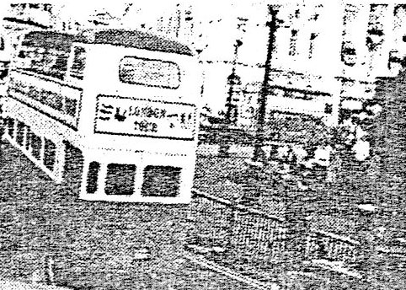
- Read the passage and fill in the blanks with proper words（在短文的空格内填入适当的词，使其内容通顺。每空格限填一词，首字母已给) (14分)
The 2012 London Olympic Games are on the way. You may have a nice trip in London with the help of the following information.
Getting around in London
By  underground | The underground is The underground is fast and convenient. There is a station every few blocks. Underground trains run from 5:30 a.m. to 12:00 midnight. You can get to any place e 86 .
By bus | Travelling by bus is a good way to see the city, especially from the top of a double-decker bus. There is always a bus stop nearby. There are special tickets for c 87 under the age of 12.
By train | Take a train to visit places outside London, like Hampton Court and Windsor Castle. You can use a Travelcard on the underground, buses and most trains. To p 88 your journey, get a map from the railway stations, take some time to think about the places you want to visit.
By taxi | London's black taxis are f 89 . Many visitors to London know they are good and comfortable. They Will cost you a few pounds, though. Take a taxi once, for the experience.
By b 90 | The "river bus" leaves from Westminster Pier and stops at different places between Westminster and Greenwich Pier. A good way to see the city from the River Thames.
By car | Don't drive your car in London! Car parks are very e 91 . You have to pay a special congestion charge (拥堵费) to drive your car into the city centre.
By bike | There aren't many good bicycle lanes in London. Cycling with a large guided group is better than r 92 alone.
On foot | The best way to visit the city! But look right and left before you cross a  street. There are many beautiful sights waiting for you.
- Answer the questions (根据短文内容回答下列问题) ( 12分)
It's March, 2050.
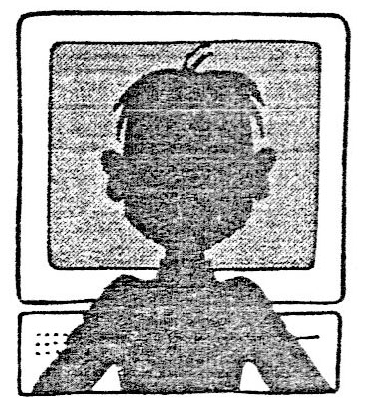
Frank and Mary Smith wake up in their comfortable house in the morning and switch on the bedroom computer to get the latest news. They used to read the Times, but changed to electronic newspapers many years ago.
There is the usual news about space: another space flight has returned from Mars and scientists have discovered a new planet. Then they turn to business news: the US dollar has risen greatly in Shanghai, one of the world's leading business centres. Mary tells the computer to buy 5,000 dollars, and there is a quick response that it has been done.
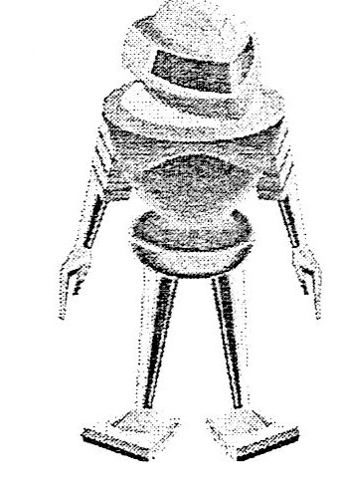
As they watch the screen, Mary orders one of the household robots to make coffee for them. Frank disappears into the study to join a video conference with his partners around the world. He is a computer engineer, working for several companies. This is his third job: he used to be in marketing and then television.
Mary has a quick look at the shopping channels—the usual selection of electric cars, household robots and cheap travel offers—before picking up the video phone to talk to her assistant. She also has a job and she is doing medical research. Both she and Frank used to have an office desk in London, but in 2014 they decided to move to the seaside and work from home.
Frank and Mary have one daughter, Louise, who also has her own workstation at home. She goes to school only one day a week, mainly to play with other students. Classrooms disappeared in 2030 because there was no longer any need for them: communications systems have made it much easier to learn at home.
Louise, now thirteen, is studying Chinese at present, which has become a world language as important as English. Louise has many Chinese friends. They communicate by computer.
According to the family doctor, Louise will live to at least 130. Her wish is to work for a few decades (十年) and then spend her time on music and painting.
- Why do Frank and Mary switch on the bedroom computer in the morning?
Because they ______________________________________________________
- Does Mary read space news or business news?
_________________________________________________________________
- Who makes coffee for Mary and Frank?
_________________________________________________________________
- How does Frank work with others from home?
_________________________________________________________________
- What are the two world languages in 2050?
_________________________________________________________________
- What do you think of Louise's life in 2050?
I think her life in 2050 is _____________ because ________________________
- Writing (作文): (共20分)
- Write a letter in at least 60 words according to the given situation (根据所给情景写一封不少于60词的信)
Suppose you are Joe. Your friend Betty is upset about a coming exam for she cares too much about the result. What do you think? Try to offer her some advice. (假如你是Joe, 你的好朋友Betty 因为过于在意考试结果而感到焦虑。请给她写一封信，谈谈你的看法，并给她一些建议。)
（注意：文中不得出现任何姓名、校名及其它相关信息，否则不予评分。）

听力文字及答案
Part 1
A. Listen and choose the right picture.
- Linda often helps her parents with the housework after meals. ( E )
- Mum, what should we buy for Dad, a shirt or a coat? ( A )
- Mary was reading her favourite book from 7 to 9 last night. ( D )
- Don't cut down the tree, Fred. Birds live there. ( C )
- The members of the art club are having a drawing lesson now. (G )
- On the top of the building tourists can enjoy a nice view of the city. (B )
B. Listen to the dialogue and choose the best answer to the question you hear.
- W: Did you have a holiday in April?
M: No. I was busy at that time. I had a holiday in May.
Q: When did the man have the holiday? ( C )
- W: You're interested in sports, aren't you?
M: Yes. I go swimming once a week and play tennis twice a month.
Q: How often does the man go swimming? (A )
- M: Shall we take a bus or the underground?
W: The stop is a bit far and I'm too tired to walk. I want to get a taxi home.
M: All right.
Q: How are they going home? ( D )
- M: Which tie is better for my new shirt, the brown one or the blue one?
W: Neither. The red one looks best on you. Believe me, Sam.
Q: Which tie does the woman think is the best? ( C )
- W: Are you doing anything tonight?
M: Nothing special. Watching TV, I suppose. There is a football match.
W: What about going to the cinema for a change?
M: Good idea.
Q: What are they going to do tonight? ( C )
- M: So many cars here. Where is ours?
W: Erm, I’d parked it next to a white car before we had coffee.
M: Oh, yes. It’s over there.
Q: Where does this dialogue probably take place? ( A )
- W: Have a look at our new jeans, please. They’ve just arrived and they are on sale.
M: Ah, thanks. I’ll let you know if I need help.
Q: What’s the woman’s job? ( B )
14. M: Have you finished reading Super Hero?
W: Yes. I enjoyed every page of it. It’s so exciting.
Q: What are the two speakers probably talking about? ( B )
15. W: I’m sorry, Mr. Wilson. I got up early but the bus was late.
M: Your bus is always late, Jane.
Q: What does the man mean? ( D )
16. M: What’re you going to do after you leave school, Grace?
W: I’m going to study painting.
M: Your parents want you to be an artist, don’t they?
W: Yes, they do. But I’m not good at it. I just paint for fun.
Q: Why is Grace going to study painting? ( A )
C. Listen to the passage and tell whether the following statements are true or false.
Jack was a hard-working businessman. He worked as a manager in a big company. He was responsible for the sales department. He was so busy that he sometimes took work home to do. One day, Jack had to prepare for a meeting. So he took some work home to complete. While he was working, his five-year-old son, Tim came to talk to him every a few minutes. He had to stop working and he couldn’t focus. After several such breaks, Jack got an idea. He found that there was a map of the world in the evening paper. He showed the map to Tim. Then he cut it into pieces and told Tim to put the map together again. He thought this would keep Tim busy for a long time and he could complete his work. However, in about four minutes, Tim excitedly told Jack he had finished the task. Jack was surprised and asked the boy how he had done it so quickly. Tim said there was a picture of a man on the other side of the newspaper. So I just turned it over and put the man together. When I got the man right, the world was right.
17. T 18. T 19. F 20. F 21. T 22. F 23. F
D. Listen to the passage and complete the following sentences.
One day Charlie and his family were on their way to the country park. “Look, Dad”, said Charlie. “The driver and I have the same watch”. He ran up to the bus driver. “Look, Mr. Driver. I have a nice watch. It’s the same as yours”. Charlie’s father called him back. “Sh…, Charley. Didn’t you notice the sign? It says, ‘You mustn’t talk to the driver while he is driving’. It’s dangerous”. “Sorry, Dad”, said Charlie. Half an hour later, they arrived at the country park and walked to the top of the hill. There was a beautiful lake. The birds was singing and the sun was shining. Charlie’s parents sat down on the grass by the lake and enjoyed themselves. But Charlie felt it was a little boring and asked, “Dad, can I drive my toy car here”? “Not here, Charlie”, said Father. “Let’s go down to the playground. You can drive there”. Charlie was playing his toy car happily all afternoon. But when his father said, “Come on, Charlie. It’s five o’clock. It’s time to go home”, Charlie kept on driving. “Please, Charlie. Be a good boy”, said his mother. Charlie stopped driving. “But, Mum and Dad, I’m the driver. Don’t you remember the sign on the bus? You mustn’t talk to me when my car is moving”. “Good child, Charlie”, said Father, laughing. “But we have to go home now”.
24. driver 25. notice 26. lake 27. boring 28. happily 29. five/5 30. remember
Part 2
II.
31. C 32. B 33. D 34. A 35. B 36. D 37. C 38. B 39. A 40. A 41. C 42. B
43. C 44. D 45. B 46. D 47. C 48. D 49. A 50. A
III.
51. E 52. A 53. H 54. I 55. C 56. F 57. D 58. G
IV.
59. three 60. teenagers 61. snowy 62. British 63. recently 64. collection 65. develop
66. dishonest
V.
67. Does consist 68. worked out 69. Whose did 70. enough to
71. are shared 72. won’t unless 73. whether/if was
Part 3
VI.
- 74. D 75. C 76. B 77. D 78. A 79. C
- 80. B 81. A 82. D 83. B 84. A 85. C
C. 86. easily 87. children 88. plan 89. famous 90. boat 91. expensive 92. riding
D. 93. they want to get latest news.
94. Mary reads business news.
95. One of the household robots.
96. He uses computer to work with others.
97. Chinese and English.
98. comfortable/amazing/happy/colourful of the computer
VII.
99. Be omitted.

