2012年天津市初中毕业生学业考试英语试卷

第Ⅰ卷 本卷共四大题，共75分。

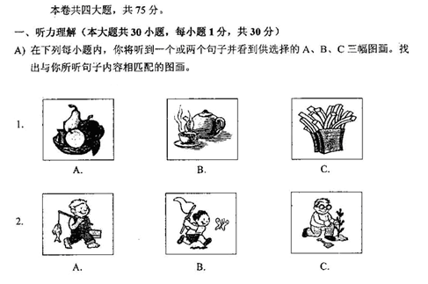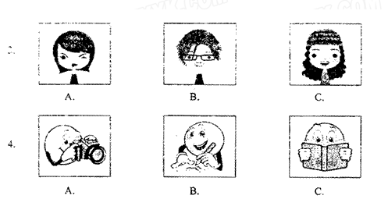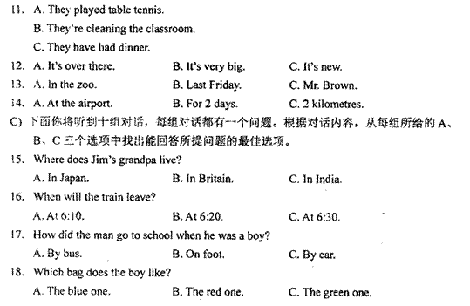
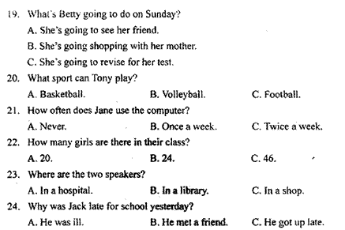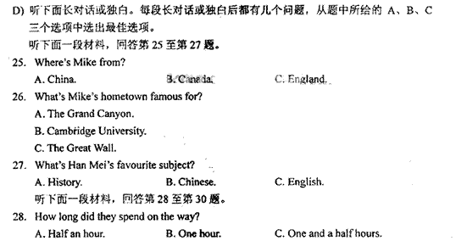
二、单项填空（本大题共15小题，每小题1分，共15分）
从下列第小题所给的A、B、C、D四个选项中，选出可以填入空白处的最佳选项。
31. —What do you think of _______ film about Zhan Tianyou?
—It’s __________ good film.
A. the; the B. a; the C. the; a D. a; a
32. —Why didn’t Sally play the violin at the concert last night?
—She said that her hand hurt, but that was only a(n) _______. I saw her play tennis just now.
A. matter B. excuse C. result D. expression
33. All the students are talking and laughing in the classroom and it’s _________.
A. noisy B. lonely C. quiet D. strict
34. —Would you please show me the way _________ the bank?
—Yes, go straight ahead. It’s opposite a school.
A. in B. for C. with D. to
35. We have never visited the museum, but we have ______ it.
A. stood for B. belonged to C. heard about D. kept to
36. Who listens _________, Tom, Jack or Bill?
A. the most carefully B. more carefully
C. the most careful D. more careful
37. A snake bit him ___________ he went to see a doctor at once.
A. if B. where C. because D. so
38. I have been to Shanghai. I ____________ there last month.
A. go B. went C. have gone D. will go
39. They were all very tired, but _______ of them took a rest.
A. none B. all C. both D. either
40. The cloth ___________ very soft and comfortable.
A. smells B. tastes C. feels D. sounds
41. —Why don’t you go out to play, Rose?
—I’m afraid I can’t. I have much homework _________.
A. do B. does C. doing D. to do
42. The 30th Olympic Games _________ in London soon.
A. held B. will be held C. were held D. have been held
43. —Can you tell me ________?
— With Lucy’s help.
A. when you did it so well B. when did you do it so well
C. how you did it so well D. how did you do it so well
44. Please pass me the cartoon book _________ has a Mickey Mouse on the cover.
A. whom B. whose C. who D. which
45. —I will have a match tomorrow. I hope I will win.
—_____________.
A. Good luck B. No idea C. That’s such a pity D. It’s all right
三、完形填空（本大题共10小题，每小题1分，共10分）
阅读下面短文，掌握其大意，然后从各题所给的A、B、C、D四个选项中选出最佳选项。
People all over the world celebrate the new year. However, not all countries celebrate in the same way, and in some countries, the new year doesn’t begin on the 46 date very year.
In many countries, the new year begins on 1st January, but people start celebrating on 31st December, New Year’s Eve. In New York many people go to celebrate in Times Square. 47 they’re waiting for the New Year, they listen to music, sing traditional songs and have fun. Just before 12 o’clock, everyone 48 down from 10: 10, 9, 8… As soon as it’s 12 o’clock, everyone shouts very 49 , “Happy New Year!”
New Year’s Day is often a family day. Some families get together for a special meal. When the weather is fine, many families go out for a 50 .
On New Year’s Day, many people make resolutions for the new year. They 51 a list of things, such as “I will help out more with housework. I will work 52 at school than others.” or “I won’t spend so much time playing video games.” When they have made 53 list, they read it to their family or friends and promise to 54 their resolutions.
So it doesn’t matter how they celebrate, 55 people in countries all over the world, it’s a time to say goodbye to the old year, and to welcome the new.
46. A. familiar B. same C. important D. normal
47. A. If B. Even though C. While D. Before
48. A. comes B. turn C. looks D. counts
49. A. loudly B. quietly C. sadly D. safely
50. A. walk B. secret C. job D. treatment
51. A. put on B. write down C. take away D. look after
52. A. quickly B. hard C. harder D. hardly
53. A. its B. his C. her D. their
54. A. follow B. make C. do D. give
55. A. by B. for C. with D. from
四、阅读理解
阅读下面的材料，从每小题所给的A、B、C、D四个选项中选出最佳选项。
A
Some children are afraid to go to the dentist, but not me. I’m a boy of 8 and I have a funny dentist. His name is Dr. Smileyface. I don’t think that’s his real name, but that’s what he tells all the children who come to see him.
He has a cool waiting room. It has video games and a big toy box. Dr. Smileyface always wears funny hats. Sometimes he has his face painted. He asks funny questions like “Are you married yet?” and “Do you eat flowers to make your breath smell so sweet?” That makes me laugh. One time, he told me this joke, “What has lots of teeth but never goes to the dentist? A comb!” When I laughed, he pulled my tooth. It didn’t hurt at all! He also teaches me how to take care of my teeth in an interesting way. Before I leave, he always gives me a surprise. Last week he gave me a toy ship and I liked it very much.
56. How does the writer feel when he goes to the dentist?
A. Angry. B. Afraid. C. Sad. D. Happy.
57. What does Dr. Smileyface teach the writer to do?
A. How to laugh. B. How to take care of his teeth.
C. To eat flowers. D. To paint his face.
58. What did Dr. Smileyface give the writer last week?
A. A toy ship. B. A toy box. C. A comb. D. Flowers.
B
We provide summer English courses and you will enjoy learning about American culture and improve your English. The courses last for 4 weeks. They start at the beginning of July and August. Our teachers are very experienced. They teach English classes for 4 hours a day. You can choose between small groups of 2 or 3, or larger groups of up to 15. We provide weekly tests to see the progress you’re making with your language skills. We also provide books and other materials.
As well as learning English, we want you to experience life in the USA. You live with an American family and take part in American life. You have meals with them and do some activities with them, too. This is the most interesting part of the course. Many families create friendships with the students. Of course, if you prefer, we can arrange hotel accommodation.
Of course, you can do many things in Los Angeles. Every day we have activities after class. You can choose to take trips to Hollywood, Disneyland or the famous beaches around LA. You can also go to various shopping centres, sports centres, movies and concerts. There are also weekend visits organized to San Francisco and other places of interest in California.
Well, if you’re interested, please fill in our application form where you will also find our list of prices. The course must be paid for one month before it begins.
59. How long do the English courses last?
A. 4 days. B. 2 weeks. C. 3 weeks. D. 4 weeks.
60. Why do organizers (组织者) advise students to live with American families?
A. Students are not rich enough to live in hotels.
B. Students can have meals with American families.
C. Students can experience life in the USA.
D. Students can teach American how to cook Chinese food
61. What’s the title of Paragraph 3?
A. Teaching B. Accommodation and Food
C. Sightseeing and Other Activities D. The Famous Beaches Around LA
62. What’s the passage about?
A. A description of an English book.
B. A description of an English course.
C. A description of life in Los Angeles.
D. A description of weekend visits to San Francisco.
C
Now, more and more cities are facing problems, such as high housing costs, pollution and crime. Let’s see what people in Hyderabad, India and in Sao Paulo, Brazil do to solve (解决) the problems.
Hyderabad, India21世纪教育网
To improve people’s lives, Hyderabad is planting more and more trees. The city is even creating greener buildings that use less water and less electricity for power. Adding green to a city has a number of advantages. For example, trees make the air cleaner. In Hyderabad, streets were grey and dirty in the past. However, today they are filled with trees and flowers, making the city cleaner and more colourful. Green areas also give people places to relax or exercise. A study in the USA shows an interesting thing: the greener a neighborhood is, the less crime there is.
Sao Paulo, Brazil
Many people work in the centre of Sao Paulo, but they don’t live there. They’ve spread out to neighborhoods outside the city because housing is cheaper. Every day, these people travel into the city, and traffic is very heavy. City planners are using different ways to deal with (处理) the problem. First, they are building better subways. Another goal is to make it cheaper for people to live in the downtown area (中心区). Doing this will reduce traffic and pollution in the city.
63. What does the underlined word “greener” mean?
A. Taller. B. Easier.
C. Better for the environment. D. More brightly coloured.
64. Which advantage of making Hyderabad greener is NOT talked about in the passage?
A. It helps people work better. B. It makes the city cleaner.
C. It reduces crime. D. It makes it easier to exercise.
65. According to the passage, what problem does Sao Paulo have?
A. A lot of people don’t have jobs.
B. Too many people live in the city centre.
C. A lot of people are moving out of the city.
D. Too many people travel into the city every day.21世纪教育网

第Ⅱ卷
五、完成句子（本大题共5小题，每小题2分，共10分）
根据所给中文意思完成句子，每空限填一词。
66. 我经常帮助妈妈收拾房间。
I often help my mum to _____________ _____________ the room
67. 2010年以来，这个地区发生了很大的变化。
Great changes have ___________ ___________ in this area since 2010.
68. 他们正在建一条隧道，它将穿过这座山。
They are building a tunnel, and it will _________ _____________ the mountain.
69. 他现在不在办公室。
He isn’t in the office __________.
70. 我想下个星期顺便看望一下吉尔。
I think I’ll _______ __________ on Jill next week.
六、补全对话（本大题共5小题，每小题1分，共5分）[来源:21世纪教育网]
根据对话内容，在每小题的空白处填入适当的话语，全对话意思完整。
(Betty is talking with her friend Daming on the phone.)
Daming: Hello, this is Daming. Who’s that?
Betty: This is Betty. I want to visit your hometown—Tianjin. Can you give me some suggestions?
Daming: 71 . What do you want to know?
Betty: 72 ?
Daming: Yes, you are right. it’s usually very hot in summer.
Betty: 73 ?
Daming: I think you’d better come in October.
Betty: 74 ?
Daming: Because the weather starts go get cooler and the trees start to change colour.
Betty: 75 ?
Daming: You can visit many places of interest here, such as Tianjin Ancient Culture Street and you can also try some traditional Chinese food.
Betty: I’m looking forward to visiting Tianjin. Thank you for your suggestions. Bye-bye.
Daming: bye-bye. I hope to see you soon.

七、任务型阅读（本大题共5小题，每小题1分，共5分）
阅读下面短文，根据内容完成句子。
Gregg Bleakney’s dream was to travel the Americas from top to Bottom. He got the idea after he finished a long bike ride. Gregg’s friend, brooks Allen, also liked riding a bike. The two friends talked and made a plan: they would travel from Alaska to Argentina—by bike.
To pay for the trip, Gregg and Brooks worked to save money for a long time. Once they were on the road, they often camped outdoors and ate cheaply. In many places, local people opened their doors to the two friends and gave them food.
On their way, there were deserts, rainforests and mountains. They visited modern cities and ancient ruins (遗迹) such as Machu Picchu in Peru. And they made many friends from all over the world.
In May 2007—two years, twelve countries, and over 30,500 kilometres later—Gregg finally reached Ushuaia, Argentina. (Near Guatemala, Brooks had to go back and Gregg continued without him.)
The trip taught both men a lot about traveling. What did they learn? Here is some of Gregg’s advice:
Travel light. You should carry many things with you.
Be flexible (灵活). Don’t plan everything. Then you’ll be more relaxed and pleased especially if there are problems.
Be polite. one traveler told Gregg, “Nobody wants to fight or cheat a nice man.” It’s true.
76. Gregg Bleakney’s dream was to _______________.
77. Before traveling, the two friends _____________to pay for the trip.
78. ___________ got to Ushuaia, Argentina in May 2007.
79. According to the passage, if you plan everything for a trip, __________.
80. One traveler told Gregg that nobody wanted to _______________.

八、综合填空（本大题共10小题，每小题1分，共10分）
根据短文内容及首字母提示，填写所缺单词，使短文意思完整。每空限填一词。
Parents sometimes learn much from their children.
Many years ago, a 81 my friend David worked day and night, he was still not rich. One day, when he arrived h 82 after work, he found his 3-year-old daughter was decorating a box with some expensive wrapping paper. He thought she was w 83 money and became angry with her. He even p 84 his daughter by beating her. However, the little girl brought the box to her father the next morning and said, “This is for you, Daddy. Merry Christmas!” He was embarrassed (尴尬) by his overreaction (过激反应), but he became angry a 85 when he found the box was empty.
He shouted at her, “Don’t you know that when you give someone a present, there should be s 86 inside it?”
The little girl looked up at him with t 87 in her eyes and said, “Oh, Daddy. I blew kisses in the box. I filled it with my l 88 . All for you, Daddy.”
The father was very surprised. He put his arms around his little girl, and said s 89 to her. Later, David told me that he kept that box by his bed for years. When he was discouraged(情绪低落), he would take out an imaginary (想像的) kiss from the box and r 90 the love of the child.

九、书面表达 （本大题共15分）[来源:21世纪教育网]
假如你有两位同学——芳芳和明明，参加了上个星期二学校组织的英语演讲比赛，他们的不同表现使你深有感触。请你根据下列表格中的内容提示写一篇英语短文。

芳芳 | 明明 | 我
1. 认为自己英语好，不需要努力；花费很多时间挑选比赛用的漂亮衣服  2. 因准备不足，太紧张，而没有完成演讲 | 1. 努力学习，向别人请教；赛前两天受伤，但不放弃  2. 在比赛中表现良好 | 应该向明明学习……

参考词汇：英语演讲比赛 English Speech Contest
要求： 1. 词数：80~100个。
2. 短文开头已给出，不计入总词数。
3. 要点齐全，行文连贯，可适当发挥。
Last Tuesday Fangfang and Mingming entered the English Speech Contest in our school. What they did made me think deeply.
Before the contest. Fangfang thought ____________________________

2012年天津市初中毕业生学业考试
英语答案

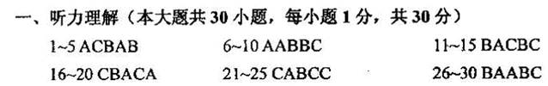
二、31~35 CBADC 36~40 ADBAC 41~45 DBCDA
三、46~50 BCDAA 51~55 BCDAB
四、56~30 DBADC 61~65 CBCAD
五、66. tidy up 67. taken place 68. go through 69. right now 70. drop in
六、71. Yes, I can / Certainly / Of course / Sure
72. Is it very hot in summer
73. When is the best time to visit Tianjin / When shall I visit Tianjin
74. Why do you think so
75. What can I do there
七、76. travel the Americas from top to bottom
77. worked to save money for a long time
78. Gregg
79. you won’t be more relaxed or pleased especially if there are problems
80. fight or cheat a nice man21世纪教育网
八、81. although 82. home 83. wasting 84. punished 85. again
86. something 87. tears 88. love 89. sorry 90. remember

