2013年漳州市初中毕业暨高中阶段招生考试
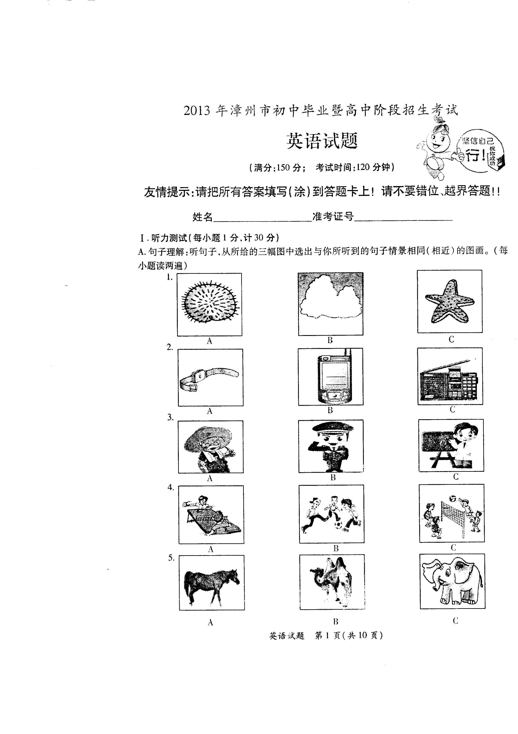
英语试题
（满分：150分； 考试时间：120分钟）

友情提示：请把所有答案填写（涂）到答题卡上！请不要错位、越界答题！！
姓名____________ 准考证号__________
Ⅰ. 听力测试：(每小题1分，计30分)
- 句子理解：听句子，从所给的三幅图中选出与你所听到的句子情景相同(相近)的图画。(每小题读两遍)
B.情景反应：根据你所听到的句子，选择最恰当的答语。(每小题读两遍)
6. A. Good morning. B. I'm very well. C. Nice to meet you, too
7. A. Good idea. B. Thank you. C. That's OK.
8. A. Coffee. B. Orange. C. Water.
9. A. No problem. B. Not at all. C. No hurry.
10. A. It's sunny. B. It's Sunday. C. It's March.
11. A. Sorry, I won't. B. Certainly. C. Never mind.
12. A. It's my present. B. I'd love to. C. Sure, here you are.
13. A. You can't miss it. B. It's too long. C. Five minutes' walk.
C. 对话理解：根据你所听到的对话内容，选择最佳选项回答问题。(每段对话读两遍)
- 听第14至19段对话，回答14至19小题。
14. Whose blouse is this?
A. Linda's. B. Nancy's. C. The boy's.
15. What class is Kathy in?
A. In Class 2. B. In Class 4. C. In Class 6.
16. Where will the woman be in August?
A. In Australia. B. In England. C. In France.
17. Who can't come to have dinner?
A. Lily's aunt. B. Lily's uncle. C. Lily's father.
18. How many times did Maria go to the reading room last week?
A. Once. B. Twice. C. Three times.
19. When does the train leave?
A. At9:00. B. At9:30. C. At 10:00

- 听下面两段对话，每段对话后各有三个问题，选择最佳选项回答问题。
听第20段对话，回答第20至22小题。
20. What was the matter with Jane yesterday?
A. She had a backache. B. She had a fever. C. She had a stomachache
21. Where will Jane go soon?
A. To the classroom. B. To the office. C. To the hospital.
22. What's the relationship between the two speakers?
A. Classmates. B. A doctor and a patient C. A teacher and a student.
听第21段对话，回答第23至25小题。
23. Where will they have a party?
A. In their school. B. At Carl's home. C. At Lucy's home
24. What will Lucy do next Monday?
A. Take a test. B. Have a match. C. Have a meeting.
25. When will the party start?
A. At 7:00. B. At 7:30. C. At 8:00.
D. 表格填空：根据你所听到的对话内容，填写下面表格，每空填一词。(对话读三遍)
A Room Reservation
Guest's name | 26._____________
Cell-phone number | 13962450468
Kind of room | The 27._______________ room
The number of rooms | 28.______________
Price for a room (per night) | 29.¥______________
Time for check-in (入住) | 30._______________10th

Ⅱ.单项选择（每小题1分，计15分）
从A、B、C三个选项中，选出最佳答案。
31. --What are those sweaters?
--They are yellow.
A. color B.size C. shape
32. --_____________does your brother go to work?
-- By bike.
A. Where B. Why C. How
33.My parents are going to take_________to Mount Wuyi this summer holiday
A. my B. me C. mine
34.Nowadays, each of the students________a new dictionary in the countryside.
A. has B. had C. have
35. -- Must I water the flowers right now?
--No, you . You may do it after supper.
A. mustn't B. needn't C. can't
36. They wonder________robots will make humans lose their jobs or not
A. that B. if C. whether
37. The sun is shining . You'd better wear sunglasses while you are out.
A. brightly B. lightly C. heavily
38. --Do you know Lin Shuhao?
--Yes. He is one of basketball players in the NBA.
A. popular B. more popular C. the most popular
39. Once you put your school things___________, you'll find them easily.
A. in danger B.in order C. in detail
40. Nobody will help you________ you help yourself.
A. unless B. because C. though
41.----I think collecting stamps is great fun.
----________We can also learn a lot from it .
A. I agree with you. B. No, I don't think so. C. No, I don't like it.
42. --A big fire ______in Dehui, Jilin Province on June 3rd, 2013.
--That's too bad. I think we should try our best to prevent fires.
A. came out B. went out C. broke out
43. Mr. Wang often encourages us_______close to nature and enjoy its beauties
A. get B. getting C. to get
44. --Why are the windows so dirty?
--Because we_________them for a long time.
A. have cleaned B. haven't cleaned C. didn't clean
45. New technology____________to stop the students from cheating in the exam last year.
A. is used B. used C. was used
Ⅲ.完形填空（每小题1.5分，计15分）
从A、B、C三个选项中，选择可以填入空白处的最佳答案。
A young man once asked his grandpa: "Grandpa, how have you achieved so much in your life,
and yet are still full of energy? " The following was the grandpa's 46____ .
I think it has a lot to do with how a person looks at things. I call it "keeping your ____47 open "
First, realize that life is filled with surprises, and many are good ones. If you don’t keep watching for them, you'll 48 half of the excitement. When you meet with challenges, 49 them bravely. Then they'll make you smarter and stronger. It is normal for you to make a 50 on the way to success. Don't be nervous. Just be thankful for what it taught you.
It's also 51 to decide exactly what you want. Your choices may create your successes or your failures. 52 think about all the ways ahead, and decide which one to follow. Then believe in 53 and go for it!
Most importantly, never 54 The one who makes up his mind to win will be the winner.
Give life 55 that you've got, and life will give its best back to you .
46. A. dream B. answer C.decision
47.A. eyes B. arms C.mouth
48.A. control B. enjoy C.miss
49.A. face B. avoid C. forget
50.A.friend B. mistake C. plan
51.A. special B. important C. suitable
52.A. or. B .But C. So

53.A. yourself B. itself C. himself
54.A. stay up B. come up C.give up
55.A. all B. none C. either
Ⅳ阅读理解（A、B、C、D、E篇：每小题1分，计45分）
- B、C篇：根据所提供的内容，从四个选项中选择最佳答案。
Join us for an English Summer Camp in English !
★Students between l3 and l8 are welcome to the English Summer Camp.
★It's a good chance to learn about British customs and improve your English.
★Eleven experienced English teachers will give you English classes
4 hours a day on weekdays.
★There are also weekend visits to London Eye, the Big Ben and London Bridge .
★It begins on August 9th and ends on August 26th, with the fees: Y 23,000 .
★ If you are interested, please come to the Children's Palace to register(登记报名） You can also
register by calling Jane Parks at 555 --2782.
★Please register before August 3rd.

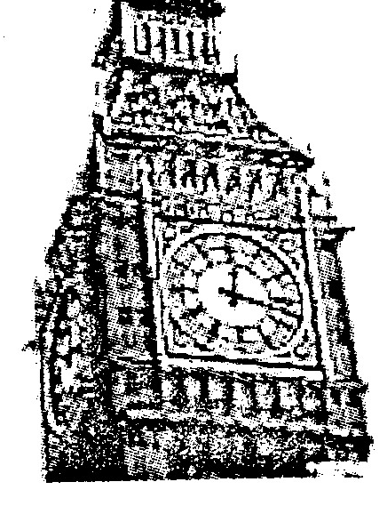

56____________can take part in the English Summer Camp.
A. Students under 13 B. Students aged 16
C. Students over 18 D. All the students
57. The English Summer Camp lasts
A. 9 days B. 16 days C. 18 days D. 26 days
58. There are ______ways for you to register for the English Summer Camp.
A. one B. two C. three D. four
59. You can go to register on
A. August 1 st B. August 6th C. August 9th D. August 26th
60. You can _______by joining in the English Summer Camp
A. visit the whole country B. become an experienced teacher
C. improve your Chinese D. know about British customs
B

People can find jobs in many ways. Sometimes you can find a job easily, by walking into a local store and looking at its notice board(布告栏). Local stores often have areas for people to put small signs telling the services that they need or they can provide. Such services include looking after children or cleaning houses.
Another popular tool for finding a job is the Internet. For example, people around the world can
use the Craigslist Web site to buy things, meet people or find a job. It is said that the site can receive two million new jobs each month.
Another useful way to find a job is through a university. For example, students at the University
of Texas can go to the job center to get help. Many college students like this way better.
At times, some experts(专业人士)can also help people find a job. Susan Miller has her own company called California Job Services in Los Angeles. She says her company helps people find a job by first helping them understand their strengths, goals and interests. Then she provides them with methods to help them find the right job. So with her help, many people have succeeded in finding a good job.
61. On the Craigslist Web site, you can't________ .
A. find a job B.meet people C. sell your old things D. do some shopping online
62. According to the passage, college students prefer to find jobs by _________
A.visiting the Internet B. asking experts for help
C. looking at the notice board D. going to a job center in the university
63. The underlined word "strengths" in the last paragraph means_________ .
A. 长处 B. 强度 C. 力量 D.人数
64. Which of the following statements is TRUE.？
A. Local stores have few areas for people to put signs
B. You can only get one service on the notice board
C. The Craigslist Web site can get two million new jobs each week
D. Susan Miller has helped many people find a good job successfully
65. The main idea of this passage is about________ .
A. how to find experts B. ways of finding a job
C. how to study and work D. ways of setting up a job center
C
We may know that there are four basic periods for human beings to pass through when you enter and live in another country. This process(变化过程) helps you deal with culture shock(文化冲击).
Culture shock begins with the "honeymoon period". This is the time when you first arrive in a place where everything about the new cu1ture is strange and exciting. You see new things, hear new sounds and language, eat new kinds of food. This period can last for quite a long time because you feel very happy.
Unluckily, the second period can be more difficu1t. After you have got used to your new life, you can become very tired and begin to miss your motherland, your family, your friends, your pets and so on. Al1 the little prob1ems in life seem to be much bigger and more worrying when you face them in a foreign country. This period can be very difficult and lead to moving backwards quickly.
The third period is called the "adjustment(调整) period". This is When you begin to realize that things are not so bad in the new country. Your sense of humor usually becomes stronger and you realize you are becoming stronger by 1earning to take care of yourself in the new place. Things are still difficult, but you are now a survivor(善于求生者).
The fourth period can be cal1ed "at ease at last". Now you feel quite comfortable in your new place. You can deal with most problems that you have. You may still have prob1ems with language,but you know you are strong enough to deal with them. At this time, you may feel a little uncomfortable if you go back to your motherland.
66. According to the passage, culture shock usually happens when you
A. get married to a foreigner B. live in a big city
C. go to live in a foreign country D. meet foreigners in your motherland
67. During the first period of the process, you feel
A. sad and lonely B. happy and excited
C. angry but strong D. easy but uncomfortable
68. You will find that you are a survivor in
A. the lst period B. the 2nd period C. the 3rd period D. the 4th period
69. The fourth period ean be regarded as a period of being
A. relaxing B. worrying C. tiring D. adjustable
70. We can conclude(lgth$it) from the passage that
A. Living in another country is fun B. it's boring to live in another country
C. knowing about culture shock is hard D. it's not easy to dea1 with culture shock
D
Farming in the USA today is very different from that 100 years ago. In those days, farmers did not
have many machines to help them. They had animals. 71. __ This meant that farms were smaller
than they are now. Farmers also worked in a different way in the past. In those clays, farmers grew fruits
and vegetables and kept cows, pigs and chickens to feed their families. 72.______
Farmers have a very special life in many ways. First of all, they can't leave the job at the end of
the day. They live on the farm and there is always work to do. Second, a lot of farm work is outdoors,
so the weather is very important for farmers. 73. _________ A lot of bad weather means farmers will
lose money. Finally, farmers work with plants and animals. They understand nature better than other
people do .
74._______ Spring is a time for planting. Farmers are busy getting the fields ready and then: Planting the seeds(种子). In summer, farmers must take good care of the plants. Some may need water. Other plants may have problems with insects or diseases. Then in fall, the fruits or plants are ready for picking. 75._______ Winter is a time for rest or for work on the farm machines.
把A---E五个选项填入文中空缺处，使短文完整正确。
- Farm work changes with the seasons .
- That is a very busy time for farmers .
- But animals work slowly compared to machines .
- It is also important for the success of their farms .
- Today farmers grow things on the farms so they can sell them .

E
Returning a father's love
He was a single father, raising a 5-year-old boy by himself. He was often worried about his son growing up without a mother to care for him.
One day, he went away on business, leaving the child
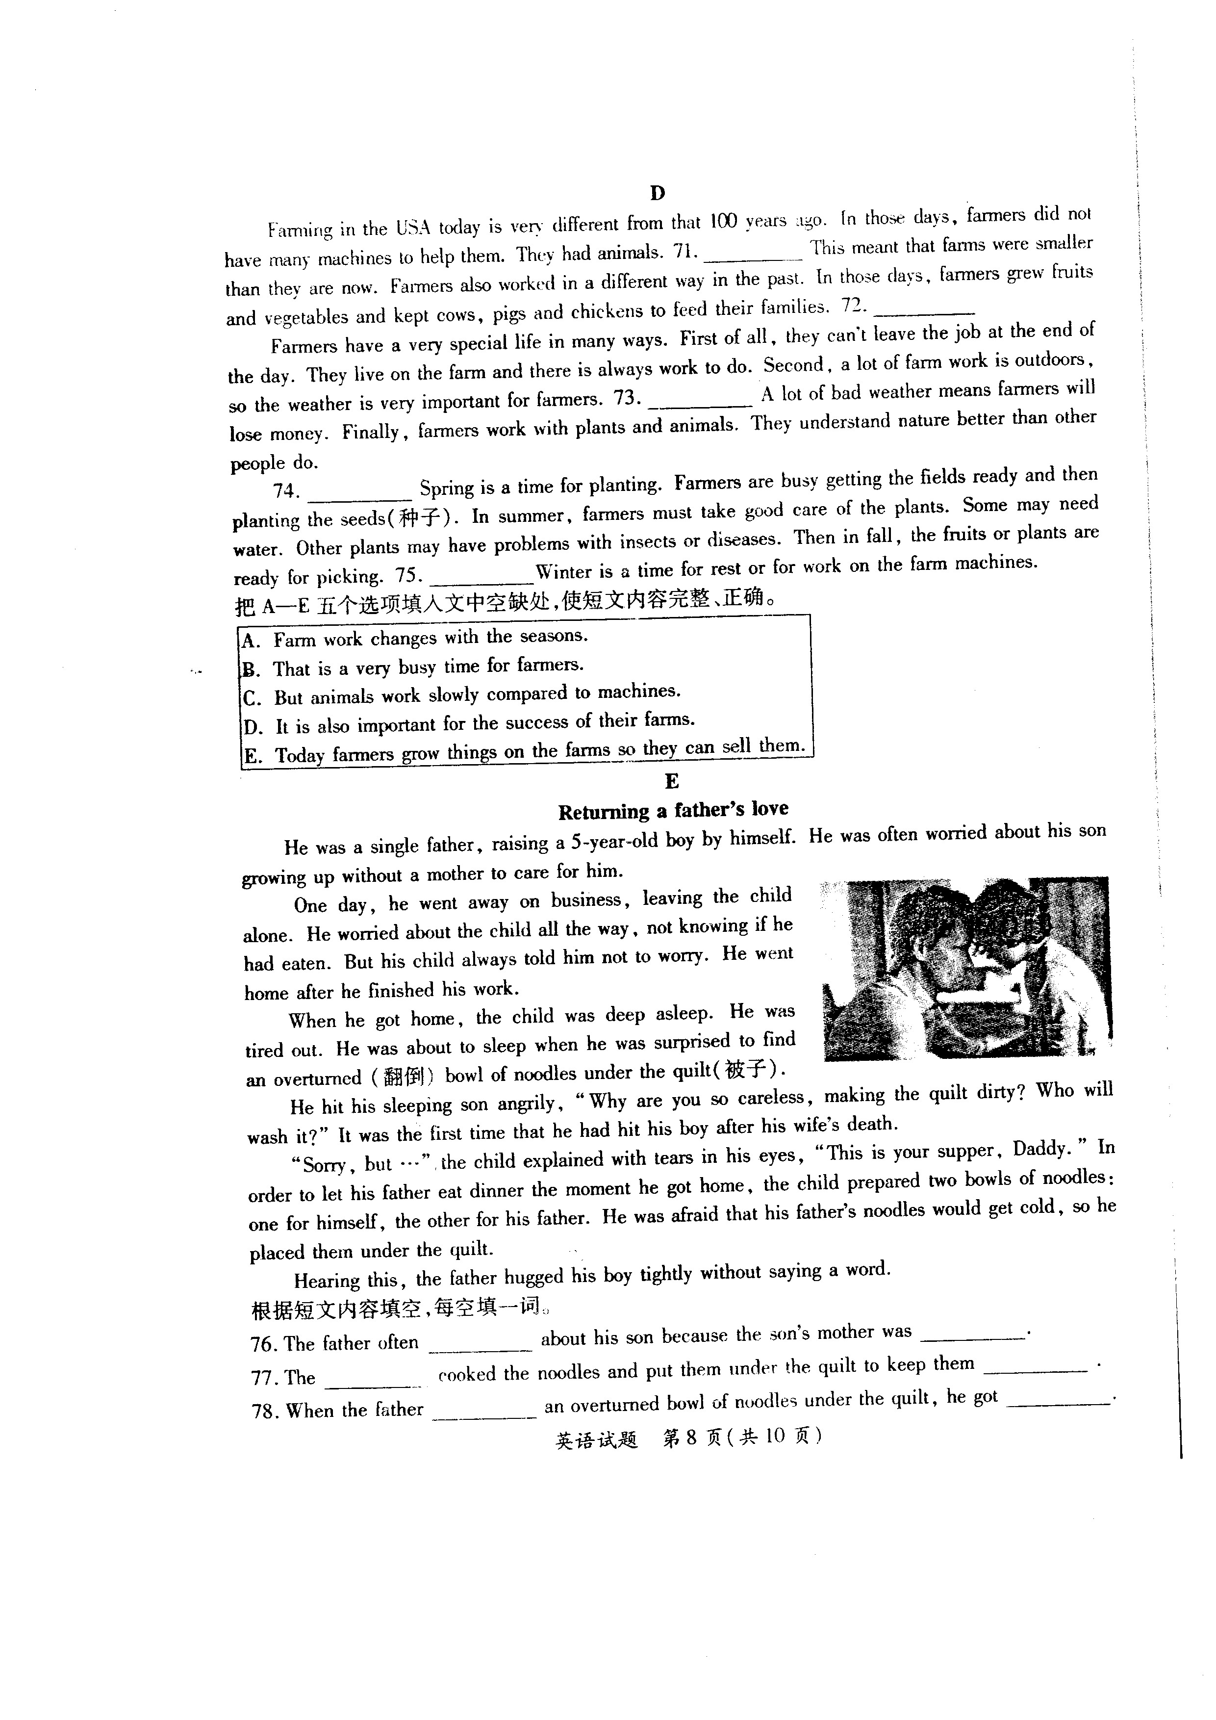
alone. He worried about the child all the way, not knowing if he
had eaten. But his child always told him not to worry. He went
home after he finished his work.
When he got home, the child was deep asleep. He was
tired out. He was about to sleep when he was surprised to find
an overturned（翻倒） bowl of noodles under the quilt, （被子）
He hit his sleeping son angrily ,”Why are you so careless , making the quilt dirty ? Who will wash it ?” It was the first time that he had hit his boy after his wife’s death .
“sorry , but ....” the child explained with tears in his eyes , “This is your supper ,Daddy .” In order to let his father eat dinner the moment he got home , the child prepared two bowls of noddles : one for himself , the other for his father . He was afraid that his father’s noodles would get cold , so he placed them under the quilt .
Hearing this , the father hugged his boy tightly without saying a word .
根据短文内容填空，每空填一词。
76. The father often about his son because the son's mother was_________ .
77. The_________ cooked the noodles and put them under the quilt to keep them_________ .
78. When the father _________ an overturned bowl of noodles under the quilt , he got __________ .
79. After what his son explained, the father felt__________
80. The boy was so , but he knew how to__________his father's love.
V. 词汇运用（每小题1分，计7分）
根据句意和汉语提示，在空格中填入正确的单词。（每空填一词）
81.That lovely baby has a small __________ （鼻子）.
82.John looks________（酷的）in the new windbreaker.
83.The tall building is made up of millions of（石头）
84.Please_________（覆盖）the table with this piece of cloth.
85. The restaurant is__________（在。。。。。。后面）the bookstore.
86. Be_________（小心）when you cross the road
87. We should do something __________（代替）of just talking about it.
VI 看图写话（每小题2分，计8分）
根据图示和提示词，写出恰当的句子，每图一句。
要求：1.使用全部的提示词； 2 . 写出完整的句式结构。
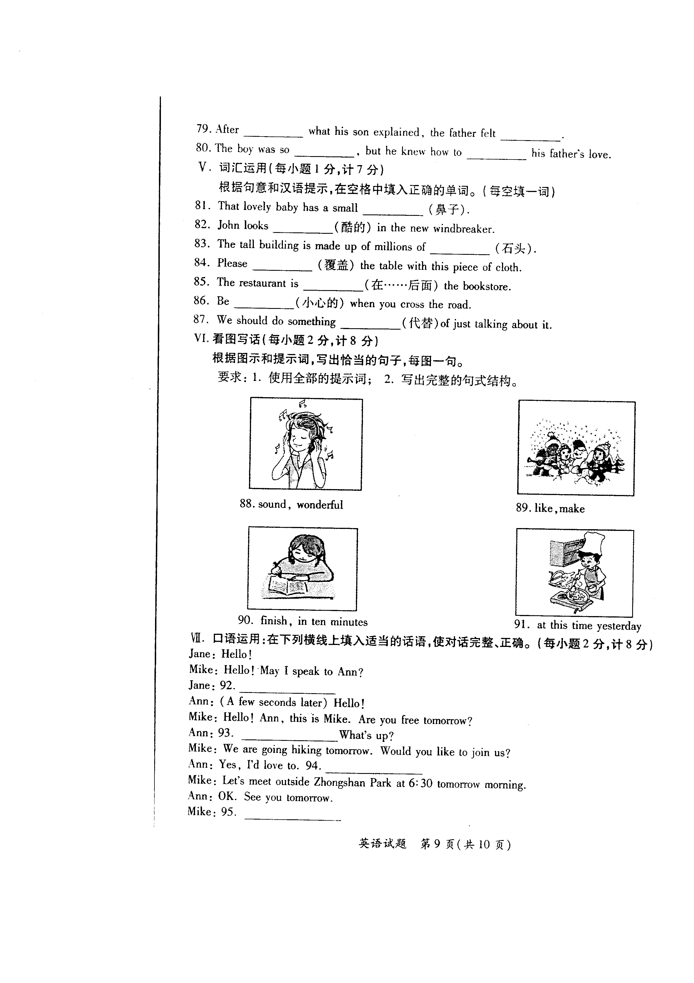
VII.口语运用（每小题2分， 计8分）
在下列横线上填入适当的话语，使对话完整正确。
Jane : Hello !
Mike :Hello ! May I speak to Ann ?
Jane : 92.___________________
Ann : (A few seconds later) Hello !
Mike : Hello ! Ann, this is Mike. Are you free tomorrow?
Ann : 93. What's up?
Mike: We are going hiking tomorrow.
Ann: Yes, I'd love to. 94.__________________
Would you like to join us?
Mike: Let's meet outside Zhongshan Park at 6:30 tomorrow morning
Ann: OK. See you tomorrow.
Mike : 95._____________________
VIII.综合填空（每小题1分 ， 计10分）
用方框中所给单词的适当形式填空，使短文正确、通顺。（每词限用一次
be , as , name , since , along , famous , take , food , travel , delicious

Shanghai is the biggest city with the largest population in the world. It is also the fastest growing
city. Its 96 means "on the sea", because it sits on the shores(海滨) of the East China Sea. The city used
to 97 a fishing town, but these days it is not only a major financial(金融的) center, it's also 98 for its art and culture.
Visitors to Shanghai can be 99 from the airport to the center in a fast train. The train 100
up to 430 kin/hour. Once you are in the city, you can't miss a popular area 101 the Huangpu River.
Also, Shanghai Museum is a great place. And if you want to try the local 109_ , you should go to
Yang's Fried Dumplings. You can get some nice dumplings and a bowl of 103 soup for only ¥ 15.
Now Shanghai is getting very "heavy" from all the growth. 104 a result, the city is going
down the soft ground. 105 1921, it has gone down for almost two meters.
IX. 短文写作（12分)
我市将承办2014年第15届省运会，为此组委会委托某英语报社向全社会征集建议，假设你是李平，请联系实际，就“政府部门，市民(citizens)及学生该为办好这次盛会做些什么？”提出建议．

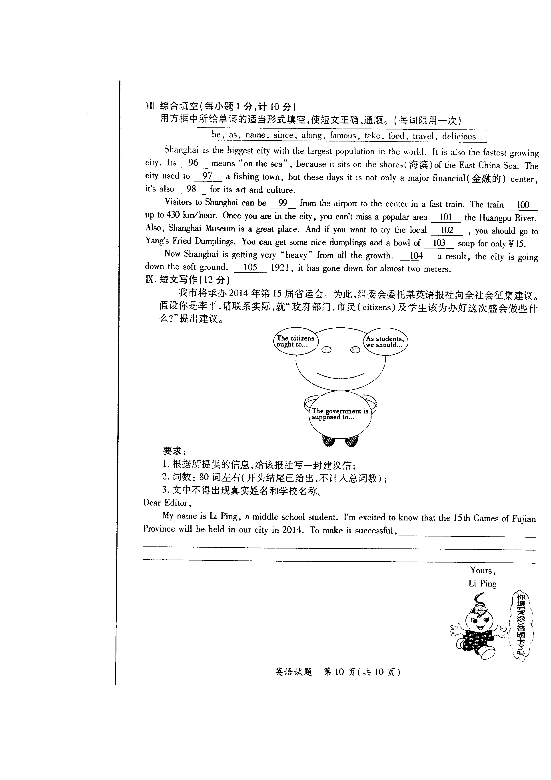
要求：
1.根据所提供的信息，给该报社写”一封建议信；
2.词数：80词左右（开头结尾已给出，不计入总词数)；
3.文中不得出现真实姓名和学校名称．
Dear Editor ,
My name is Li ping , a middle school student . I’m excited to know that the 15th Games of Fujian Province will be held in our city in 2014 . To make it successful , ____________________________________________ ____________________________________________________________________________________________________________________________________________________________________________________________________________________________________________________________________________________________________________________________________________________________________________ Yours ,
Li Ping

参考答案
1.C 2. A 3. B 4. A 5. B 6. C 7. B 8. A 9. A 10. B
11. A 12. C 13. C 14. A 15. C 16. A 17. B 18. B 19. C 20. B
21. B 22. A 23. B 24. A 25. C
26. Cassie 27. double 28. five/5 29. 328 30. July
31. A 32. C 33. B 34. A 35. B 36. C 37. A 38. C 39. B 40. A
41. A 42. C 43. C 44. B 45. C 46. B 47. A 48. C 49. A 50.B
51. B 52. C 53. A 54. C 55. A 56. B 57. C 58. B 59. A 60.D
61. C 62. D 63. A 64. D 65. B 66. C 67. B 68. C 69. A 70.D
71. C 72. E 73. D 74. A 75. B
76. worried, dead 77. boy/son, warm/hot 78. found/saw, angry 79.hearing , moved
80. young, return 81. nose 82. cool 83. stones 84. cover 85.behind
86. careful 87. instead
88. The music sounds wonderful.
89. They/The children like making snowmen.
90. The girl/She will finish her homework in ten minutes.
91. The man/He was cooking at this time yesterday.
92. Hold on, please./Just a moment./Wait a moment.
93. Yes./Yes, I am.
94. When and where shall we meet?
95. See you./Goodbye. / Bye.
96. name 97. be 98. famous 99. taken 100. travels
101. along 102. food 103. delicious 104. As 105. Since
IX.短文写作
One possible version:
Dear Editor,
My name is Li ping , a middle school student . I’m excited to know that the 15th Games of Fujian Province will be held in our city in 2014 . To make it successful , the government is supposed to build more new gyms for the players and take mor measures to improve the environment Of our city. Besides, the citizens ought to be polite and ready to help others. They had better talk with others in Putonghua. They should ny their best to keep the city clean and tidy. As students, we should do more exercise to keep fit and try to be volunteers of the Games.
In a word, if everyone makes a contribution, the Games will be more successful.
Yours,
Li Ping

