2013年福建省泉州市初中毕业、升学考试
英语试题
第一卷
第一部分 听力考查（30分）
第一节听句子：(10分)
(A)从A、B、C三幅图画中选出符合句子内容的图画。(句子读两遍) (5分)

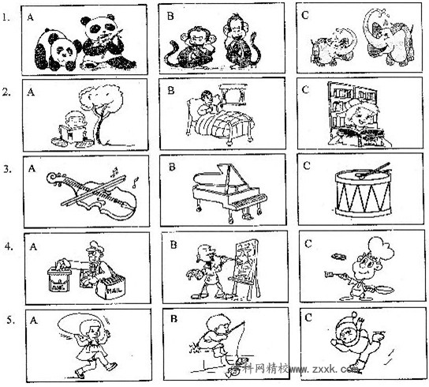
(B)根据你所听到的句子，选择恰当的答语。(句子读两遍)(5分)

6. A. Me, too. B. Thank you. C. Not at all.
7. A. Sure. B. So do I. C. I'm full.
8. A. Well done! B. I'd like that. C. Much better.
9. A. Spring. B. Cartoon. C. Soccer.
10. A. Over 5,000 years. B. About 1.3 billion. C. Just in Asia.
第二节听对话：
(A) 根据你所听到的对话，选择正确的答案。(对话读两遍) (15分)
听第一段对话，回答第11、l2小题：

11. Jack's hometown is in the of Sichuan.
A. east B. west C. south
12. Where do Jack's parents work?
A. In a restaurant. B. In a bank. C. In a supermarket.

听第二段对话，回答第l3、l4小题：

13. What kind of music does Tom like best?
A. Folk music. B. Pop music. C. Classical music.
14. Kate enjoys collecting now.
A. stamps B. coins C. dolls
听第三段对话，回答第l5、l6小题：
15. Mary can't go with John because she's now.
A. playing tennis B. climbing hills C. doing her homework
16. What day is it today?
A. Saturday. B. Sunday. C. Monday.
听第四段对话，回答第l7、18小题：

17. Where did Helen put her umbrella just now?
A. In the desk. B. On the shelf. C. Behind the door. 18. What's Li Ming's favorite color?
A. Green. B. Yellow. C. Blue.
听第五段对话，回答第l9、20小题：

19. Sally won the girls' .
A. long jump B. 100-meter race C. high jump
20. What does Sally look like?
A. She's tall with short hair. B. She's short with long hair. C. She's tall with long hair.
听第六段对话，回答第21、22小题：

21. When is the man leaving for Shanghai?
A. On June 26th. B. On July 26th. C. On August 26th.
22. How much does he pay for the tickets?
A. ￥980. B. ￥1,960. C. ￥2,940.
听第七段对话，回答第23—25小题：

23. What subject does Mr. Smith teach?
A. Biology. B. History. C. Science.
24. Mr. Smith gave a lecture about last month.
A. culture B. space C. customs
25. Why do the students like Mr. Smith's lessons?
A. He's honest. B. He's confident. C. He's humorous.
（B）听一段较长对话，回答第26—30小题。（对话读三遍） (5分)
26. The radio says it will be tomorrow.
A. cloudy B. sunny C. rainy
27. Where will they have the party?
A. At Maria's home. B. At Uncle Bob's home. C. In the open air.
28. What will Uncle Bob do for the party?
A. He'll cook the meal. B. He'll clean the house. C. He'll do some shopping.
29. When does the conversation happen?
A. In the morning. B. At noon. C. At night.
30. What presents will Morn receive on her birthday?
A. A scarf and some roses. B. A card and some flowers. C. A purse and a scarf.
第二部分选择填空(35分)
(A) 单项选择：从每小题A、B、C三个选项中，选出能填入空白处的最佳答案。(15分)

31.—What's the time, please?

—It's a quarter eight.

A. past B. at C. to
32. —Michael, my new iPhone 5 doesn't work.
—Why not ask Mr. Liu it?

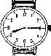

A. repair B. to repair C. repairing
33. —What sweet music!
—So it is. Soft music usually makes us ________.
A. upset B. relaxed C. nervous
34. —You shouldn't lose in computer games, boys.
—Sorry, we won't do it again.
A. you B. yourself C. yourselves
35. — do you go to see your grandparents?
—Twice a week.
A. How often B. How soon C. How long
36. —Dad, something is wrong with my ________.
—Don't worry. Let me take you to see a dentist.
A. ear B. eye C. tooth
37. —Have you had your car for long?
—Yes. it's very old, it still runs well.
A. Since B. Because C. Although
38. —How do you usually go to work?
—On foot. Walking is much than driving during the heavy traffic time.
A. fast B. faster C. fastest
39. —Mum, I'm going to school now.
—OK. your coat, please. It's cold outside.
A. Put on B. Put away C. Put out
40. —There are so many old temples in Quanzhou.
—Thanks to the government's effort, most of the ancient buildings ________.
A. well protect B. well protected C. are well protected
41. —What do you think of the movie War Horse?
—Wonderful. It's the best one that I in the past few years.
A. watch B. watched C. have watched
42. —How about having a picnic with me this weekend?
— .
A. Good idea B. Here you are C. Sorry to hear that
43. —Excuse me, which is the way to the railway station?
— .
A. Never mind B. Sorry, I am new here C. That's OK
44. —What will you talk about at the class meeting?
—We plan to discuss to realize China Dreams.
A. why should we do B. how should we do C. what we should do
45. —Would you mind if I play the piano now?
— . My brother is sleeping.
A. You'd better not B. Of course you can C. Yes, please

(B) 完形填空．从每小题A、B、C三个选项中，选出能填入空白处的最佳答案。(10分)

What do you do when you are in trouble on a lonely island? Surely you need to 46 a way to get in touch with the outside world. Your best 47 of doing this is to draw the attention of a passing plane.
The smoke from a fire can be seen from far away, 48 it is a good way to attract attention. If the weather is dry, it's 49 to start a fire. But remember that fires can be very dangerous if they are out of control. 50 make a fire unless you're sure that it can't spread. If the ground is dark, 51 smoke can be seen more easily. Green grass and leaves produce white smoke.[来源:学§科§网Z§X§X§K]
It's a good idea to make some 52 , too. For example, "F" means "I need food and water'', "IF' 53 "I need medicine" and “I” for "I am too 54 hurt to move from here". These are useful symbols. Use large pieces of wood to make them. If you 55 find any wood, use earth.
You can be found more easily in this way.
46. A. give B. find C. show
47. A. place B. service C. chance
48. A. so B. but C. or
49. A. hard B. easy C. impossible
50. A. Never B. Always C. Sometimes 51. A. light B. black C. blue
52. A. plans B. rules C. symbols
53. A. looks for B. waits for C. stands for
54. A. quietly B. badly C. slowly
55. A. can’t B. mustn’t C. needn’t
C) 口语运用：根据对话内容，从方框中选出能填入空白处的最佳选项，补全对话。(10分)
A. Is it serious?
B. Then how to wash hands properly?
C. And we'd better use warm water.
D. How can we stay away from it?
E. Good afternoon, boys and girls.
Students: Good afternoon, Miss Jiang.
Teacher: 56 .Today, we'll talk about a new bird flu. It has hit some Chinese cities.
Monitor: 57 .
Teacher: Yes, it is. It's reported that about 35 people have been ill.
Monitor: 58 .
Teacher: We should keep away from animals. And we ought to wash our hands correctly.
Monitor: 59 .
Teacher: It should take at least 20 seconds each time. 60 See a doctor at once if you have a high fever or have trouble breathing.
第三部分阅读理解(45分)
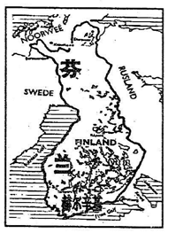
（A）
Finland is a great country to visit, especially for relaxing. You can easily find peace and quiet there because much of the country is covered with forests. It also has lots of hills and thousands of lakes and islands. Depending on the season, visitors can enjoy themselves in bird-watching, hiking, fishing and other outdoor activities. There is even a part of Finland where people can see the beautiful Northern Lights.
If you are a nature lover, you will discover plenty to enjoy in Finland. You will also find that the people of Finland are easy-going. This might be because they spend a lot of time having a sauna(桑拿)to relax themselves together. Finland even has a competition that is about spending time in one sauna. In the Sauna World Championships, people try to stay as long as they can in a sauna. This is really a hot competition! Finland is always considered as one of the best places in the world to live, from its capital, Helsinki, to its great number of lakes and forests.
Finland is truly one of the world's greatest treasures.
根据短文内容，判断下列句子是否正确，对的涂(A)，错的涂(B)。 (10分)
61. Forests cover much of Finland.
62. Visitors can enjoy hiking and fishing whenever they visit Finland.
63. The Northern Lights can be seen in a part of Finland.
64. The people of Finland are serious and hard-working.
65. Having a sauna is a popular way for people to relax themselves in Finland.

(B)(C)两篇 根椐短文内容。从每小题A、B、C三个选项中选出一个最佳答案。(20分)
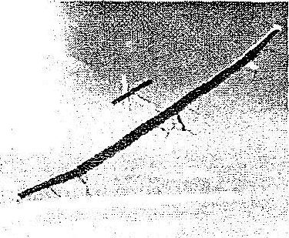
（B）
A plane without oil! Super Google glasses! Sound like the year 2050? Take a look at the coolest inventions of 2013.
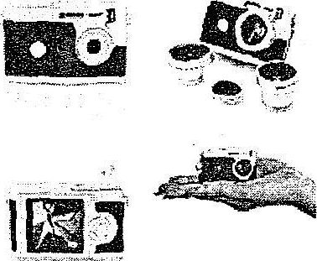
Solar-powered (太阳能的) plane. A plane flew for more than 18 hours over the US on Saturday and didn't use a drop of oil! How? Solar Impulse is a solar-powered plane, the biggest such plane in the world. It has the same weight as a small car. It carries only one person, it can get solar power from the sun.
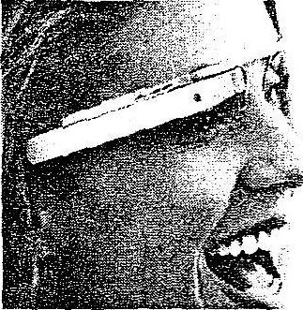
Super light camera. It weighs only 36g. It's as light as six coins. It's easy for you to take this small camera with you when traveling. It's small, but it also has many uses. You can take a colorful photo or a black and white one. There are many shapes you can use. You can also use the camera as a key ring.
Google glasses. They are the latest technology from Google. People who wear the glasses can record what they see and hear around them, and put them on the Interact for the world to see. There is a GPS system in the glasses, and it will find where you are and tell you where you need to go. Google glasses are a bit like a helpful secretary. You can tell them what you want to write in an e-mail and they will type it for you.
66. The solar-powered plane can't .
A. fly without oil B. carry over 18 persons C. get power from the sun
67. Which has the same weight as six coins according to the passage?
A. Solar Impulse. B. Super light camera. C. Google glasses.
68. Google glasses can if you need.
A. record other people's activities B. drive and park your car
C. find a helpful secretary for you
69. From the passage, we can know .
A. how we make a solar-powered plane B. who invented the super light camera
C. what Google glasses can do
70. The best title for the passage may be “ ”.
A. Life in the year 2050 B. Coolest inventions of 2013
C. Latest technologies from Google
(C)
Once there was a king called Midas. He lived in a golden palace with his beautiful daughter. He was very rich, but he still wanted more. He believed gold was the only reason for his happiness.
One day, a god called Dionysius was traveling with his friends. One of them got lost, and woke up in the garden of Midas' palace. The king looked after this stranger for several days, and fed him well.
When Dionysius discovered this, he was very grateful. He said to King Midas, "Whatever you ask of me, I will give you." Midas thought for a second, and then remembered his love of gold. "I would like everything I touch to turn into gold," he asked.
Dionysius tried to warn him, but Midas had made up his mind. "So be it," said Dionysius.
From that moment, everything Midas touched turned into gold. At first he was very excited. He touched a table and it became gold. But as he reached out for a grape, it turned into metal and he could not eat it. Midas began to panic. At that moment, his daughter entered the room. Midas rushed over to her and hugged her. As he let go, he realized that his own daughter was now nothing more than a dead, golden statue (雕像), shining brightly.
Midas cried and cried. Then he turned to Dionysius. Dionysius told him to go down to the river and wash his hands. As Midas was washing them, he saw gold going from his fingers. He returned to the palace and found everything he had touched had changed back.
From then on, Midas didn't care for gold any longer.
71. Which of the following did Midas love most before he met Dionysius'?.
A. His daughter. B. The palace. C. Gold.
72. How did Midas feel when he could turn things into gold at first?
A. Excited. B. Sad. C. Worried.
73. The underlined word "panic" means “ ” in Chinese.
A．狂喜 B．恐慌 c．愤怒
74. In which way did Midas change everything back?
A. Cutting off his fingers. B. Washing his gold in the river.
C. Asking Dionysius for help.
75. What does the passage mainly tell us?
A. Wealth doesn't mean everything. B. Nothing is more important than wealth.
C. The only reason for happiness is wealth.
(D)
根据短文内容，将下面A—E五个句子分别填入文中空缺处，使补全后的短文意思通顺，
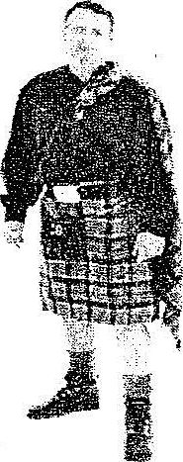
结构完整。(5分)
lt's not just women who wear skirts. 76 In Scotland, men wear a kind of skirt called a kilt (短褶裙). The kilt is their national dress and an important part of their culture.
77 It has different colors. Each family in Scotland has its own colors.
Why did people in Scotland start to wear kilts? 78 One is that the kilt was made in the 1720s by an English factory owner called Thomas Rawlinson. He had a number of workers from Scotland in his factory and be thought their long clothes got in the way of their work. 79 .
In the old days, soldiers in Scotland wore kilts. Later, all men there began to wear them. Today, most men in Scotland only wear kilts on special occasions. Soldiers also wear them in important celebrations. 80 But they no longer wear them to fight.
A. They still use kilts as their dress uniform.
B. A kilt is a skirt reaching down to the knee.
C. So he cut them into shorter skirts.[来源:]
D. Men can wear them, too.
E. There are many stories.
第二卷
(E)
Nowadays, Chinese people love to travel to foreign countries. Some people may say they can do everything they want because they spend money in the country. In fact, this is not true. Besides enjoying ourselves, we should respect local customs and care for the environment. How to be a good tourist when traveling abroad? Let's take a look!
- It's impolite to talk loudly in public places like coffee shops and museums.
- It is good manners to give tips (小费) when you travel in most Western countries.
- Don't spit or litter. Stop yourself from writing or drawing on famous buildings.
- You shouldn't take your shoes off when taking a plane.
◆ It isn't good to change seats while the plane is taking off. Also it's not good to reach for your luggage (行李) while the plane is landing.
- You mustn't cross the road before the traffic lights are green.
- In a self-service restaurant, don't take too much food. Wasting food is not a good idea.
任务型阅读：根据短文内容，填写下列表格，每格只填一词。(10分)
Bad manners that we should avoid when traveling abroad
◇Talking 81 in public.
◇Refusing to give tips.
◇Spitting and littering everywhere. Writing or 82 on famous buildings.
◇Taking off your 83 during a flight.
◇Changing 84 while the plane is taking off and .getting luggage while the plane is landing.
◇Crossing the road when the traffic lights are still 85
◇Taking 86 food than you need in a self-service restaurant.
第四部分语言知识运用(25分)
(A)词汇运用：(10分)
- 选择括号内恰当的单词或词组填入空白处，使句意完整、正确。
87.— (Whose / Which) schoolbag is that?
—It's Jack's.
88. —Jane cried out for help as she saw a big mouse.
—Poor girl! She isn't as (brave / braver) as me.
89. —When did you hear the news?
—I knew nothing about it (until / after) my friend told me.
90. —If we (obey / break) the traffic rules, the roads will be safer.
—I agree with you.
91. —Are your parents (angry / pleased) with you this time?
—Yes. I've passed all the exams.
◆根据中文提示写出单词或词组，使句意完整、正确。
92. —These (苹果) taste delicious. How many do you want?
—Two kilos, please.
93. —How was your trip to Sansha in (五月份) ?
—Great. We had a good time.
94. —Mo Yah won the Nobel Prize for Literature.
—I know. We are all (骄傲) of him.
95. —What do you usually do in your spare time?
— I often (种植) flowers in the garden.
96. —Please (查找) these new words in the dictionary.
— OK.
(B)遣词造句：根据提供的图画和提示词，写一个符合图意的完整、正确的句子。(10分)

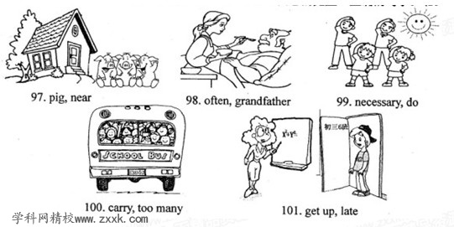

(C)综合填空：根据短文内容选择方框内的单词，并用其正确的形式填入空白处，使补全后的短文意思通顺，语法正确，结构完整。(5分)
sorry either take friend if
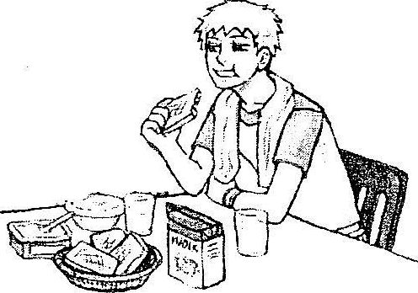
When I was young, Mum used to give the family something special for meals. She once put some burnt (烤焦的) bread in front of Dad. To my surprise, Dad 102 his bread, smiled at Mum and ate it up.
After dinner, Mum said 103 to Dad for burning the bread. And I will never forget what he said, "I love burnt bread, dear. It doesn't matter at all."
That night, I asked Dad 104 he really liked the bread. He said, "Your mum worked very hard all day. She's really tired. And you see—a bit of burnt food never hurt anyone!"
Now I know life is not perfect. Nobody is perfect, 105 . What we really need is to understand each other, whether it is between husband and wife, parent and child or between two 106 . So be kind to those around you and a happy life will surely be yours.
第五部分 书面表达
相互学习是一种好态度、好习惯，它是我们共同进步的好方法。请以“Learn From Each Other”为题，写一篇英语短文，让我们分享你与他人互相学习的经历和感受。
温馨提示：1. 短文中请勿使用真实姓名、地点或所在学校名称。
2.词数：80左右。
Learn From Each Other

（记得将你的答案填写在答题卡上哦！）
亲爱的同学们，当你完成这份试卷后，觉得自己的水平离及格线仍有一定的差距时，请你别担心。我们特意在下面给出五道附加题，希望能祝你一臂之力！快来试试看吧！
附加题：从每小题A、B、C三个选项中，选出能填入空白处的最佳答案。(10分)
1. 有英国友人问你‘'How are you?”，你应回答：“ ”。
A. I’m fine, thanks. B. I'm fifteen. C. Nice to meet you.
2．当英国友人夸奖你时，你应回答：“ ”。
A. Where, where? B. Thank you. C. No way.
3. 假如你不小心弄坏了英国友人的铅笔，你应该说：“ ”。
A. That’s OK. B. It’s right. C. I'm sorry.
4. 你与英国友人告别时，你应该说：“ ”。
A. Goodbye. B. Excuse me. C. How do you do?
5.在英国旅游时会经常看到一些标志，你知道下列哪个是表示 “No Smoking”?

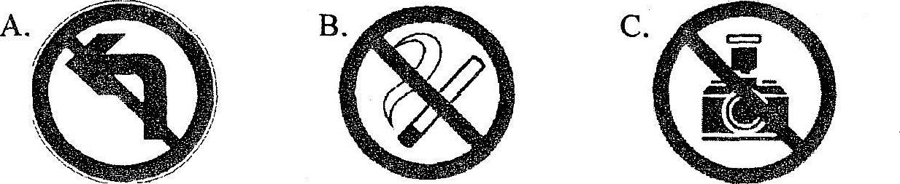
(注：如果考生全卷得分低于90分，即及格线，则本题的得分将计入全卷总分，但计入后全卷总分最多不超过90分；如果考生全卷得分已经达到或超过90分，则本题的得分不计入全卷总分。)
2013年福建省泉州市初中毕业、升学考试
英语试题参考答案及评分标准

第一卷
第二部分 选择填空（35分）
（A）单项填空：31-35 ABBCA 36-40 CCBAC 41-45 CABCA
（B）完形填空：46-50 BCABA 51-55 ACCBA
评分标准：每小题1分。
(C)口语运用 补全对话：56-60 EADBC
评分标准：每小题2分。
第三部分 阅读理解 （45分）（注：其中E篇10分放在第二卷）
(A) 61-65 ABABA (B) 66-70 CBACB (C)71-75 CABCA
评分标准：每小题2分。
- 76-80 DBECA
评分标准：每小题1分。
第二卷
（E）任务型阅读（10分）
81.loudly 82.drawing 83.shoes 84.seats 85.red 86.too much
评分标准：每小题2分，只要有5个全对即给满分。
第四部分 语言知识运用（25分）
（A）词汇运用。（10分）
87.Whose 88.brave 89.until 90.obey 91.pleased
92.apples 93.May 94.proud 95.plant 96.find out / look up
评分标准：每小题1分。
（B）遣词造句。（10分）
97.There are three pigs near the house.
98.I often help my grandfather to eat food.
99.It is necessary to take exercise every day.
100.The school bus carries too many people.
101.I got up so late that I was late for school.
评分标准：每小题2分。每写出一个符合题意的完整、正确的句子，得2分；能读懂题意，写出关键词的得1分；大小写错误、拼写错误、语法错误的扣0.5分。
（C）综合填空。（5分）
102.took 103.sorry 104.if 105.either 106.friends
评分标准：每小题1分，拼写错误的不给分。

第五部分 书面表达（15分）
范文
Learn From Each Other
I have a good friend . His name is Tom . We often learn form each other . My English was poor . I was worried about it . But Tom’s English is very good . So he help me with my English . So my English has improved a lot . But Tom’s math was poor . So I ofen help him to work out the math problems .
We learn from each other and have fun together.

附加题：1-5 ABCAB

