2013年福建省南平市初中毕业、升学考试
英 语 试 题
（满分：150分；考试时间：120分钟，其中听力30分钟，笔试90分钟）

★ 友情提示： 请考生将选择题（1—65题）答案用2B铅笔填涂在答题卡上；其他试题请考生将答案用0.5毫米的黑色签字笔书写在答题卡上，答在本试卷上一律无效。

I.听力部分（共三大题，每小题1.5分，满分30分）
A. 单句理解 听句子，从所给图中选出与所听到的句子情景相同（相近）的图画 （句子读两遍，每小题1.5分，满分7.5分）
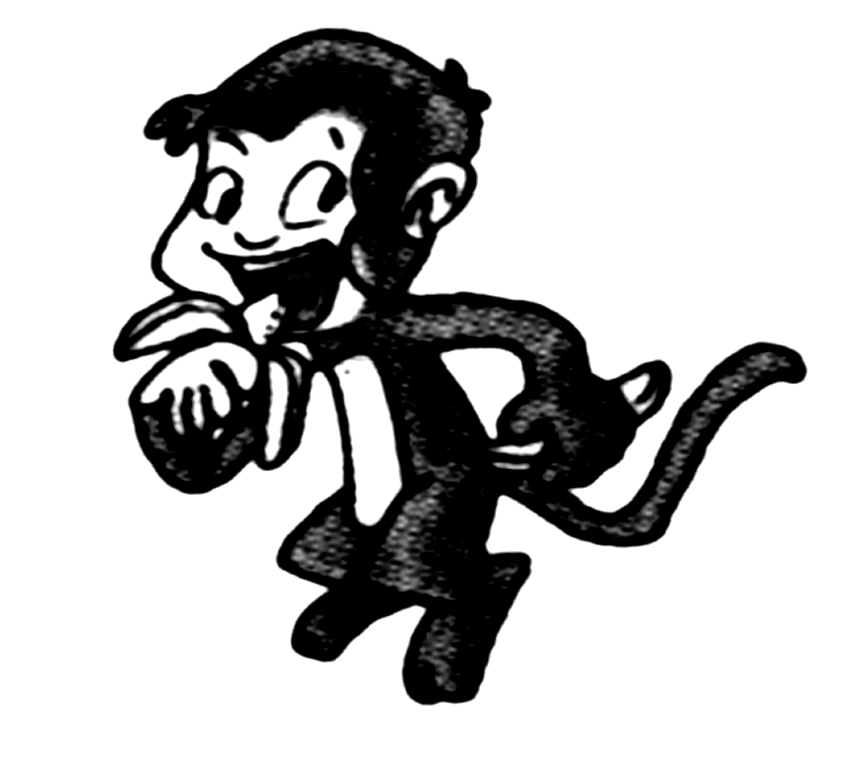
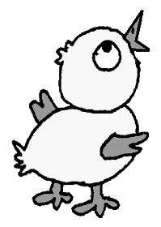
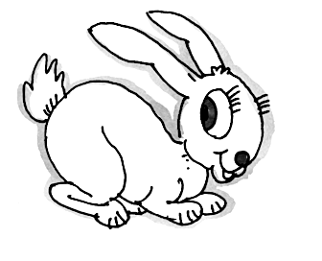

1. A. B. C.

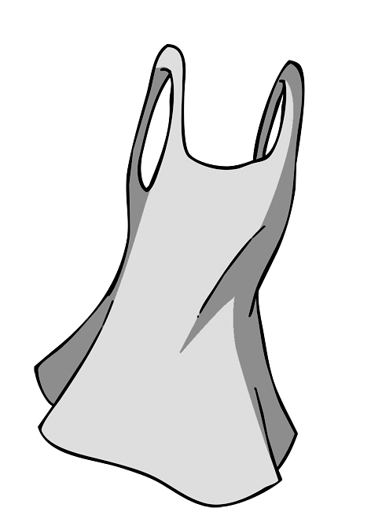
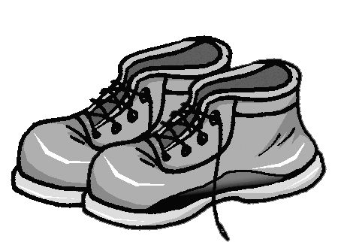
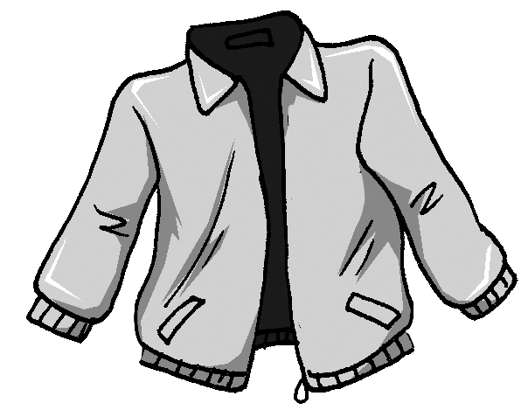

2. A. B. C.

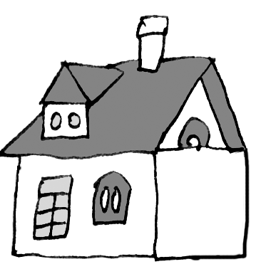
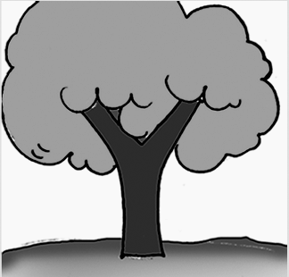
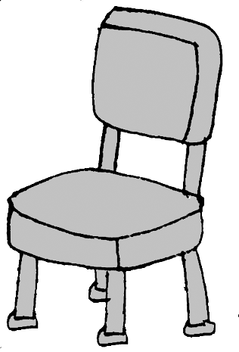

3. A. B. C.

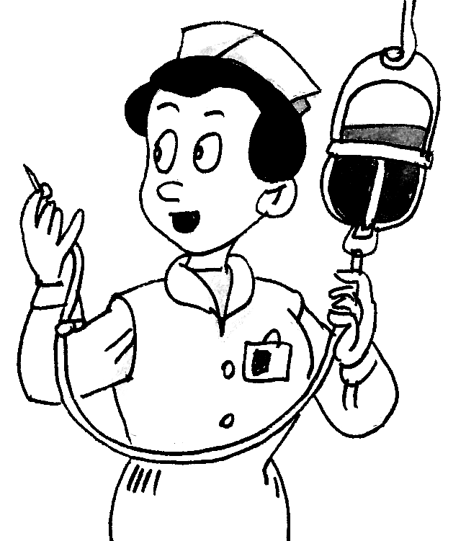
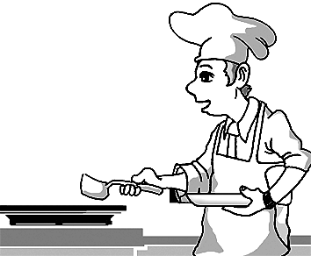
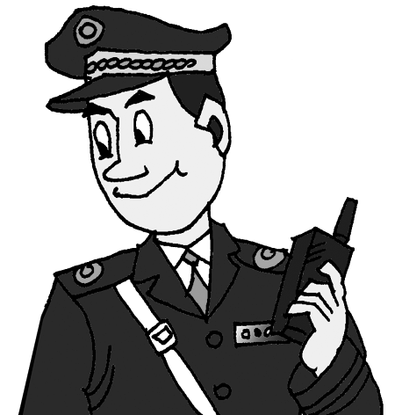

4. A. B. C.

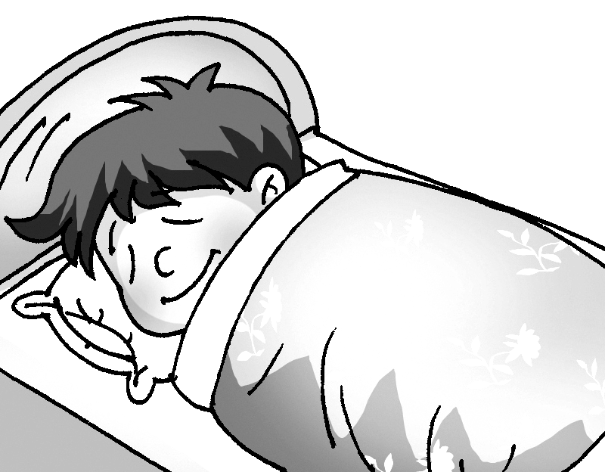
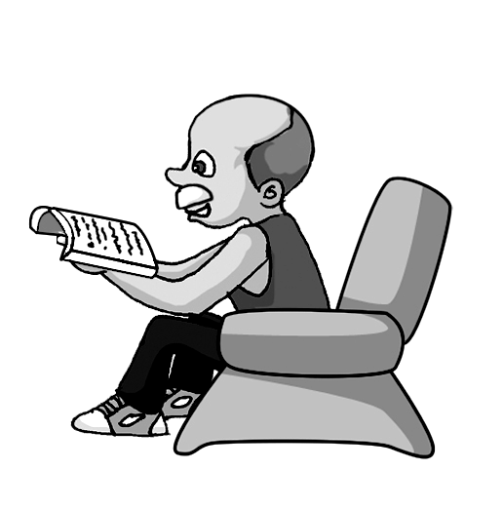
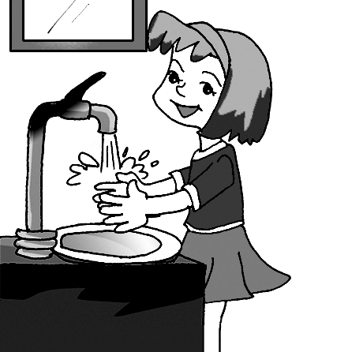

5. A. B. C.

B.听对话 根据所听到的内容，选择正确的答案 （对话读两遍，每小题1.5分，满分15分）
第一节 听下面3段对话，每段对话后有一个小题，从题中所给的A、B、C三个选项中，
选出最佳答案。
听第一段对话，回答第6题。
6. Where are they probably talking?
A. In a shop. B. In a school. C. In a theater.
听第二段对话，回答第7题。
7. What does the girl ask the boy to do?
A. To buy her a dictionary. B. To look up some words. C. To give back her dictionary.
听第三段对话，回答第8题。
8. What does the woman think of pig pets?
A. She doesn’t like pig pets. B. She likes pigs very much. C. Pigs are hard to look after.
第二节 听下面3段对话，每段对话后有二或三个小题，从题中所给的A、B、C三个选
项中，选出最佳答案。
听第四段对话，回答9、10题。
9. What is the man doing at the moment?
A. Doing exercise. B. Catching a bus. C. Making a film.
10. How many times has the woman seen his movie?
A. Never. B. Many times. C. Only once.
听第五段对话，回答11、12题。
11. How will Peter get to Guizhou?
A. By bus. B. By train. C. By car.
12. Why does he go to Guizhou?
A. To travel. B. To work. C. To be a volunteer.
听第六段对话，回答13至15题。
13. What’s the weather like today?
A. Cloudy. B. Sunny. C. Rainy.
14. What did the man borrow from the woman?
A. A book. B. A magazine. C. A newspaper.
15. How did the man feel while reading?
A. Excited. B. Sad. C. Bored.
C. 听短文 根据短文内容选择最佳答案（短文读三遍，每小题1.5分，满分7.5分）
16. The special shops in England sell ________.
A. clothes, shoes and books B. clothes, bags and books C. books and bikes
17. The things in the shops are very ________.
A. nice B. cheap C. expensive
18. People use the money from the shops to ________.
A. buy more things
B. build schools for poor kids
C. help sick children and poor people
19. There are about ________ special shops in England.
A. 1,200 B. 10,200 C. 120
20. Young people buy things from the shops because________.
A. they can buy things from the 1980s and 1990s
B. their parents like them
C. the things there are very old
II.单项选择 从A、B、C三个选项中，选出可以填入空白处的最佳答案 （每小题1分，满分15分)
21. I am thirsty. I need ________ orange juice.
A. an B. a C. /
22. — Is this your watch? — No, it isn’t. It’s ________.
A. mine B. her C. his
23. Kate is often late for class. Mr. Brown is very angry ________ her.
A. of B. with C. at
24. Some boys think English is ________ of all the subjects.
A. difficult B. more difficult C. the most difficult
25. John is a lazy man, he always says much________ does little.
A. but B. and C. or
26. Neither you nor Maria _______hard enough at your lessons, you need more work.
A. work B. works C. are working
27. Michael doesn’t play soccer ________ the other boys in his class.
A. as well as B. as good as C. as wonderful as
28. The book is really useful, it’s well worth________.
A. read B. to read C. reading
29. There are forty-eight students in our class. ________of us are girls.
A. two third B. two thirds C. two three
30. My father decided ________. My mother and I are glad about it.
A. not smoke B. didn’t smoke C. not to smoke
31. — Why didn’t you go to Peter’s birthday party?
— I_______ to.
A. wasn’t invited B. didn’t invite C. haven’t invited
32. Jack and I ________ along the street when it started to rain last night.
A. walked B. was walking C. were walking
33. ________ good for our environment to plant more trees.
A. It B. It’s C. That’s
34. This room is ________. It is very nice.
A. Sally and Linda’s B. Sally’s and Linda’s C. Sally and Linda
35. He didn’t tell me ________.
A. what present did he like B. what present he liked C. what present does he like
III.完形填空 从A、B、C三个选项中，选出可以填入空白处的最佳答案 (每小题1.5分，满分15分)
In women’s tennis, many fans will be watching young Russian Maria Sharapova. In 2004, Sharapova won Wimbledon(温网)only 18 years old. Like many other 18-year-old 36 , Maria Sharapova likes to go shopping, talk with friends and read Harry Potter. But she is still very 37 from others.
The Russian tennis player is one of the 38 sportswomen in the world. She can make 100 million dollars a year. So far, Sharapova has not only 39 five big games but also been in lots of fashion magazines. In June, 2013, people saw her again in the France Wimbledon final match, though she was beaten and only got the second 40 . Will she let money and fame(名气) 41 the way she lives?
“I know things will come up, and I 42 to keep my head cool. I leave business for other people. I just want to go out and play tennis,” she said. Sharapova has a strict 43
for herself. When she is not playing games, she usually practices for two hours each day 44
she can stay fit.
She goes to school using the Internet. Her mother divides her textbooks into small parts, so she doesn’t have to 45 many pages with her. She takes just three courses a year, doing homework a few times a week.
36. A. boys B. girls C. children
37. A. boring B. same C. different
38. A. bravest B. richest C. most important
39. A. got B. received C. won
40. A. place B. time C. game
41. A. fill B. change C. stop
42. A. have B. stand C. spend
43. A. program B. plan C. holiday
44. A. how B. whether C. so that
45. A. take B. leave C. keep
IV. 阅读理解（共二部分，满分45分）
- 阅读以下A、B、C三篇短文，请根据要求作答。A篇根据短文内容，判断句子的正误，正确的涂“A”，错误的涂“B”（每小题1分，满分5分）；B、C篇根据短文内容，从题中所给A、B、C三个选项中，选择最佳答案（每小题2分，满分20分）
A
Who can help you? Maybe you think your parents, teachers or others can help you. But in fact, all these people only help you to help yourself.
There have been many great men in history. They had few people to help them. They could not get good education, either. But they tried their best to learn and never gave up. One famous teacher in England once told his students, “ I cannot make you great men, but I can help you make men of yourselves.”
Many young people shake the world because of their hard work. Guan Tianlang , a 14-year-old Chinese boy, has become the youngest golf player in Master history, and Alexia Sloane, a blind schoolgirl from Cambridge, works as the youngest interpreter(口译员). However, some young people do nothing and they depend on others. If these young people can see their weak points and change their ways, they can be successful. They are nothing now, and will be nothing in the future, unless they take the advice of their parents and teachers, and most importantly, depend on themselves.
46. Many great men in history succeeded because they got good education.
47. The famous teacher thought he could help his students make men of themselves.
48. Now nearly all young people do nothing and can not see their weak points.
49. Young people should take the advice of their teachers and parents.
50. If you want to be successful, you should depend on yourself.
B
Beatles still rocking after half a century
Fifty years ago four normal boys from Liverpool, England, recorded their first song Love Me Do. This music shook the world. No one knew that later the four boys would become the most famous and successful music group of all time. They are the Beatles.
New York, London, Hamburg… The Beatles may have traveled the world, but they never forgot where they came from – Liverpool, a city with a rich history.
Many of the songs the Beatles wrote were about their hometown and personal lives. In the song Penny Lane, they sing of a small road from their Liverpool childhood that is “in my ears and in my heart”. The song Strawberry Fields Forever stands for a famous strawberry field in the city. The boys could go and pick fruit there.
The North West of England is famous for friendliness and helping others. This is found in the Beatles’ music. The song Hey Jude, which was played at the Olympic Opening Ceremony（开幕式）in London in 2012, and is one of the most successful songs of all time, comes from real life. When John Lennon divorced (与……离婚) his wife, his son Julian was very upset. Paul McCartney wrote the song to comfort the boy, nicknamed（昵称）Jude.
The Beatles’ role in Liverpool’s history is everywhere. They are so important to the city that their airport is called the “John Lennon Airport”. Its motto is “above us only sky”, four words taken from the beautiful song Imagine.
51. The Beatles’ songs were mainly about ________.
A. their travel diary to different cities
B. their hometown and personal lives
C. their family life and friendship
52. Their first song ________ shook the world.
A. Penny Lane B. Love Me Do C. Strawberry Fields Forever
53. Paul McCartney wrote the song Hey Jude ________.
A. to cheer up the boy Julian B. to remember his wife C. to remember their friendship
54. The motto “above us only sky” comes from ________.
A. Imagine B. Love Me Do C. Strawberry Fields Forever
55. From the story we know________.
A. the airport in London is called the “John Lennon Airport”
B. Liverpool is famous for friendliness and helping others
C. the song Penny Lane expresses their childhood in Liverpool
C
Every Chinese person can recite the poem, “Every grain(粮食) on the plate comes from hard work .” A CCTV program, News One Plus One, reported the food Chinese people throw away every year is enough to feed 200 million people for a year.
Do we have too much food? Of course not. There were 925 million hungry people around the world in 2010, especially in developing countries. Six million children die of hunger every year.
Chinese people are well known for being hospitable and generous (热情好客的). Many even feel that they lose face if their guests have eaten all the food on the table. Luckily, a number of people have realized the importance of saving food. Last November, Li Hong, a waitress in a restaurant in Nanjing, lost her job because she took some leftover food home for her son. Many people stood by her side and said no to wasting food.
What should we do in our daily life to waste less food? Here are some suggestions:
1. Do not order too much in a restaurant. Only order as much as you want to eat. If you cannot eat all the food you ordered, take the rest of it home.
2. Don’t be too picky(挑剔的) about food. Some food may not taste great, but your body needs it.
3. Keep an eye on what food you have at home. Don’t buy too much, especially for fruit and vegetables.
56. According to the report, the food wasted in China can feed ________a year.
A. 925 million people B. 6 million people C. 200 million people
57. We shouldn’t waste food because ________.
A. there is not enough food to feed all the people
B. we lose face if our guests eat up all the food
C. it’s not good to be hospitable and generous
58. What does the underlined word leftover mean in Chinese?
A. 变质的 B. 剩下的 C. 生的
59. Which of the following is NOT a good way to save food?
A. Not ordering more than you need at a restaurant.
B. Knowing what you have at home when shopping.
C. Not eating the food you don’t like even if it is healthy.
60. The best title for the passage would be________.
A. Waste Not B. Eat Not C. Buy Not
（二）D篇根据图表信息选择正确答案（每小题2分，满分10分）；E篇根据材料内容回答问题（每小题2分，满分10分）
D
Big News In My Eyes
----By Chen Chen, Xinhua High School Beijing
Space research: China sent up another spaceship, Shenzhou X, with three astronauts into space successfully on June 11th, 2013. It’s the fifth time China sent its spaceships with people into space. | Friendship between China and Africa:  In 1956, China welcomed African students for the first time, the number of students studying in China reached more than 27,000 in 2012.
Safety comes first: Chinese style road crossing becomes a hot topic in China from last year. Now many cities have started to punish these jaywalkers(乱闯马路的人). | Crazy dancing: CCTV 1 is holding a dancing competition, hundreds of dancers from different provinces are fighting for it, some famous persons are invited.
Oral health: Brush your teeth twice daily and visit the dentist at least once a year. The mouth is a mirror of a disease. The examination is not only for the health of teeth, but the whole body. For more of it, please visit www. Mydr. com. cn.
61. China has sent up ________ spaceships with people into space.
A. three B. five C. ten
62. African students began to study in China in ________.
A. 1956 B. 2012 C. 2013

63. Many cities in China decided to do something to ________.
A. stop the crazy dancing
B. punish the dentist on line
C. stop the Chinese style road crossing
64. If you visit www. Mydr. com.cn, you can ________.
A. find news from searching into space
B. enjoy the crazy dancing
C. get information about tooth diseases
65. The Big News In My Eyes is________.
A. written by Chen Chen B. from CCTV 1 C. from Shenzhou X
E
Cellphones are very popular with people. Now, they have taken an important place in people’s daily lives, especially in young people’s. With the help of the developing technology, they are becoming smaller and easier to use.
Now the scientists in Canada made a smartphone of electronic(电子的) paper. The paper phone is flexible(易弯曲的) and can be written on or used as a touch screen.
Though this kind of new paper phone is only 0.1 centimeter thick, people can do many things with it. For example, people can use it to make phone calls, read books, watch movies and play music. So many people will use it as a computer.
The scientists think there will be no paper in the office. And you can store what you want in it.
The scientists from Queen’s University in Kingston, Canada said this paper phone would be in style in the future. It may be the end of paper and printers.
To let people be satisfied with this kind of cellphones, scientists will make it more beautiful. People will see the paper phone later this year.
66. What is this kind of phone made of?
67. Can we use the phone to listen to music?
68. Why will scientists make the phone more beautiful?
69. When can we see the paper phone?
70. What do you think of the smartphone?
V. 口语应用 根据对话内容，填入适当的句子，使对话完整、正确，其中有一项是多余的（每小题2分，满分10分）.
A. I just like blue and green. B. Would you like to choose one for me?
C. Thank you. D. You’re a little fat,
E. It looks so beautiful on you. F. Don’t be worried.
A: Hi, Mary. What a nice dress!
B: 71 I just bought it yesterday.
A: 72 I also want to buy one like yours.
B: But I’m afraid it doesn’t fit you, 73 you’d better try a dark color.
A: 74 Because blue is the symbol of peace and green is the sign of spring.
B: Oh, I see. Maybe you can try dark blue or dark green.
A: All right. 75
B: Yes, I’d love to. Let’s go!
VI. 遣词造句 根据每题所提供的图画情景和提示词，写一个与图画情景相符的句子（每小题2分，满分10分）
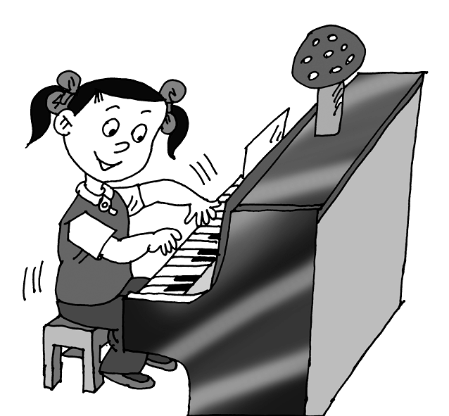
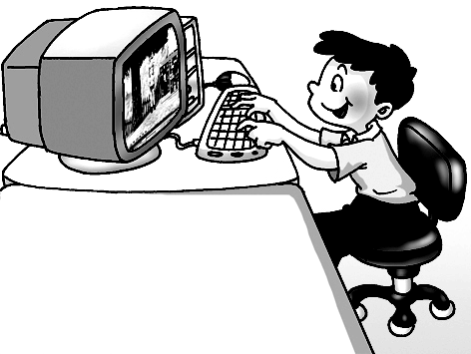
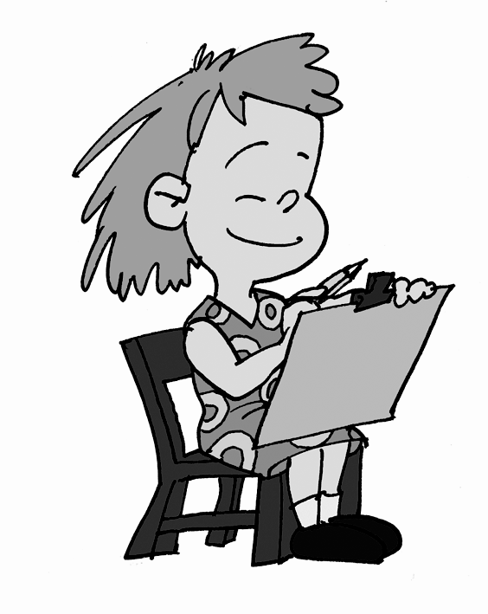
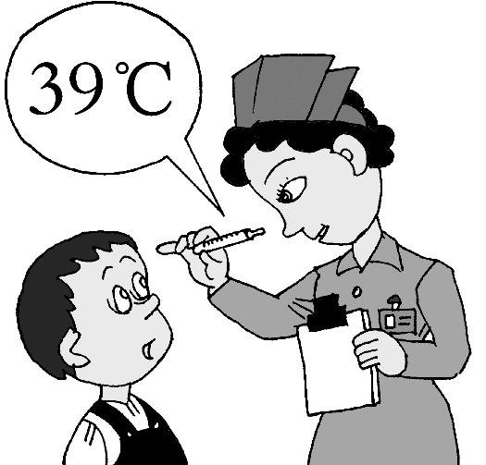
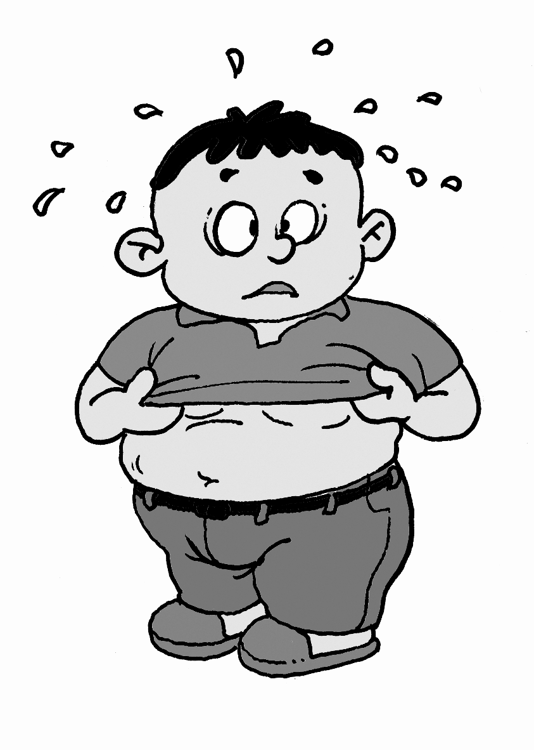

76 77 78 79 80
76. Jane, three times a week
77. learn, for a few months
78. too…for him to
79. be harmful to, too long
80. feel sad, because
VII. 综合填空 选择框格内所给词的适当形式填空，每词限用一次（每小题1分，满分10分）
sister, careful, else , tell, polite, they , however, ready, room , wash
Behavior is something all parents want and expect. To behave well, 81 , is not as easy as said.
◆ Do your best at school. Your parents will like to see you studying. Listen to your teachers, do your homework and get 82 for all tests!
◆ Always do your housework. If your parents 83 you that you have to take out the rubbish or do some 84 , be sure to do it! And make sure your 85 is clean and tidy.
◆ Give everyone lots of love and gifts now and again. Be friendly to everyone, even if they make you angry. If you have young brothers or 86 , be kind to them. Help them with 87 homework, play with them and listen to them now and again 88 .
◆ Don’t play music loud, think about everyone 89 in your house!
◆ Try to be calm, and if your friends speak loud, don’t talk loudly like elephants.
◆ Be responsible（有责任的）! For example, if your parents give you housework to do, do it well.
◆ Always be 90 to your parents. Say good night before you sleep.
81. 82. 83. 84. 85.
86. 87. 88. 89. 90.
VIII.书面表达（满分15分）
91. 习近平总书记说“有梦想，有机会，有奋斗，一切美好的东西都能够创造出来。”作为一名中学生，你一定有自己的梦想。请以“Everyone Needs a Dream”为题写一篇80词左右的短文。注意：文中不得出现真实校名和姓名。

内容包括：⑴ Is it important to have a dream?
Good Luck!
⑵ What’s your dream?
⑶ How do you realize the dream?

