2010年福建省南平市中考英语试题
(满分：150分；考试时间：120分钟，其中听力30分钟，笔试90分钟）
I. 听力部分（共四大题，每小题1分，满分30分）

A.单句理解听句子，从所给图中选出与所听到的句子情景相同（相近）的图画（句子读两遍，每小题1分，满分5分）
1.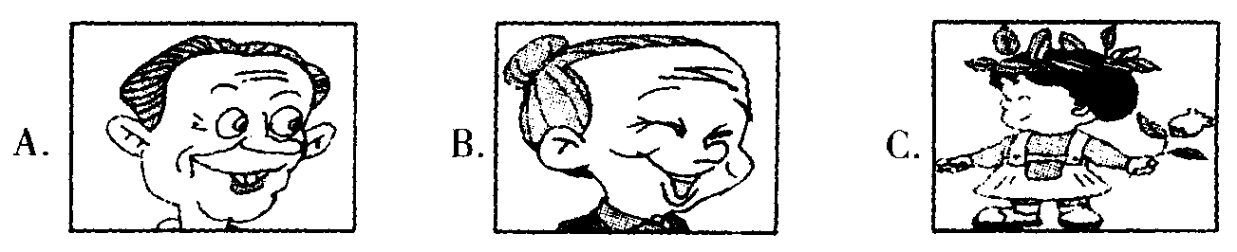

2.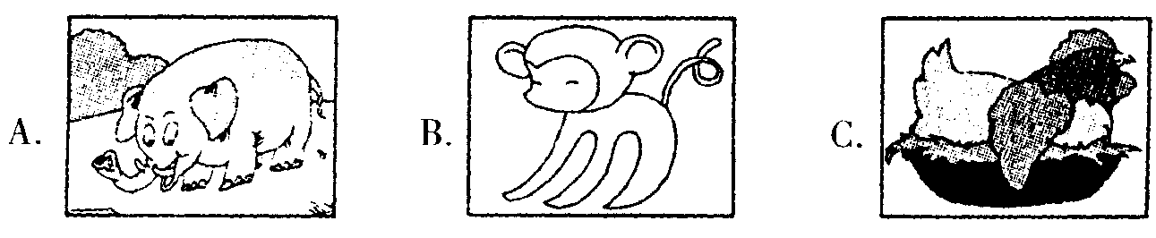

3.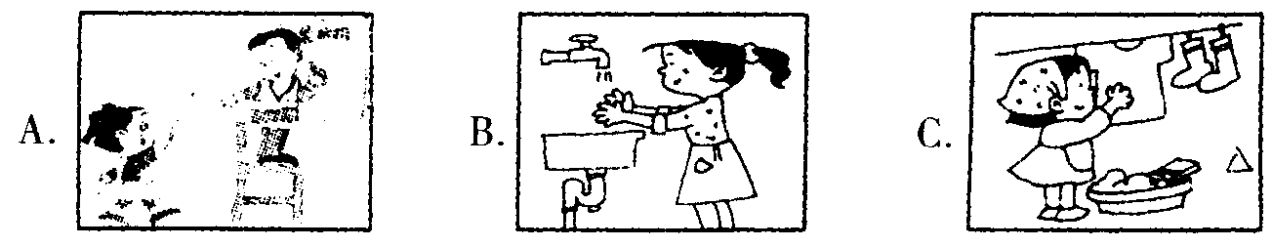

4.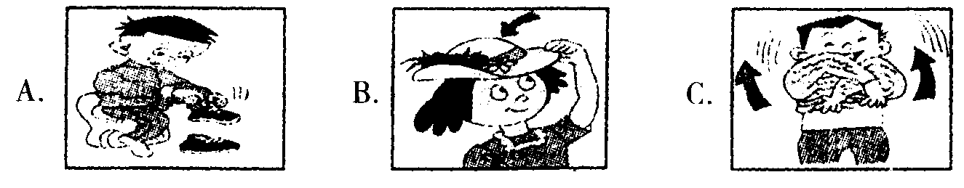

5.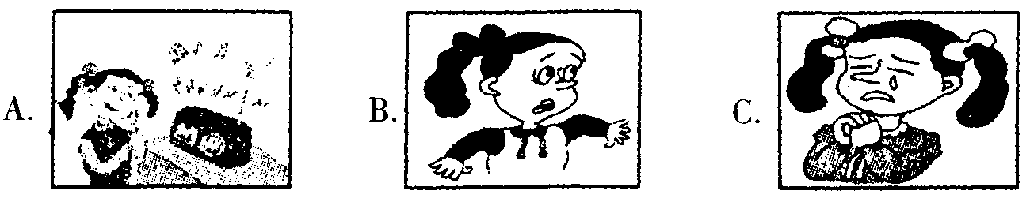

B.听对话根据所听到的内容，选择正确的答案（对话读两遍，每小1分，满分15分）

第一节听下面5段对话，每段对话后有一个小题，从题中所给的A、B、C三个选项中，选出最佳答案。
6. Why isn't Maria having her supper?
A. She is not hungry.
B. She has a toothache.
C. She doesn't like the food.
7. What are they talking about?
A. A dog.
B. Shopping.
C. Their families.
8. Can Jane go to the party this evening?
A. Yes, she can.
B. No, she can't
C. We don't know.
9. How often does Kate write home?
A. Once a week.
B. Once a year.
C. Once a month.
10. What can we learn from the conversation?
A. The woman is on the train.
B. The woman is going to the bank.
C. The No. 52 bus will take the man to the train station.

第二节听下面4段对话，每段对话后有二或三个小题，从题中所给的A、B、C三个选项中，选出最佳答案。

听第一段对话，回答11、12题。
11. What will the weather be like tomorrow?
A. Sunny.
B. Rainy.
C. Cloudy.
12. What can the woman do tomorrow?
A. She has to stay at home.
B. She'll have a picnic.
C. She'll climb the hill.
听第二段对话，回答13、14题。
13. What flowers did the girl want first?
A. White roses.
B. Red roses.
C. Black roses.
14. What did the girl buy at last?
A. 11 red roses.
B. 11 yellow roses.
C. 11 white roses.
听第三段对话，回答15至17题。
15. How long did the boy stay on a small hill?
A. One day.
B. One week.
C. One month.
16. How did he get his food and water?
A. By himself.
B. From the farmers there.
C. From the shop there.
17. What was his house made of?
A. Wood.
B. Stones.
C. Wood and stones.
听第四段对话，回答18至20题。
18. What are they going to do this Saturday?
A. Go to the conceit.
B. Go to the movie.
C. Watch TV.
19. What is the movie about?
A. Love.
B. Music.
C. Sports.
20. How much is one ticket?
A. 50 yuan.
B. 100 yuan.
C. 150 yuan.

C.听短文，根据短文内容选择最佳答案（短文读三遍，每小题1分，满分5分）
21. Mr. Smith is years old.
A. 30 B. 40 C. 50
22. He used to be a .
A. teacher B. driver C. businessman
23. His wife felt worried a few years ago because .
A. he often had a cold
B. he made much money
C. she was in a bad mood
24. Mr. Smith is interested in now.
A. doing sports B. drinking and smoking C. doing housework
25. From the passage we know that .
A. Mr. Smith isn't feeling well now
B. Mr. Smith doesn't like his new job
C. Mr. Smith doesn't drink or smoke any more

D.听一段材料，根据所听到的内容，完成表格中26至30题（对话读三遍，每小题1分，满分5分）
Information about Susan
Susan comes from 26 She likes 27 .
She will visit China for the 28 time.
She will get to Shanghai by 29 next 30 .

II.单项选择从A、B、C三个选项中，选出可以填入空白处的最佳答案（每小题1分，满分15分）
31. There is big apple in the basket, it's very nice.
A. a B. an C. the
32. —Are these your coats?
—No,they aren't are there.
A. Our B. We C. Ours
33. —Let's invite our headmaster to our food festival.
一That great.
A. sounds B. listens C. looks
34. Michael was born the morning of February 23rd ,1996.
A. on B. in C. at
35. Don't worry about making when you learn languages.
A. friends B. mistakes C. things
36. Hurry up! There's little left.
A. milk B. money C. time
37. The girl always does her homework than her brother.
A. more carefully B. more careful C. carefully
38. Neither Alice nor Jane how to get to the zoo.
A. know B. doesn't know C. knows
39. Don't put off today's work for tomorrow. I mean today's work today.
A. must do B. must be done C. was done
40. The students were excited say anything that day.
A. so；that B. too；to C. very；that
41. Money is important, it's not the most important thing.
A. and B. or C. but
42. Mr. Green asks his daughter computer games on weekdays.
A. not play B. not to play C. not playing
43. In our city, people have moved into their now houses.
A. thousand B. thousands C. thousands of
44. I was listening to music my uncle called me.
A. before B. when C. if
45. The new-designed car is on show now. I wonder .
A. how much it costs
B. how much did it cost
C. how much does it cost

III.完形填空从A、B、C三个选项中，选出可以填入空白处的最佳答案（每小题1分，满分10分）
Living in another country can be very lonely. Last year I went to a middle school in America. I had no friends there. I was 46 alone, and sometimes I felt like I was the only person in the world.
One Monday，our teacher 47 a boy into the classroom and told us，“ This is Terry King，your new classmate. ” He was tall and fat, and when he smiled, his 48 turned into a line. He was always smiling, and it seemed that he had no 49 .
Terry took the seat next to me. Then he looked at me for a minute. I didn't realize that we 50 become good friends later.
After school that day，I went to a 51 to play my favorite computer game. When I went inside ，I got a big surprise ： Terry was there and was playing the 52 game ！
“Hey,I'm surprised to see you here，” I said. I sat down beside him
“Me，too，"he smiled. I turned round and looked at his screen. He was a good 53 .
I hoped we could play 54 I asked excitedly，“Do you like this game,too?"
In fact, I had never talked to a classmate so freely before, but his 55 helped me to open up.
”Would you like to play with me?"I asked.
“Sure，” he answered. He seemed as happy as I was. As we started the game,we started our friendship, too.
46. A. always B. never C. seldom
47. A. made B. took C. invited
48. A. nose B. ears C. ejes
49. A. friends B. worries C. hobbies
50. A. need B. must C. could
51. A. net bar B. club C. coffee house
52. A. different B. boring C. same
53. A. student B. player C. boy
54. A. quietly B. easily C. together
55. A. smile B. exercise C. question
IV.阅读理解（共二部分，满分40分）

(一）阅读以下A、B、C三篇短文，请根据要求作答。A篇根据短文内容，判断句子的正误。

正确的涂“A”，错误的涂“B”（每小题1分，满分5分）。B、C篇根据短文内容，从题中所给A、 B、C三个选项中，选择最佳答案。（每题2分，满分20分）
A
Being safe at school and in your everyday life needs knowledge. Here is some advice.
▲ Always notice the environment around you. You shouldn't walk alone outside at night. Make sure where the public phones are. You can find them quickly if necessary.
▲ Don't use earphones when running in the school or riding on the street. Or you will keep yourself away from the outside world and can be easily hurt.
A Never break the traffic rules. Don't ride your bikes too fast or play on the street.
▲ If you are followed by a stranger，cross the street and go in the other direction，let the stranger know that you know he or she is there. Get help from others. Don't go home directly. You are safer on the street than you are in your home or in the lift alone.
▲ Call 110 or ask police for help if anything dangerous happens，never try to fight it yourself.
56. You'd better not go out alone at night in a new environment.
57. It's good for you to use earphones while running outside.
58. It's not safe for you to ride bikes too fast or play on the street.
59. If you find a stranger following you, go home right away.
60. If anything dangerous happens, try your best to stop it yourself.
B
One day,a teacher was giving a speech to his students. He held up a glass of water and asked the class. “How heavy do you think this glass of water is?" The students' answers were from 20g to 500g.
“ It does not matter on the weight itself. It depends on how long you hold it. If I hold it for a minute ,it is OK. If I hold it for an hour, I will have an ache in my right arm. If I hold it for a day, you will have to call an ambulance(救护车）. It is exactly the same weight,but the longer I hold it, the heavier it becomes. ”
“ If we carry our burdens all the time，sooner or later，we will not be able to carry on，the burden is becoming increasingly heavier.，’
“What you have to do is to put the glass down, rest for a while before holding it up again. ” We have to put down the burden sometimes, so that we can be refreshed and are able to carry on. So before you return home from work tonight, put the burden of work down. Don't carry it back home. You can pick it up tomorrow.
61. The teacher used a glass of water in class because .
A. he was very thirsty
B. his arms were strong，
C. it was a good example
62. The underlined word “burdens” in this passage mean in Chinese.

A.负担 B.理想 C.状态
63. According to the teacher, you may feel if you put down the burden sometimes.
A. much heavier
B. more active
C. more nervous
64. This was a lesson about .
A. how to relax oneself in life
B. how to solve a physics problem
C. how to keep fit by drinking water
65. Which of the following statements is TRUE according to the passage?
A. Your body could become heavier and heavier if you held a glass of water in your hand.
B. All the students in the class knew the exact weight of the glass of water.
C. The teacher had a good way of making his lesson clear and easy to be understood.
C
Beijing-Shanghai Railway was completed in 1968. The line runs 1,462km between China's two main cities and passes through five provinces and the city of Tianjin. Since opening, it has been one of the busiest routes in our country. The Beijing-Shanghai route is now served by 10 trains a day, five of which are non-stop. The journey time is just under 12 hours.
Now trains are allowed to travel at 250kph (kilometers per hour) and the journey time is only 10 hours.
Fujian started the Fuzhou-Xiamen high-speed rail services in April,2010. The high-speed services make the trip faster and more comfortable, and the trip needs only less than two hours.
China succeeded in speeding up the trains for the sixth time，now it has become one of the countries with high-speed rail services. Trains are able to run at speeds of 200kph on some 6，003km of tracks(轨道），and on some sections, the highest speed can increase to 250kph. The 6，003km of tracks serve both high-speed passenger trains and low-speed cargo(货物）trains.
Railway operators have to deal with the problem of the different speeds between the two kinds of trains to make sure they both run safely.
66. The Fuzhou-Xiamen high-speed rail services came to use .
A. in 1968 B. in April,2010 C. in Beijing
67. How many times have the trains been speeded up so far?
A. Five. B. Six. C. Seven.
68. When the Beijing-Shanghai train runs at 250kph, the passengers spend on the train.
A. ten hours B. twelve hours C. less than two horn's
69. Which of the following sentences is TRUE?
A. Beijing-Shanghai Railway passes through six provinces.
B. All of the trains run without any stops on Beijing-Shanghai Raiilway.
C. Since opening, Beijing-Shanghai Railway has been one of the busiest routes in China.
70. The passage above is probably from .
A. a story-book
B. a newspaper
C. an advertisement

(二）D根据图表信息选择正确答案（满分5分）；E是任务型阅读，请根据材料内容完成句.子（满分10分）
D
YAHOO—Here's good news for football fans ！ You can enjoy FIFA World Cup 2010 in South Africa from June 11th to July 12th. Come and join us!
BAIDU—Human beings are planning to goto the Mars ！ Six astronauts are training for it. A Chinese named Wang Yue is among them.
XINHUA—The world's big money headache (金融风暴）
The world has a big headache and it's caused by money. It began in America in 2008 and it's spread around the world helped by the speed of the Internet.
SINA—Chinese President Hu Jintao declared the opening of the World Expo 2010 in Shanghai on April 30th. It will last about six months. It was the fkst time for the 159-year-old World Expo to be held in a developing country.
CCTY—Several hundred entertainment(娱乐)stars gathered to attract donations for earthquakehit Yushu county on CCTV on Tuesday evening. Many people and organizations around the country want to help.

仔细阅读表格，选择正确答案。
71. isn't mentioned(提及）in the news above.
A. Earthquake B. Football C. The moon
72. If you want to watch the World Cup, you can go to .
A. America B. China C. South Africa
73. The World Expo will last from .
A. May to October B. June to November C. March to August
74. If you want to know something about the big money headache, you may read .
A. News 3 B. News 4 C. News 5
75. Lots of entertainment stars hoped to .
A. celebrate the World Expo
B. raise money for Yushu
C. stop the money headache
E
Food is very important. Everyone needs to eat well if he or she wants to have a strong body. Our minds also need a kind of food. This kind of food is knowledge. We begin to get knowledge even when we are very young. Little children are interested in everything around them. They learn some-
thing while they are watching and listening. When they are getting older, they begin to read story books, science books and so on. When they find something new, they love to ask questions to find out the answers.
In the past,when we graduated from college and got jobs,only some of us went on with our study. But today，many of us find it necessary to get knowledge all the time，so lifelong learning is becoming more and more popular.
What is the best way to get knowledge? If we learn by ourselves, we will get the most knowledge. If we are always getting answers from others and do not ask why，we will never learn well When we study in the right way, we will learn more and understand better.
根据短文内容填空，每空一词。
76. According to the passage we know is a kind of food for our .
77. When we are very ，we are interested in around us.
78. Older children read different kinds of and try to find out the they want to know.
79. Today, it's very necessary for us to keep all the .
80. Learning by is a good to help us learn more and understand better.
V. 口语运用（满分15分）
A.从II栏中找出与I栏内容相匹配的最佳选项（每小题1分，共5分）
I  81. May I ask you some questions?  82. My car won't start.  83. I'm afraid of the boss.  84. I can't get on well with my friends.  85. I can't decide what to wear. | II  A. You'd better choose the green dress,  B. Try to be confident and work hard.  C. Check the car carefully.  D. Sure, go ahead.  E. Be friendly and helpful.
B.情景选择根据所给情景选择最佳答案（每小题2分，共⑴分）
86. 一I like folk music. What about you?
— It's too boring.
A. I can't stand it. B. I like it,too. C. 1 don't mind it.
87. —Why not do some shopping?
A. Thank you. B. Good idea. C. It's a pleasure.
88. —I'm terribly sorry to step on your foot.
— .
A. Never mind. B. Don't say that. C. You're welcome.
89. —Can I get you something to drink?
A. Better not.
B. It's kind of you,thanks.
C. It doesn't matter.
90. —Excuse me, may I use your dictionary?
A. No,thanks.
B. I'd love to.
C. Sorry,John is using it now.
VI.词汇运用（满分15分）

A.根据句意，填入所缺单词，使句子意思连贯，语法正确。（每空一词，每题1分，满分5分）
91. Tony often tells a lie, so his parents are always with him.
92. Don't make so much ，the baby is sleeping.
93. Little Tom is very lazy and never works hard, he did in his exam last week.
94. Mrs. Green comes from England, she us English in our school.
95. On way home, they saw many birds flying in the sky.

B.根据每题所提供的图画的情景;提示词写一个与图画情景相符的句子。（每题2分，满分10分）
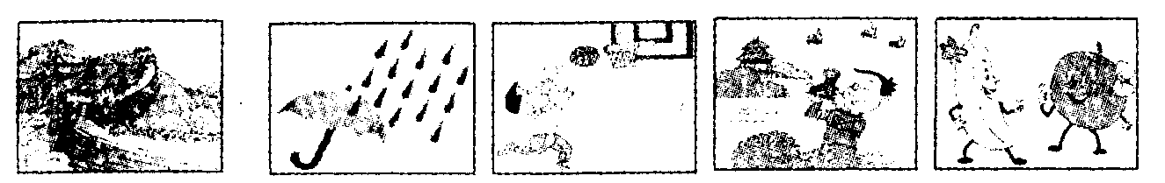
96 97 98 99 100
96. China, be famous for .
97. heavily, last night .
98. Sam, be fond of .
99. we, use cameras to .
100. be good for, health .

VII.选择框格内单词的适当形式填空，每词限用一次。（满分10分）
bring, father，short，look for，far，much，car，without，nothing，because
Almost everyone in the world uses oil in some way. 101 oil, the world will stop, so men 102 it everywhere. Oilmen drill(钻)for oil in deserts, in mountains and under the sea. Quite often they find 103 ，but the search for oil always goes on. Oil is very important 104 none of our machines can run without it. Big ships carry oil everywhere. Perhaps the oil in your 105 car has come from somewhere 106 away. Perhaps it has come from Iraq or some other countries. 107 and buses need oil, and so do many other things. With the help of oil, our world has developed greatly. But it has also 108 us a big problem. If we use too 109 oil, we will be 110 of it one day. Do you think so?
VIII.书面表达（满分15分）

节约能源与环保是当今世界的热点话题，作为一个中学生，你认为应该怎样养成“低碳”生活的习惯，从节约水、电，不乱扔垃圾等小事做事，节约能源。
保护环境。以"Better Habits,Better Environment”为题，用英语写一篇短文，字数80词左右。

2010年福建省南平市中考英语试题参考答案
I . A. 1 〜5 A B B C C
B. 6 〜10 BABCC 11 -15 BABCB 16 〜20 ACBAA
C. 21 -25 B C A A C
D. 26. Canada 27. traveling/travelling 28. second 29. air/plane 30. Friday
11.31 -35 ACAAB 36-40 CACBB
41 -45 C B C B A IH. 46 -50 A B C B G 51 〜55 ACBCA
IV. A. 56 〜60 A B A B B
B. 61 〜65 C A B A C
C. 66 -70 B B A C B 、
D. 71 -75 C C A A B
E. 76. knowledge，minds 77. young, everything
78. books，answers
79. learning/studying, time/lives 80. ourselves, way
V. 81 〜85 DC BE A 86 -90 ABABC
VI. A. 91. angry 92. noise 93. badly 94. teaches
95. their
B. 96. China is famous for the Great Wall.
97. It rained/was raining heavily last night.
98. Sam is/was fond of/playing basketball.
99. We use/can use cameras to take photos/pic¬tures.
100. Fruits/Bananas and/or apples are good for
our/people's health. /
Fruit/Eating fruit is good for our/people's health.
It's good for our/people's health to eat fruits/ apples and bananas.
VII. 101. Without 102. look for/are looking for 103. nothing 104. because 105. father's 106. far 107. Cars 108. brought 109. much 110. short
VIII. 111. One possible version：
Better Habits, Better Environment Everyone hopes to have a better environment. What shall we do for it?
As middle school students，we should do our best to save energy and protect our environ¬ment. It's very important to have good habits in our daily life. We should save water and elec¬tricity by hands. We can also reuse paper and never waste food，or throw litter about. Riding bikes or taking buses is a good way to produce less pollution.
There are many other things we can do，in a word，remember “ Better Habits，Better Environment" .

