2012三明市英语中考

本试卷分第Ⅰ卷(选择题)和第Ⅱ卷(非选择题)两卷，满分100分，考试时间60分
钟，请将答案写在答案专页上。
第Ⅰ卷(选择题，共60分)
一、阅读下列图解，请选出针对该图解最合适的解释：(共5小题；每小题1分)
1
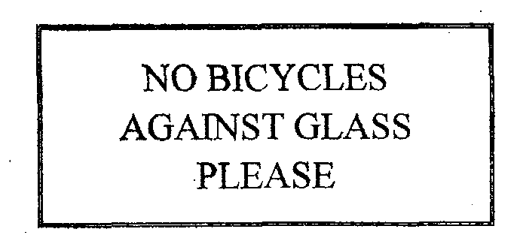
A．Do not leave your bicycles touching
the window．
B．Broken glass may damage your bicycle
tires．
C．Your bicycle may not be safe here．
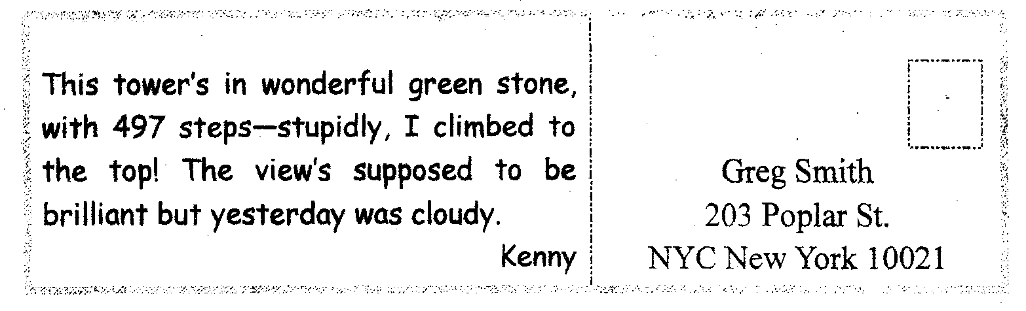
2
What did Kenny like about the tower?
A．The view it gave from the top．
B．The material used to build it，
C．The number of steps it has．
3
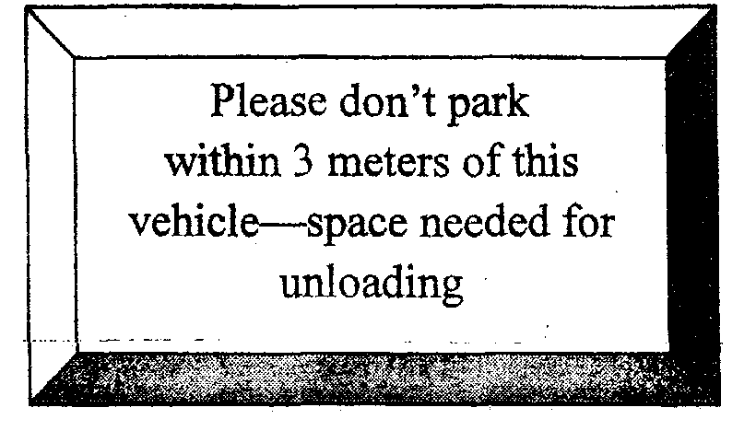
A．You should not park near here
because it is an exit，
B．This parking space is kept for
the Vehicle’S owner；
C．You are asked not to park any
closer than 3 meters to this vehicle．
4
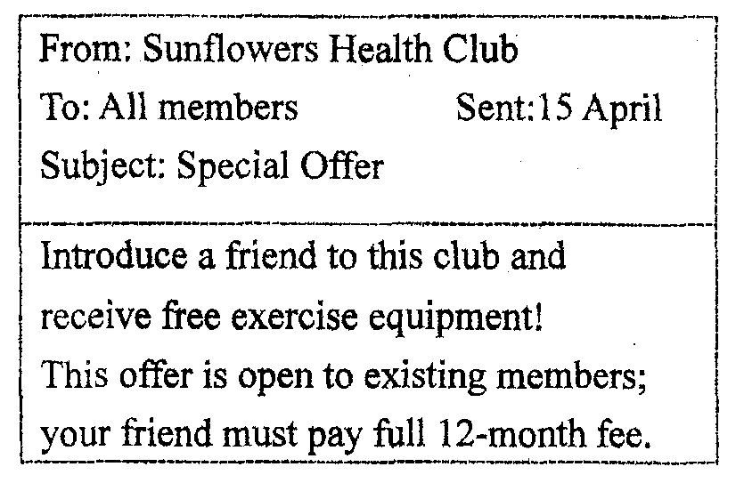
A．Sunflowers is selling exercise
equipment to members at a
special price．
B．You will qualify for a gift if you
persuade a friend to join
Sunflowers．
C．Your yearly fee for Sunflowers
Health Club must be paid now．
5
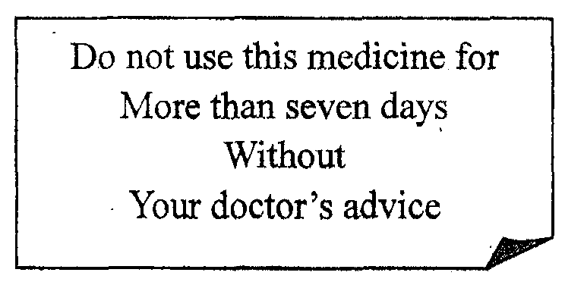
A．Contact your doctor if you wish
to continue using this medicine
after one week．
B．Doctors call only supply enough
medicine for one week at a time．
C．You cannot keep this medicine for
more than seven days．
二、单项选择：(共15小题；每小题1分，满分15分)
6．——Will you be able to finish the{ob t11iS week?
——___________，but I'm not skilled enough，you know．
A．I can’t say so B．I expect so
C．I’m sure so D．I don’t know so
7．——__________________
——No thanks．I'm trying to take off a couple of pounds．
A．Do you need help? B．I could carry that for you．
C．Care for some dessert? D．These cakes are just right．
8．——I can help you with your physics before the exam．
——___________?That sounds great! Thanks ．
A．Could you B．Are you kidding
C．I beg your pardon D．What did you say
9．——We spent all our money because we stayed at ____most expensive hotel in town．
——Why didn’t you stay at________ cheaper one?
A．the．．．．a B．a．．．．a C．the．．．．the D．a．．．．the
10．We all know it’s no use crying_______ spilt milk．
A．over B．about C．on D．to
11．______volleyball is her main focus，she’s also great at basketball．
A．While B．Unless C．Since D．Because
l2．A burning cigarette he threw into the wastepaper basket______ fire to the hotel．
A．made B．set C．caused D．caught
13．He was a wonderful teacher．Everyone agreed it would be hard to find ____like him．
A．another B．other C．the other D．an other
14．The______ boy ate all the cookies without giving any to his sister．
A．greedy B．shy C．outgoing D．creative
15．It______ be very difficult to learn Spanish．
A．shall B．must C．should D．need
16．Cars make it possible for you to reach any place you want．________，a car may present
parking problems in a city．
A．But B．However C．Although D．Therefore
17．Peter, John and Tom each________．
A．say they came first B．says they came first
C．says he came first D．say came first
18．The Boston Marathon_____every April on Patriot’s Day to remember the Battles of
Lexington and Concord．
A．run B．is run C．ran D．has run
l9．________the morning news．many houses on the island were destroyed by the flood．
A．According to B．In addition to
C．In spite of D．In contrast to
20．Which is me best sentence?
A．I've smoked。but I don’t anymore． B．I used to smoke．but I don’t anymore．
C．I smoked．but I don’t anymore． D．I was smoking．but I don’t anymore．
三、完形填空：(共20小题；每小题1分，满分20分)
Even at the age of 75,Thelma was very attractive and full of life．When her husband passed away, her children 21 that she move to a “senior living 22 ．”A friendly and life-loving person，Thelma decided to do so．
Shortly after 23 ．Thelma became a self-made activities director，doing all sorts of things for the people in the community and quickly became very 24 and made many friends.
When Thelma 25 80，her newfound 26 thanked her by 27 ．a surprise birthday party for her．When Thelma entered the dining room for 28 that night，she was 29 by all the members of the community and one of them 30 her to the head table．The 31 was filled with laughter and entertainment，but throughout the evening，Thelma could not take her eyes off 32 at the other end of the table。
When the party ended, 33 quickly rose from her seat and rushed over to the man．“ 34 me，” Thelma said．Please forgive me if I made you feel 35 by staring at you all night．I just couldn’t 36 myself from looking your way．You 37 ，you look just like my 38 husband．”
“Your fifth husband!” replied the gentleman。“Forgive me for asking，but 39 have you been married?”
With that，a 40 came across Thelma’s face as she replied，“Four．”
They were married shortly after。
21．A．ordered B．suggested C．asked D．wished
22．A．society B．community C．house D．neighborhood
23．A．moving in B．coming in C．staying in D．getting in
24．A．10nely B．important C．popular D．happy
25．A．turned B．changed C．got D．grew
26．A．members B．directors C．nurses D．friends
27．A．doing B．taking C．throwing D．giving
28．A．breakfast B．1unch C．tea D．dinner
29．A．stopped B．held C．met D．greeted
30．A．carried B．led C．helped D．told
31．A．night B．day C．people D．friends
32．A．the food B．the cake C．a lady D．a gentleman
33．A．her friend B．the director C．Thelma D．a lady
34．A．Pardon B．Allow C．Let D．Permit
35．A．uneasy B．unlucky C．sorry D．pleased
36．A．let B．help C．make D．find
37．A．see B．hear C．1isten D．understand
38．A．next B．future C．fourth D．fifth
39．A．how much B．how long C．how often D．how many times
40．A．tear B．smile C．、wind D．change
四、阅读理解：(共20小题；每小题1分，满分20分)
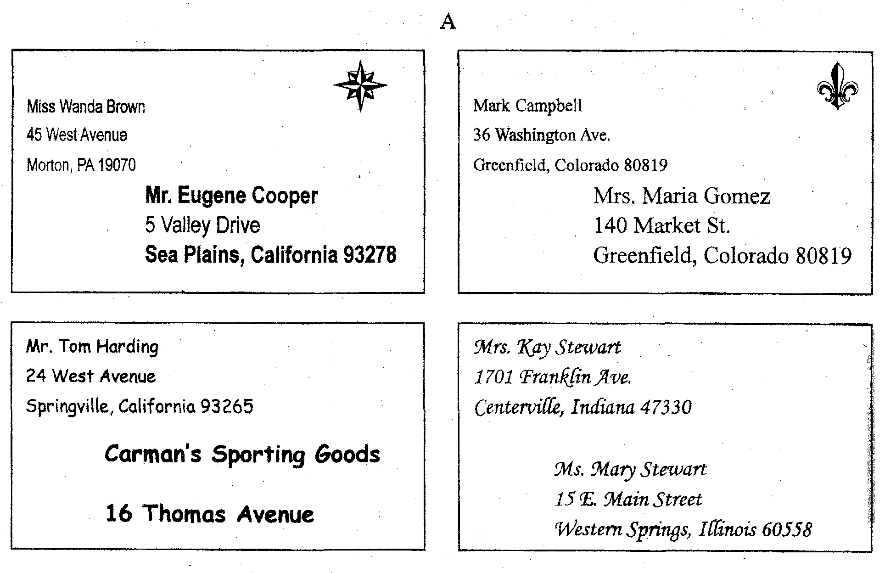
41．How many different states are these letters going to?
A．2． B．4． C．3． D．5．
42．What carl you learn from reading these envelopes?
A．How much it costs to mail letters．
B．When the letters were received．
C．Why the letters need stamps．
D．Where the letters are going。
43．Which is Ms．Mary Stewart’s street address?
A．140 Market Street． B．36 Washington Avenue．
C．15 E．Main Street． D．5 Valley Drive．
44．Who might be ordering a baseball glove?
A．Eugene Cooper． B．Mark Campbell．
C．Kay Stewart． D．Tom Harding．
45．Which word means the same as Avenue?
A．Main， B．West ． C．Street． D．Valley．

B
The day I got home from the hospital，my plaster cast was pure white．It went from my wrist to my shoulder, and every time I looked at it I felt creepy．It finally hit me that I had a broken arm．
My best friend、Rita，was the first person to visit me．As soon as she saw my all．white cast，she wanted to write On it．She drew a huge RITA straight down my arm in four colors。When my friend Bob saw how big Rita had written her name．he decided to outdo her．He wrote ROBERT E．RAFFIERT0 in letters three times the size of Rita’s．
Betsy thought Bob and Rita had the wrong idea，so she wrote her signature in tiny letters near my elbow．Esma called Rita，Bob and Betsy copycats．“All they wanted to do was sign their names，”she said as she wrote a poem．
The next day, I met Larry and Eduardo on the way to school．Larry found some space on my cast to write，GET WELL SOON．Eduardo wrote，sound SOFTBALL TEAM MISSED YOU．After many days there was no room left Oil my cast．
And then a funny thing happened．When I read all the names and notes on my cast．I was no longer sad about my broken arm．I was reminded of the wonderful friends I have．
46．This story is about_________．
A．someone who liked to wear a cast
B．someone who broke a leg
C．people who signed a friend’s cast
D．people who work in a hospital
47．What did Esma write on the cast?
A．A poem． B．Her name in big letters。
C．Her name in tiny letters． D．Get well soon．
48．After wearing the cast for several days，the person who tells the story is ______
A．excited to take it off
B．happy to have good friends who care
C．sad to have a broken arm
D．angry with everyone who wrote on it
49．What is a signature?
A．A written name． B．A word on a cast．
C．A tiny story． D．A word with many letters．

C

WESTWAY SCOUTS NEWSLETTER
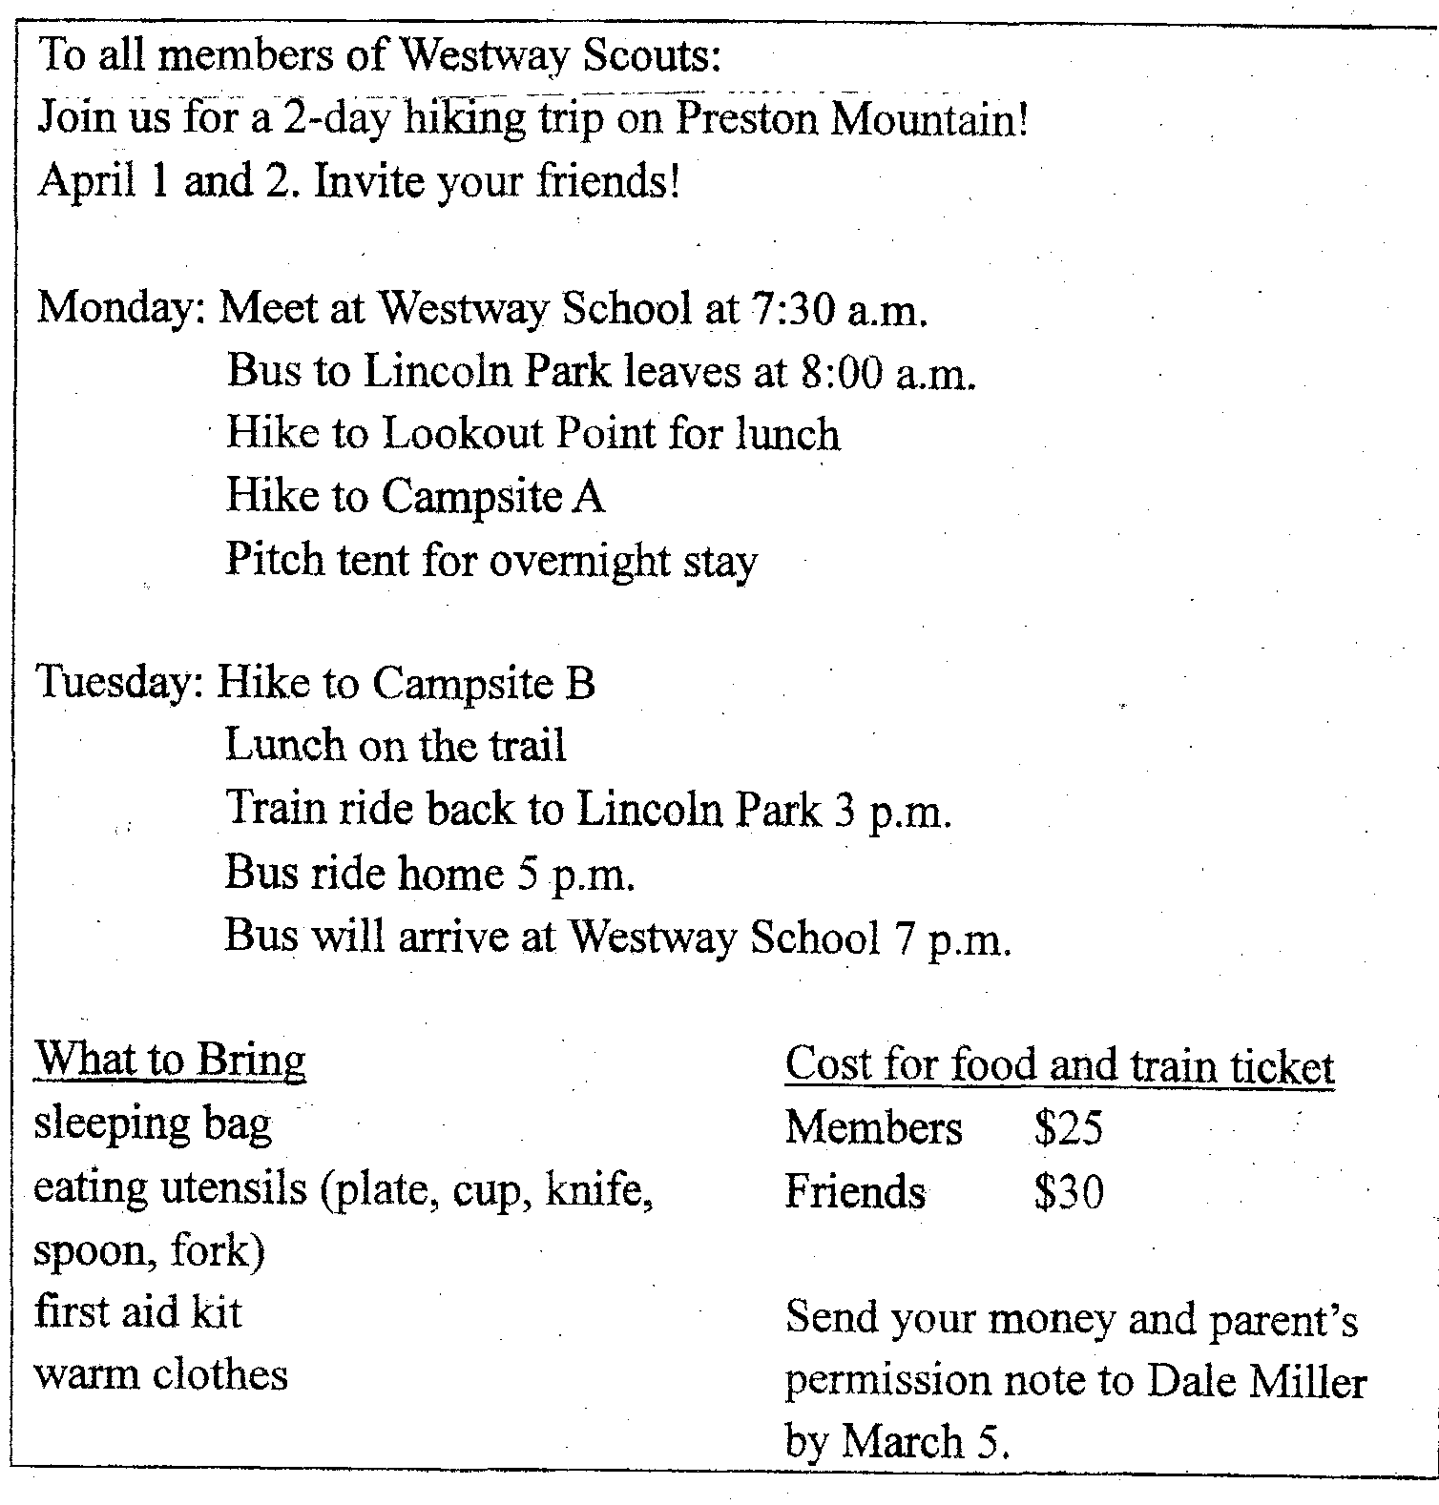
50．Why are the Scouts going on the trip?
A．To meet other Scouts． B．To ride on a train．
C．To learn to cook on the trail． D．To learn about hiking．
51．What will the group do on Tuesday?
A．Meet at Westway School． B．Go to Lookout Point．
C．Go to Campsite B． D．Pitch a tent．
52．The weather is likely to be______________．
A．cool B．hot C．mild D．sunny
53．In this newsletter, utensils are things_______ ．
A．to eat B．to eat with C．to wear D．for washing

D
“Aunt Vicki, we’ve been driving for six hours now．My head hurts，and my stomach is screaming for food．”I shouted.
“I'm hungry, too，”Aunt Vicki said，“Look for a sign for a restaurant．Any restaurant will do．I don’t care what kind of food we eat now．”
For a while，Aunt Vicki and I enjoyed the sights on this quiet road to San Antonio，Texas．But looking at the flat land，covered with oil wells，soon tired us．
I felt myself getting skinnier by the minute and was just wondering how my baseball cap would taste．Then Aunt Vicki yelled，“A sign．Read that sign! There’s a restaurant ahead．”RICARDO’S．THE BEST FOOD IN THE SOUTHWEST．TEN MILES AHEAD．My mouth watered as I stared at a picture of crisp fried chicken，golden French fries and juicy burgers．
We drove silently for another five miles．Then another sign appeared：101 FLAVORS OF ICE CREAM AT RICARDO’S．DON’T MISS IT!“I can’t wait to have a huge banana split。I can almost eat the sign，”I said excitedly．
It wasn’t long before another sign appeared：YOU HAVE JUST PASSED RICARDO’S．Our smiles turned to frowns as we looked back．There was a small，white building with a sign hung on the door：RICARDO’S．CLOSED FOR VACATl0N．
54．Which is the best title for this story?
A．A Summer Vacation． B．The Hungry Travelers．
C．Texas Restaurants． D．A Meal at Ricardo’s．
55．On the roads in Texas，they found_________。
A．buildings and people B．few places to eat
C．mountains and lakes D．fields of corn
56．When your mouth waters, you want to _______．
A．drink B．eat C．brush your teeth D．go to sleep

E

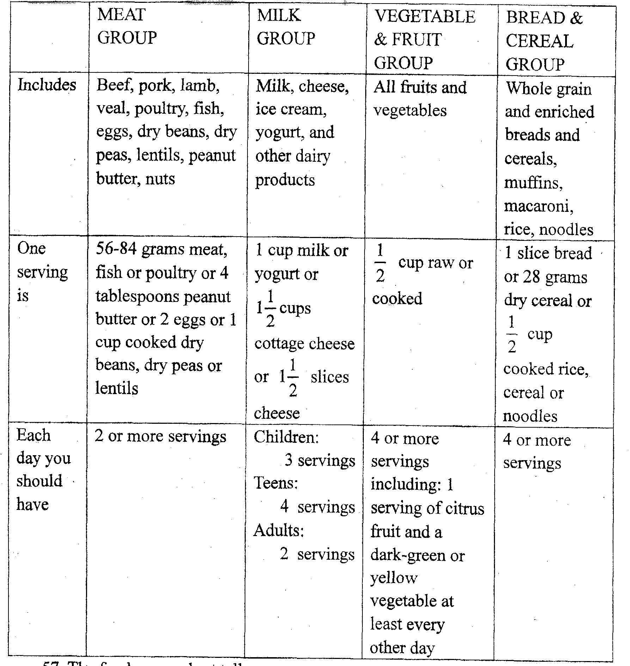

Your diet is made up of the food you eat．Food contains things that your body needs to grow and stay strong．For example，milk arid other dairy products have calcium which helps build strong bones and teeth．If you eat some foods from each group every day, you should have a healthy, balanced diet．
57．The food group chart tells you_________ ．
A．what to eat daily B．when to eat dinner
C．how to cook food D．how much food costs
58．Eating too much from one food group for a long time might________．
A．be good for you B．not be healthy
C．make you stronger D．make you hungry
59．What is a diet?
A The foods that are bad for you． B．Milk and fruit．
C．The foods you like． D．The foods you eat．
60．What does“balanced”mean in this passage?
A．Not falling over． B．Some foods from each group．
C．Too much food． D．How much you eat every day．

第Ⅱ卷(非选择题，共40分)
五、单词拼写：(共10小题；每小题1分，满分10分)
61．It suddenly o_________ to me that I had no money with me．
62．Tom is a very naughty boy and is certainly b________ my control．
63．Do you want a large, r_______ or small coke to go with your hamburger?
64．I'm t_______ sorry! Did I hurt you?
65．Sir, the total price is$26。74，I________ tax．
66．It’s best not to get_______ in other people’s private affairs．(卷入)
67．If you don’t______ at first，try, try, and try again．(成功)
68．We’11 have dinner at a__________ Italian Cafe tonight．(典型的)
69．Morn is busy preparing dinner in the _________．(厨房)
70．It is said that a cow has four____________．(胃)
六、阅读下面短文，根据空格中所给的首字母在空白处填入适当的单词。
使短文语义完整，每空一词：(共10小题；每小题1分，满分10分)
You know that the earth turns．This makes day change to night．Here is a story about how the earth began to turn。
L_______(71)ago，the world did not turn．One side always faced the s_________(72) ．It was always day there．The day side was hot and dry．P________(73)there lived underground to keep cool．The other side never saw the sun at all．The night side was dark and windy．People there were always cold．
Then a w________(74)woman of the night people had an i______(75)．She called day people and night people together．They met oil the night side of the world．
The woman said：“M_________(76)makes us want to dance．Maybe music will make the earth want to move，” So the people got harps and horns and drums．They p ______(77)music．Some of them danced in a big circle．
Then they heard a noise．They felt something move u_______(78)their feet．The earth was starting to turn。The sky got lighter．It was the f__________(79)sunrise．
Now both sides of the earth have day and night．Both sides have sunrises and s___________(80)．

七、完成句子：(共10小题；每小题2分，满分20分)
81．今天轮到谁做晚饭了?
_______________________________ to cook dinner tonight?
82．很抱歉来晚了，我们的车在路上坏了。
Sorry we are late，but__________________________________________________
83．剧烈的头疼要把他给逼疯了。
He_____________________________ by a splitting headache．
84．我希望你来做最后的决定。
I’d like you ______________________________．
85．他越等越不耐烦了。
The longer he waited，_______________________________________．
86．为了保持健康，就有必要进行体育锻炼。
It is necessary______________________________________________．
87．你知道天气是如何影响我们的情绪的吗?
Do you know how __________________________________________?
88．你每天服这个药两次，不久你的病就会好的。
__________________________________，and you will be well
89．我到昨天才知道了那个秘密。
I knew nothing____________________________________________．
90．很久以后我才又睡着。
It was a long time__________________________________________．

