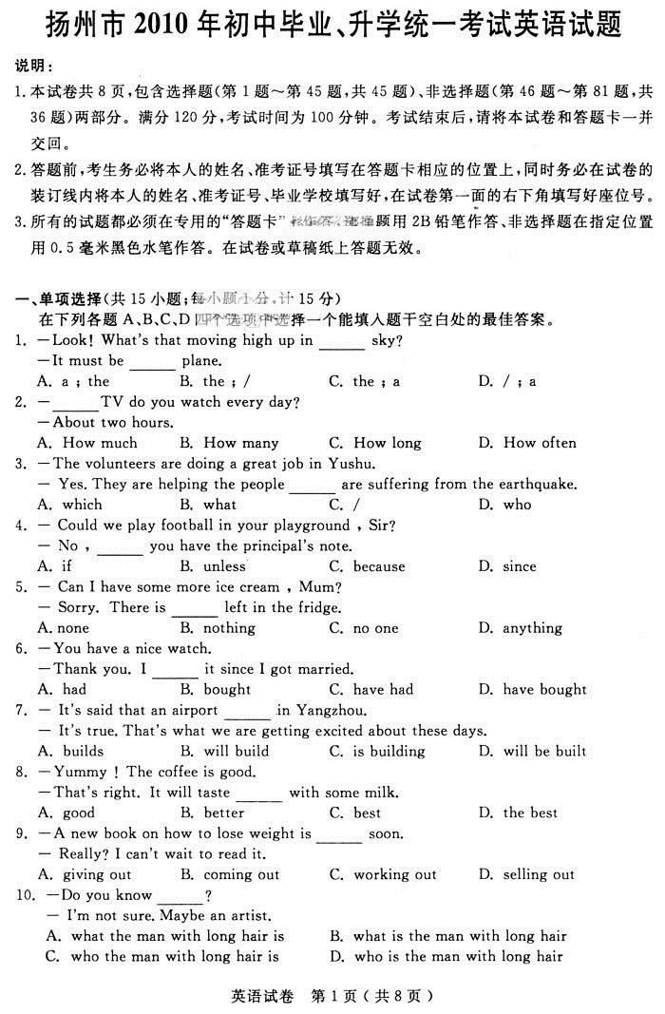
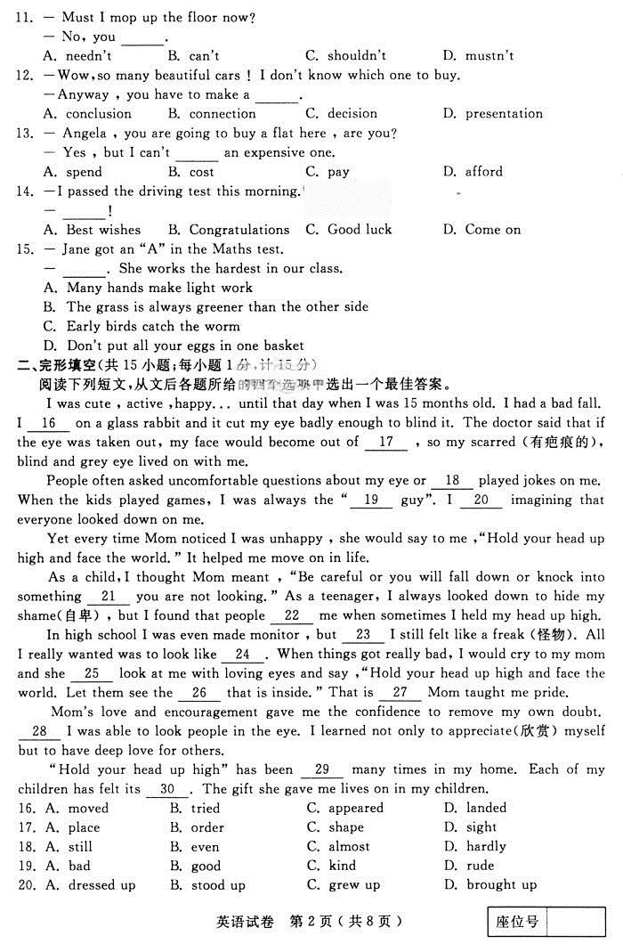
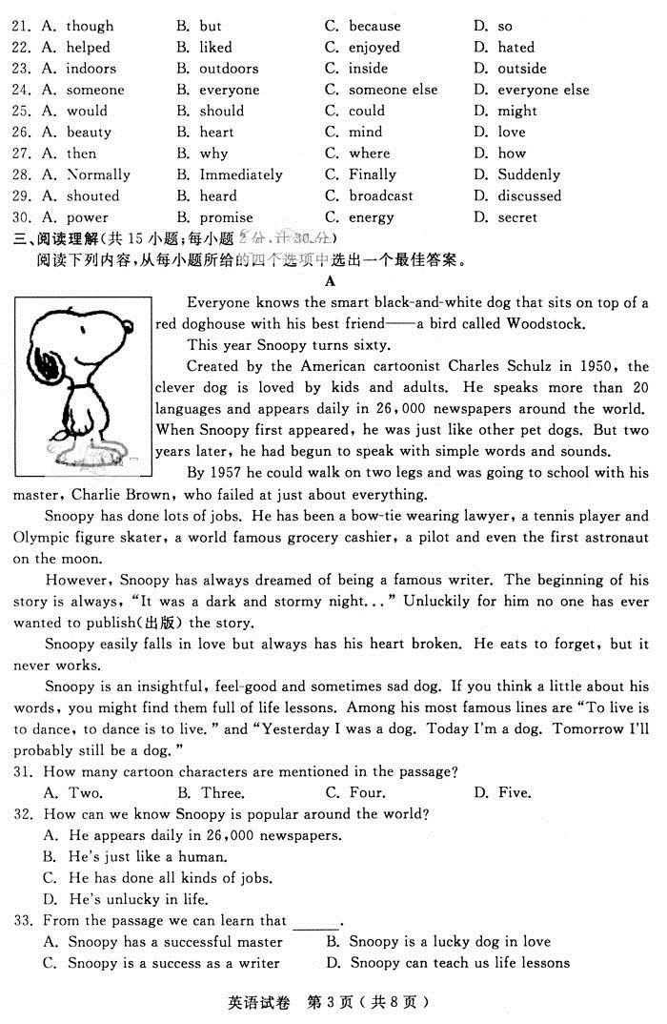
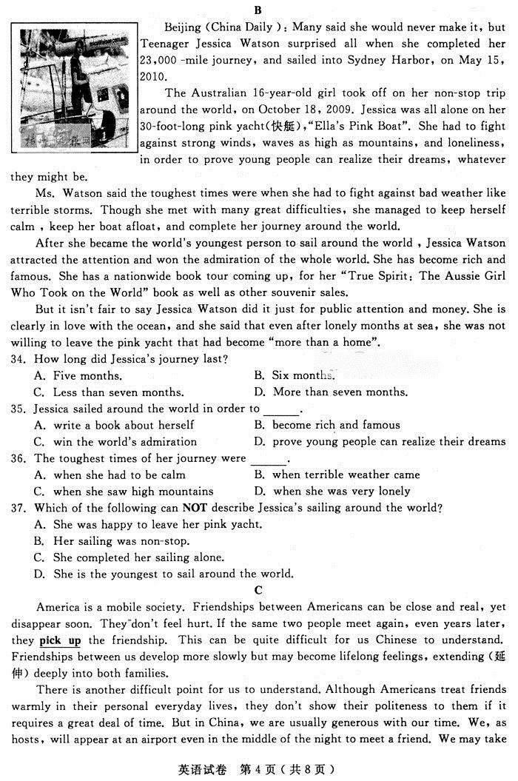
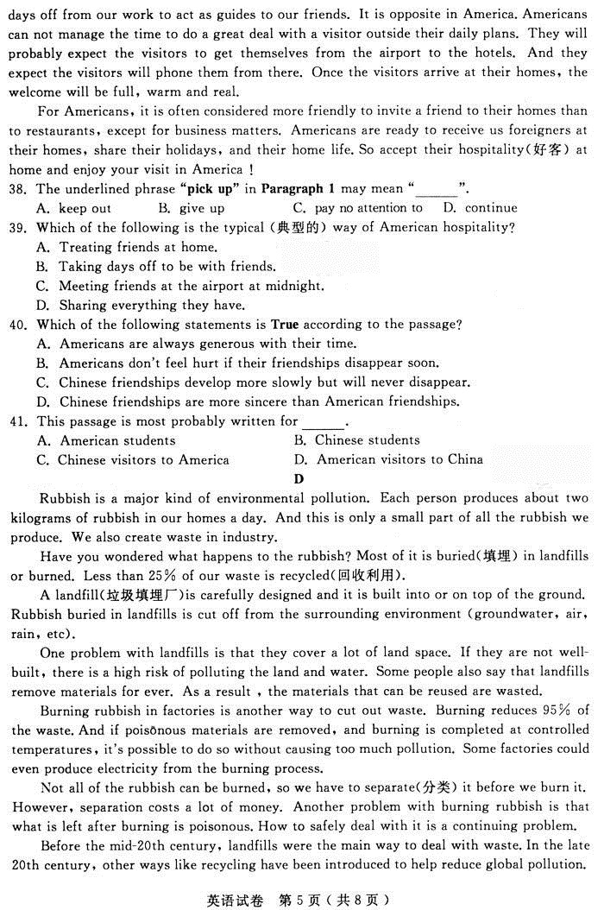
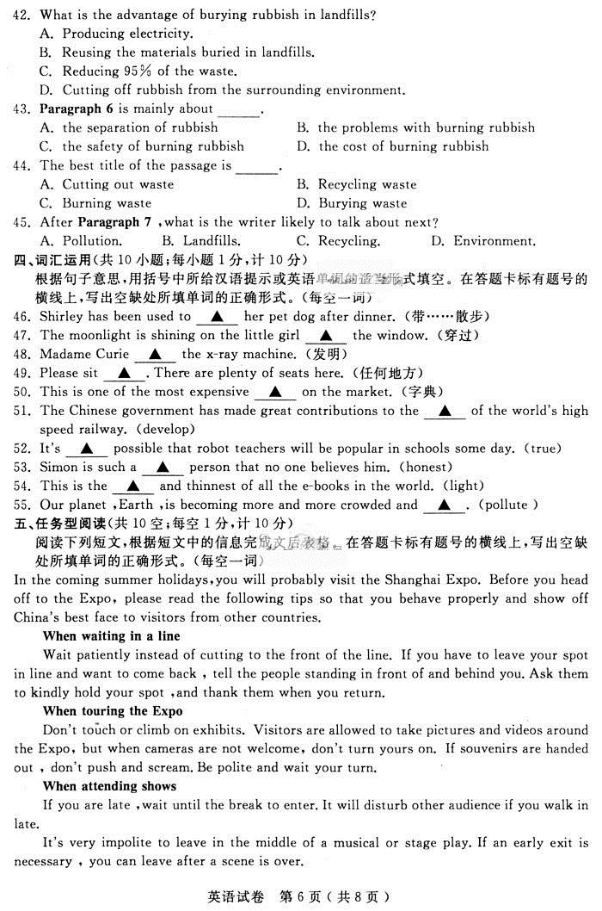
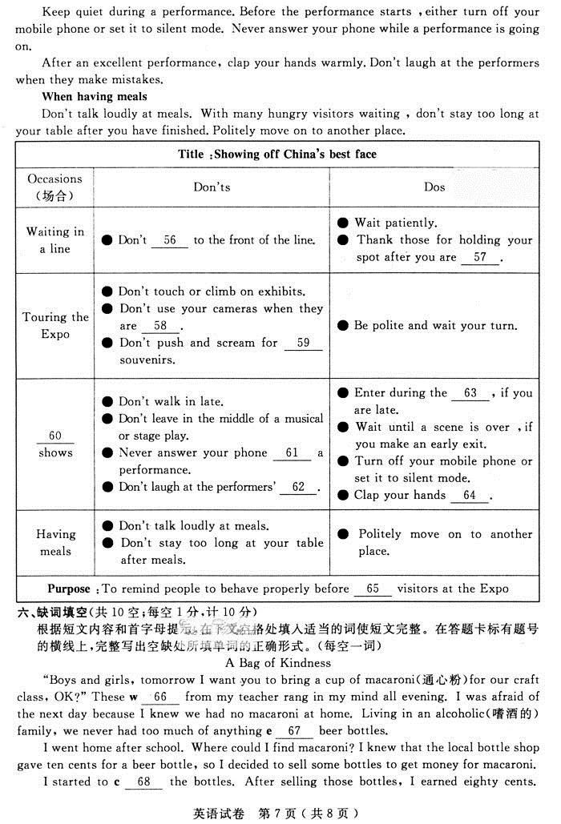
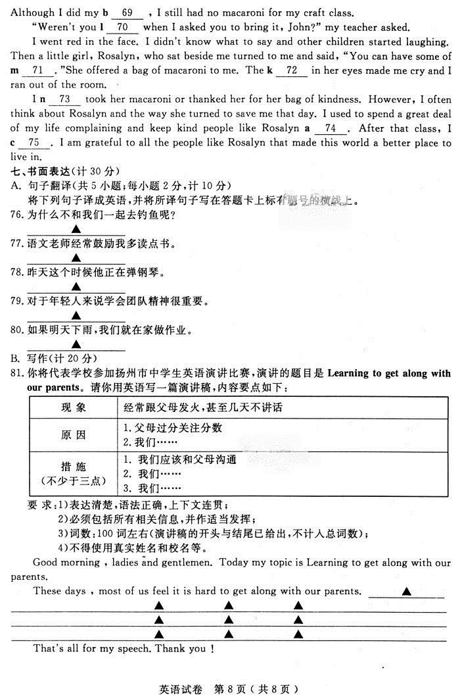

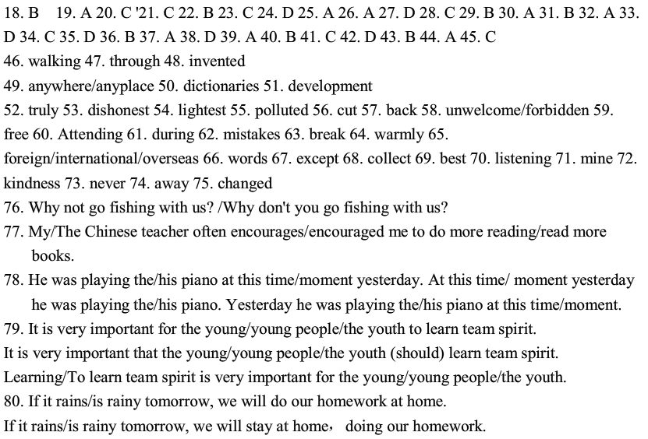
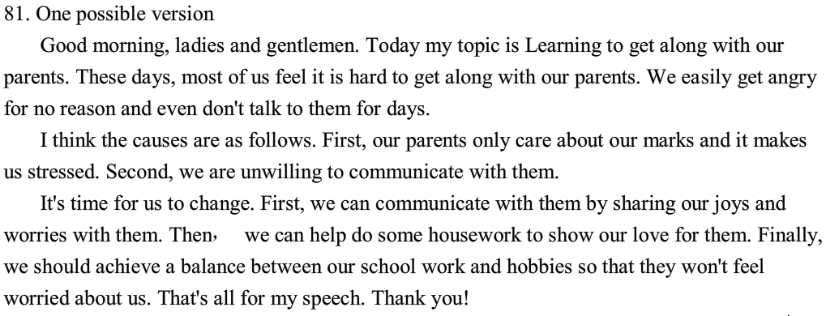

扬州市2010年初中毕业、升学统一考试英语试题
说明：
1.本试卷共8页，包含选择题（第1题～第45题，共45题）、非选择题（第46题～第81题，共36题）两部分。满分120分，考试时间为100分钟。考试结束后，请将本试卷和答题卡一并交回。
2.答题前，考生务必将本人的姓名、准考证号填写在答题卡相应的位置上，同时务必在试卷的装订线内将本人的姓名、准考证号、毕业学校填写好，在试卷第一面的右下角填写好座位号。
3.所有的试题都必须在专用的“答题卡”上作答，选择题用2B铅笔作答、非选择题在指定位置用0.5毫米黑色水笔作答。在试卷或草稿纸上答题无效。

一、单项选择（共15小题；每小题l分，计15分）
在下列各题A、B、C、D四个选项中选择一个能填入题干空白处的最佳答案。
1. —Look! What’s that moving high up in ___________ sky ?
—It must be ___________ plane .
A . a ; the B. the ; / C. the ; a D. / ; a
2. —___________TV do you watch every day ?
—About two hours .
A. How much B . How many C. How long D. How often
3. —The volunteers are doing a great job in Yushu.
— Yes .They are helping the people___________ are suffering from the earthquake.
A. which B. what C. / D . who
4. — Could we play football in your playground , Sir ?
— No , ___________ you have the principal’s note.
A. if B. unless C. because D. since
5. — Can I have some more ice cream , Mum ?
— Sorry. There is ___________ left in the fridge .
A .none B .nothing C. no one D. anything
6. —You have a nice watch .
—Thank you . I ___________ it since I got married .
A. had B. bought C .have had D .have bought
7. — It’s said that an airport ___________ in Yangzhou.
— It’s true .That’s what we are getting excited about these days.
A. builds B. will build C. is building D. will be built
8. —Yummy ! The coffee is good .
—That’s right . It will taste ___________ with some milk.
A. good B. better C. best D. the best
9. —A new book on how to lose weight is___________ soon .
— Really ? I can’t wait to read it.
A. giving out B. coming out C. working out D. selling out
10. —Do you know___________?
— I’m not sure .Maybe an artist .
A .what the man with long hair is B. what is the man with long hair
C. who the man with long hair is D. who is the man with long hair
11. — Must I mop up the floor now ?
— No, you ___________ .
A. needn’t B. can’t C . shouldn’t D. mustn’t
12. —Wow，so many beautiful cars !I don’t know which one to buy .
—Anyway , you have to make a ___________.
A. conclusion B. connection C. decision D. presentation
13. — Angela , you are going to buy a flat here , are you ?
— Yes , but I can’t ___________ an expensive one .
A. spend B. cost C. pay D. afford
14. —I passed the driving test this morning.
— ___________!
A. Best wishes B. Congratulations C. Good luck D. Come on
15. — Jane got an “A” in the Maths test .
— ___________. She works the hardest in our class .
A. Many hands make light work B. The grass is always greener than the other side
C .Early birds catch the worm D. Don’t put all your eggs in one basket
二、完形填空（共15小题；每小题l分，计15分）
阅读下列短文，从文后各题所给的四个选项中选出一个最佳答案。
I was cute , active ,happy… until that day when I was 15 months old. I had a bad fall .I 16 on a glass rabbit and it cut my eye badly enough to blind it. The doctor said that if the eye was taken out, my face would become out of 17 , so my scarred (有疤痕的), blind and grey eye lived on with me.
People often asked uncomfortable questions about my eye or 18 played jokes on me. When the kids played games, I was always the “ 19 guy”. I 20 imagining that everyone looked down on me.
Yet every time Mom noticed I was unhappy , she would say to me ,“Hold your head up high and face the world.” It helped me move on in life .
As a child，I thought Mom meant , “Be careful or you will fall down or knock into something 21 you are not looking.” As a teenager, I always looked down to hide my shame(自卑) , but I found that people 22 me when sometimes I held my head up high.
In high school I was even made monitor , but 23 I still felt like a freak (怪物). All I really wanted was to look like 24 . When things got really bad, I would cry to my mom and she 25 look at me with loving eyes and say ,“Hold your head up high and face the world. Let them see the 26 that is inside.” That is 27 Mom taught me pride.
Mom’s love and encouragement gave me the confidence to remove my own doubt . 28 I was able to look people in the eye . I learned not only to appreciate (欣赏)myself but to have deep love for others.
“Hold your head up high” has been 29 many times in my home. Each of my children has felt its 30 . The gift she gave me lives on in my children.
16. A. moved B. tried C. appeared D. landed
17. A. place B .order C . shape D .sight
18. A .still B. even C. almost D. hardly
19. A. bad B . good C. kind D. rude
20. A. dressed up B. stood up C. grew up D. brought up
21. A. though B. but C. because D. so
22. A. helped B . liked C . enjoyed D . hated
23. A. indoors B . outdoors C . inside D . outside
24. A. someone B . everyone C .someone else D. everyone else
25. A .would B .should C. could D. might
26. A. beauty B. heart C . mind D. love
27. A. then B. why C. where D. how
28. A. Normally B .Immediately C. Finally D. Suddenly
29. A. shouted B . heard C. broadcast D. discussed
30. A .power B .promise C .energy D. secret
三、阅读理解（共l5小题；每小题2分，计30分）
阅读下列内容，从每小题所给的四个选项中选出一个最佳答案。
A

Everyone knows the smart black-and-white dog that sits on top of a red doghouse with his best friend –– a bird called Woodstock.
This year Snoopy turns sixty.
Created by the American cartoonist Charles Schulz in 1950, the clever dog is
loved by kids and adults. He speaks more than 20 languages and appears daily in
26,000 newspapers around the world . When Snoopy first appeared, he was just
like other pet dogs. But two years later, he had begun to speak with simple words
and sounds.
By 1957 he could walk on two legs and was going to school with his master, Charlie Brown, who failed at just about everything.
Snoopy has done lots of jobs. He has been a bow-tie wearing lawyer, a tennis player and Olympic figure skater, a world famous grocery cashier, a pilot and even the first astronaut on the moon.
However, Snoopy has always dreamed of being a famous writer. The beginning of his story is always，“It was a dark and stormy night…” Unluckily for him no one has ever wanted to publish（出版） the story.
Snoopy easily falls in love but always has his heart broken. He eats to forget, but it never works.
Snoopy is an insightful , feel-good and sometimes sad dog. If you think a little about his words, you might find them full of life lessons. Among his most famous lines are “To live is to dance, to dance is to live.” and “Yesterday I was a dog. Today I’m a dog. Tomorrow I’ll probably still be a dog.”
31.How many cartoon characters are mentioned in the passage ?
A. Two. B. Three. C. Four. D. Five.
32.How can we know Snoopy is popular around the world？
A. He appears daily in 26,000 newspapers. B. He’s just like a human.
C. He has done all kinds of jobs. D. He’s unlucky in life .
33. From the passage we can learn that ____________.
A .Snoopy has a successful master B . Snoopy is a lucky dog in love
C .Snoopy is a success as a writer D . Snoopy can teach us life lessons
B
Beijing (China Daily ): Many said she would never make it, but Teenager Jessica Watson surprised all when she completed her 23,000 -mile journey, and sailed into Sydney Harbor, on May 15, 2010.

The Australian 16-year-old girl took off on her non-stop trip around the world, on October 18, 2009 . Jessica was all alone on her 30-foot-long pink yacht（快艇）,“Ella’s Pink Boat”. She had to fight against strong winds, waves as high as mountains, and loneliness, in order to prove young people can realize their dreams, whatever they might be.
Ms. Watson said the toughest times were when she had to fight against bad weather like terrible storms. Though she met with many great difficulties, she managed to keep herself calm , keep her boat afloat, and complete her journey around the world.
After she became the world’s youngest person to sail around the world , Jessica Watson attracted the attention and won the admiration of the whole world .She has become rich and famous. She has a nationwide book tour coming up, for her “True Spirit: The Aussie Girl Who Took on the World” book as well as other souvenir sales.
But it isn’t fair to say Jessica Watson did it just for public attention and money .She is clearly in love with the ocean, and she said that even after lonely months at sea, she was not willing to leave the pink yacht that had become “more than a home”.
34.How long did Jessica’s journey last ?
A. Five months. B. Six months.
C .Less than seven months. D. More than seven months.
35. Jessica sailed around the world in order to____________.
A. write a book about herself B. become rich and famous
C. win the world’s admiration D. prove young people can realize their dreams
36. The toughest times of her journey were ____________.
A . when she had to be calm B . when terrible weather came
C . when she saw high mountains D . when she was very lonely
37.Which of the following can NOT describe Jessica’s sailing around the world ?
A . She was happy to leave her pink yacht. B. Her sailing was non-stop.
C. She completed her sailing alone . D .She is the youngest to sail around the world.
C
America is a mobile society. Friendships between Americans can be close and real, yet disappear soon. They don’t feel hurt .If the same two people meet again, even years later, they pick up the friendship. This can be quite difficult for us Chinese to understand. Friendships between us develop more slowly but may become lifelong feelings, extending (延伸) deeply into both families.
There is another difficult point for us to understand .Although Americans treat friends warmly in their personal everyday lives, they don’t show their politeness to them if it requires a great deal of time. But in China, we are usually generous with our time. We, as hosts, will appear at an airport even in the middle of the night to meet a friend. We may take days off from our work to act as guides to our friends. It is opposite in America .Americans can not manage the time to do a great deal with a visitor outside their daily plans. They will probably expect the visitors to get themselves from the airport to the hotels. And they expect the visitors will phone them from there. Once the visitors arrive at their homes, the welcome will be full, warm and real.
For Americans, it is often considered more friendly to invite a friend to their homes than to restaurants, except for business matters. Americans are ready to receive us foreigners at their homes, share their holidays, and their home life .So accept their hospitality(好客) at home and enjoy your visit in America !
38.The underlined phrase “pick up” in Paragraph 1 may mean “____________”.
A .keep out B. give up C. pay no attention to D. continue
39. Which of the following is the typical (典型的) way of American hospitality ?
A .Treating friends at home. B .Taking days off to be with friends .
C. Meeting friends at the airport at midnight. D. Sharing everything they have.
40. Which of the following statements is True according to the passage?
A. Americans are always generous with their time.
B. Americans don’t feel hurt if their friendships disappear soon .
C. Chinese friendships develop more slowly but will never disappear.
D. Chinese friendships are more sincere than American friendships .
41.This passage is most probably written for____________ .
A .American students B .Chinese students
C. Chinese visitors to America D. American visitors to China
D
Rubbish is a major kind of environmental pollution. Each person produces about two kilograms of rubbish in our homes a day. And this is only a small part of all the rubbish we produce. We also create waste in industry.
Have you wondered what happens to the rubbish? Most of it is buried(填埋) in landfills or burned. Less than 25% of our waste is recycled(回收利用).
A landfill（垃圾填埋厂）is carefully designed and it is built into or on top of the ground. Rubbish buried in landfills is cut off from the surrounding environment (groundwater, air, rain, etc).
One problem with landfills is that they cover a lot of land space. If they are not well-built, there is a high risk of polluting the land and water. Some people also say that landfills remove materials for ever. As a result , the materials that can be reused are wasted .
Burning rubbish in factories is another way to cut out waste. Burning reduces 95% of the waste .And if poisonous materials are removed, and burning is completed at controlled temperatures, it’s possible to do so without causing too much pollution. Some factories could even produce electricity from the burning process.
Not all of the rubbish can be burned, so we have to separate(分类) it before we burn it. However, separation costs a lot of money. Another problem with burning rubbish is that what is left after burning is poisonous .How to safely deal with it is a continuing problem.
Before the mid-20th century, landfills were the main way to deal with waste .In the late 20th
century, other ways like recycling have been introduced to help reduce global pollution.
42.What is the advantage of burying rubbish in landfills?
A. Producing electricity. B. Reusing the materials buried in landfills.
C. Reducing 95% of the waste. D. Cutting off rubbish from the surrounding environment.
43. Paragraph 6 is mainly about____________.
A. the separation of rubbish B. the problems with burning rubbish
C .the safety of burning rubbish D. the cost of burning rubbish
44. The best title of the passage is____________.
A . Cutting out waste B . Recycling waste C .Burning waste D. Burying waste
45. After Paragraph 7 ,what is the writer likely to talk about next ?
A. Pollution. B. Landfills. C. Recycling. D. Environment.
四、词汇运用（共l0小题；每小题l分，计l0分）
根据句子意思，用括号中所给汉语提示或英语单词的适当形式填空。在答题卡标有题号的横线上，写出空缺处所填单词的正确形式。（每空一词）
46. Shirley has been used to ▲ her pet dog after dinner. (带……散步)
47. The moonlight is shining on the little girl ▲ the window . (穿过)
48. Madame Curie ▲ the x-ray machine . (发明)
49. Please sit ▲ .There are plenty of seats here . (任何地方)
50. This is one of the most expensive ▲ on the market. (字典)
51. The Chinese government has made great contributions to the ▲ of the world’s
high speed railway . (develop)
52. It’s ▲ possible that robot teachers will be popular in schools some day. (true)
53. Simon is such a ▲ person that no one believes him. (honest)
54. This is the ▲ and thinnest of all the e-books in the world. (light)
55.Our planet ,Earth ,is becoming more and more crowded and ▲ . (pollute )
五、任务型阅读（共l0空；每空l分，计l0分）
阅读下列短文，根据短文中的信息完成文后表格。在答题卡标有题号的横线上，写出空缺处所填单词的正确形式。（每空一词）
In the coming summer holidays，you will probably visit the Shanghai Expo. Before you head off to the Expo, please read the following tips so that you behave properly and show off China’s best face to visitors from other countries.
When waiting in a line
Wait patiently instead of cutting to the front of the line. If you have to leave your spot in line and want to come back , tell the people standing in front of and behind you .Ask them to kindly hold your spot ,and thank them when you return .
When touring the Expo
Don’t touch or climb on exhibits . Visitors are allowed to take pictures and videos around the Expo, but when cameras are not welcome, don’t turn yours on . If souvenirs are handed out , don’t push and scream .Be polite and wait your turn .
When attending shows
If you are late ,wait until the break to enter .It will disturb other audience if you walk in late.
It’s very impolite to leave in the middle of a musical or stage play .If an early exit is necessary , you can leave after a scene is over.
Keep quiet during a performance .Before the performance starts ,either turn off your mobile phone or set it to silent mode. Never answer your phone while a performance is going on .
After an excellent performance, clap your hands warmly .Don’t laugh at the performers when they make mistakes.
When having meals
Don’t talk loudly at meals. With many hungry visitors waiting , don’t stay too long at your table after you have finished .Politely move on to another place.
Title ：Showing off China’s best face
Occasions  (场合) | Don’ts | Dos
Waiting in a  line | ● Don’t 56 to the front of the line. | ● Wait patiently.  ● Thank those for holding your spot after you are 57 .
Touring  the Expo | ● Don’t touch or climb on exhibits.  ● Don’t use your cameras when they are 58 .  ● Don’t push and scream for 59  souvenirs . | ●Be polite and wait your turn.
60 shows | ● Don’t walk in late.  ● Don’t leave in the middle of a musical  or stage play .  ● Never answer your phone 61  a performance .  ● Don’t laugh at the performers’ 62 . | ● Enter during the 63 , if you  are late.  ● Wait until a scene is over ,if you  make an early exit.  ● Turn off your mobile phone or  set it to silent mode .  ● Clap your hands 64 .
Having meals | ● Don’t talk loudly at meals.  ● Don’t stay too long at your table after meals. | ● Politely move on to another  place.
Purpose :To remind people to behave properly before 65 visitors at the Expo
六、缺词填空（共10空；每空l分，计l0分）
根据短文内容和首字母提示，在下文空格处填入适当的词使短文完整。在答题卡标有题号的横线上，写出空缺处各单词的正确形式。（每空一词）
A Bag of Kindness
“Boys and girls, tomorrow I want you to bring a cup of macaroni（通心粉）for our craft class, OK ?” These w 66 from my teacher rang in my mind all evening. I was afraid of the next day because I knew we had no macaroni at home. Living in an alcoholic(嗜酒的)family, we never had too much of anything e 67 beer bottles.
I went home after school. Where could I find macaroni? I knew that the local bottle shop gave ten cents for a beer bottle, so I decided to sell some bottles to get money for macaroni.
I started to c 68 the bottles. After selling those bottles, I earned eighty cents. Although I did my b 69 , I still had no macaroni for my craft class.
“Weren’t you l 70 when I asked you to bring it, John?” my teacher asked.
I went red in the face. I didn’t know what to say and other children started laughing. Then a little girl, Rosalyn, who sat beside me turned to me and said, “You can have some of m 71 .”She offered a bag of macaroni to me. The k 72 in her eyes made me cry and I ran out of the room .
I n 73 took her macaroni or thanked her for her bag of kindness. However, I often think about Rosalyn and the way she turned to save me that day. I used to spend a great deal of my life complaining and keep kind people like Rosalyn a 74 . After that class, I c 75 . I am grateful to all the people like Rosalyn that made this world a better place to live in.
七、书面表达（计30分）
A. 句子翻译(共5小题；每小题2分，计10分)
将下列句子译成英语，并将所译句子写在答题卡上标有题号的横线上。
76.为什么不和我们一起去钓鱼呢？
▲
77.语文老师经常鼓励我多读点书。
▲
78.昨天这个时候他正在弹钢琴。
▲
79.对于年轻人来说学会团队精神很重要。
▲
80.如果明天下雨，我们就在家做作业。
▲
B. 写作（计20分）
81.你将代表学校参加扬州市中学生英语演讲比赛，演讲的题目是Learning to get along with our parents。请你用英语写一篇演讲稿，内容要点如下：
现 象 | 经常跟父母发火，甚至几天不讲话
原 因 | 1. 父母过分关注分数  2. 我们……
措 施  （不少于三点） | 1. 我们应该和父母沟通  2. 我们……  3. 我们……
要 求：1）表达清楚，语法正确，上下文连贯；
2）必须包括所有相关信息，并作适当发挥；
3）词数：100词左右（演讲稿的开头与结尾已给出，不计入总词数）；
4）不得使用真实姓名和校名等。
Good morning , ladies and gentlemen. Today my topic is Learning to get along with our parents .
These days , most of us feel it is hard to get along with our parents . ▲
▲ ▲ ▲
▲ ▲ ▲
▲ ▲ ▲
That’s all for my speech .Thank you !

扬州市2010年初中毕业、升学统一考试英语试题
参考答案及评分标准
说明：1、各阅卷点按本细则要求统一标准，不得擅自改动；
2、此评分细则不得上网外传。
一、单项选择（共15小题；每小题l分，计15分）
1-5 CADBA 6-10 CDBBA 11-15 ACDBC
二、完形填空（共15小题；每小题l分，计15分）
16-20 DCBAC 21-25 CBCDA 26-30 ADCBA
三、阅读理解（共l5小题；每小题2分，计30分）
31-33 BAD 34-37CDBA 38-41 DA BC 42-45 DBAC
四、词汇运用（共l0小题；每小题l分，计l0分）
根据句子意思，用括号中所给汉语提示或英语单词的适当形式填空。（每空一词）
46. walking 47. through 48. invented 49. anywhere/anyplace 50. dictionaries
51. development 52. truly 53. dishonest 54. lightest 55. polluted
五、任务型阅读（共l0空；每空l分，计l0分）
阅读下列短文，根据短文中的信息完成文后表格。（每空一词）
56. cut 57. back 58. unwelcome/forbidden 59. free 60.Attending
61.during 62. mistakes 63. break 64. warmly 65. foreign/ international /overseas
六、缺词填空（共10空；每空l分，计l0分）
根据短文内容和首字母提示，在下文空格处填入适当的词使短文完整。（每空一词）
66. words 67. except 68.collect 69. best 70. listening
71. mine 72. kindness 73. never 74.away 75. changed
七、书面表达（计30分）
A．句子翻译(共5小题；每小题2分，满分10分)
将下列句子译成英语。
76.Why not go fishing with us? / Why don’t you go fishing with us?
(1分：Why not / Why don’t you ; 1分：go fishing with us ，go 形式正确0.5分,其余0.5分)
77. My/The Chinese teacher often encourages /encouraged me to do more reading / read more books. （0.5分：My /The Chinese teacher often ； 1分：encourage sb. to do sth. ,动词形式正确 0.5分, to do 形式正确0.5分 ；0.5分：do more reading / read more books ）
78. He was playing the / his piano at this time/moment yesterday .
At this time/moment yesterday he was playing the / his piano.
Yesterday he was playing the / his piano at this time/moment .
（1.5分：He was playing the / his piano，时态1分，play the / his piano 0.5分；
0.5分：at this time/moment yesterday）
79. It is very important for the young / young people/ the youth to learn team spirit.
It is very important that the young / young people/ the youth (should) learn team spirit.
Learning / To learn team spirit is very important for the young / young people/ the youth .
（结构1分：It is + adj. to do sth. ；0.5分：for sb. ；0.5分：learn team spirit
或者: 结构1分：It is + adj. +that 从句; 0.5分：the young / young people/ the youth ；
0.5分：should learn team spirit
或者: 1分：Learning / To learn team spirit，动词形式正确0.5分，team spirit写出0.5分；
1分：is very important for the young / young people/ the youth ，is very important for 0.5分，the young / young people/ the youth 0.5分 ）
80. If it rains / is rainy tomorrow, we will do our homework at home .
If it rains / is rainy tomorrow, we will stay at home ,doing our homework .
（1分：If it rains / is rainy tomorrow ， If 结构0.5分，动词形式正确0.5分；
1分：we will do our homework at home，动词形式正确0.5分，其它0.5分）
或者：1分：If it rains / is rainy tomorrow ， If 结构0.5分，动词形式正确0.5分；
1分：we will stay at home ,doing our homework ，will stay at home 0.5分，doing our homework 0.5分）
B. 写作（计20分）
81. Good morning , ladies and gentlemen. Today my topic is Learning to get along with our parents .
These days , most of us feel it is hard to get along with our parents .We easily get angry for no reason and even don’t talk to them for days.
I think the causes are as follows .First , our parents only care about our marks and it makes us stressed . Second , we are unwilling to communicate with them .
It’s time for us to change. First，we can communicate with them , by sharing our joys and worries with them .Then , we can help do some housework to show our love for them . Finally , we should achieve a balance between our schoolwork and hobbies so that they won’t feel worried about us.
That’s all for my speech .Thank you !
写作评分标准及评分说明
一、评分标准：
一档文17-20分：写出全部内容要点，层次清楚、语言流畅，有句式变化，有复杂结构（至少2-3个），基本无语法错误（1-2个错误），或有少量由于使用复杂结构而引起的语法或拼写错误，但不影响意义理解。
二档文13-16分：基本写出全部内容要点，层次清楚、语言流畅，有少量语法错误（3-4个错误）。
三档文9-12分：写出大部分内容要点，语言基本通顺，有一些语法和拼写错误，基本不影响意思表达。
四档文5-8分： 写出一半左右有关内容要点，语言不太通顺，语法结构单调、错误较多，只有少数句子可读，影响理解。
五档文0-4分： 言不达意，不知所云；只有2-3个短语可读。
二、评分说明：
- 短语及句子结构不对，人称、时态、语态误用，均为大错。一处大错扣1分。
- 通篇人称、时态、标点错误，统扣2分。
- 拼写、标点符号、冠词、介词等方面的错误为小错。3个小错相当于1处大错。
- 相同错误，只扣一次。
- 词数不足90词扣2分。
- 文中若出现自己及学校等真实名称扣3分。
- 书写潦草，卷面不清，乃至影响阅卷，扣2分。
内容要点：
1、经常跟父母发火，甚至几天不讲话
2、父母过分关注分数
3、我们自身的原因: ……
4、第一条改进措施：我们应该和父母沟通
5、第二条改进措施：我们……
6、第三条改进措施：我们……

扬州市2010年初中毕业升学统一考试英语试题
阅卷分析
一、试卷总体评析
扬州市2010年初中毕业升学统一考试英语试题整体内容切合新世纪新课标要求，符合中考命题思路。题型设计规范合理，试卷整体难度适中，试卷长度合适，大多数学生能在规定的时间内完成考试。从内容和选材上，既注重学生对基础知识的运用，又突出对学生能力的考查。整个试卷基本上没有偏题、难题和怪题，体现情境，贴近生活，让学生能轻松上手，同时又能很好的贯彻新大纲对学生的各层面要求，具有一定的代表性和开放性，亦具有清新的时域特色。
二、试卷基本情况分析
1.试题结构
全卷满分120分，分为七大题81小题。具体如下表：
题型 | 识记 | 理解 | 应用 | 综合 | 累计分值 | 题数 | 答题方式
单项选择 |  |  | 15 |  | 15 | 15 | 四选一
完型填空 |  |  |  | 15 | 15 | 15 | 四选一
阅读理解 |  | 30 |  |  | 30 | 15 | 四选一
词汇运用 | 10 |  |  |  | 10 | 10 | 根据汉语或源词提示填空
任务型阅读 |  |  |  | 10 | 10 | 10 | 阅读并完成相关信息表
缺词填空 |  |  |  | 10 | 10 | 10 | 根据首字母填空
书面表达A |  |  |  | 10 | 10 | 5 | 根据汉语意思译出全句
书面表达B |  |  |  | 20 | 20 | 1 | 提示作文
2.试题特点
（1）难易适中，突出基础亦强调能力。整卷既切符扬州大市的中考要求，亦体现了新课标的考查要求-即语言考查重在语用知识在情景中的运用。本卷语篇体现了时代性和开放性，篇幅和难度较以往略有提高，对学生能力有较高的要求。写作以敏感的九零后与父母的代沟为题材，让学生欲语尽言，以准确体现学生对英语知识的运用程度。整体上看，试题真正面向绝大多数学生，其中单项选择题、词汇题、句子翻译题学生得分较高，语篇和写作得分相对较低。
（2）依纲据本，选材广泛时新。基础知识的考查基本源于课本，高于课本。语篇理解选材广泛，从动漫形象史奈比，环球航行少女到中美友谊观，社会生活垃圾的处理以及上海世博会，可谓贴心近时于学生的理解世界。句子翻译皆源于课本，难度不大，满分较多。这些试题让学生更好的掌握了基础知识，充分发挥出了应有的水平。
（３）试题不落俗套，原创新颖。纵观全卷，在全面考查基础知识点、考查学生能力的同时，大多数题目都具有原创的特点。出题思路清晰，少有照抄照搬的现象。如写作是以九零后与父母相处的敏感代沟问题为题材，使学生感到能写、愿写、有话可写。
（４）体现义务教育的特点，注重激励全体学生。整个试卷面向全体，尤其选项合理不刁钻，学生易于上手。在测试过程中，学生能正常运用所学的基础知识与技能去分析解决问题。全卷中没有出现偏、难、怪题，学生普遍评价较好。
（5）整个试卷可操作性强。评分标准客观公正，易于对比。电脑阅卷使评分更加客观公正。本试卷除选择题外，还有60分的主观题。主观题多题都有开放性的特点，所给答案都一一对应，作文阅卷经由一评二评三评终断，提高了阅卷质量，亦更为公正。
3.试题综合分析
从整体上讲，本次中考切依新课改思潮，把握了课改与语言趋展的总体方向。命题标准规范，思路清晰，难易恰当，考查层面到位，贴实合时，有新意也有创意，具有良好的导向作用。
三.试题解析，典型试题分析
1.单选题（15题15分）。测试要点及分布析表如下：
题号 | 考查知识点 | 说 明
1 | 冠词 | 基本的特指与泛指用法
2 | 选择疑问词 | How much TV的搭配
3 | 定语从句 | who引导人性先行词
4 | 连词 | unless的使用
5 | 不定代词 | none与nothing的使用区别
6 | 完成时延续用法 | have had与since 搭配
7 | 时态语态结合 | 将来时被动will be built
8 | 形容词比较级 | 根据语境使用比较级taste better
9 | 动词短语辨析 | 动词短语的选择coming out
10 | 宾语从句 | 宾语从句的引导词和语序考查
11 | 情态动词 | 情态动词must与need’t的基本问答
12 | 动词短语 | 动词短语make a decision
13 | 动词“花费”的选择 | afford sth
14 | 情景应答 | 应答Congratulations
15 | 英语谚语 | 根据语境判断-早起的鸟儿有虫吃
由上表可见，单项选择题知识覆盖面广，信息量大，综合考查学生对基础知识的掌握程度和实际运用能力。其主要特点如下：
（1）突出语言的交际性和实用性。如第2题，第4题，第5题，第12题，第13题以及第14题考查了学生实际运用知识的能力。其中第2，5题错得较多，体现了学生实际运用的能力不足。
（2）重视语境的设置。本次考试没有出现单纯的语法知识考查，考生只有通过上下文，通过综合分析才能得到答案。如2，4，5，12，13小题就是典型。
（3）考查各种词汇在句子结构中的运用。动词的选择与搭配，系动词用法，情态动词在不同语境下的使用占很大比例，如第6，9，11，12，13题。同时还考查了不定代词、形容词比较级、连词、冠词和各种从句等的使用，覆盖面比较广泛。
（4）兼顾时态语态的运用。如6，7，9题，在具体的应用语境下来选择正确的时态和语态。
2.完形填空题（15题15分）
考查基础知识的综合运用，要求学生有一定的阅读并理解语境形成正确判断的能力。试卷设题多以实词为主，其中动词5题，名词3题，副词3题，形容词1题，代词1题，占86.7%。分析如下：
题号 | 考 查 内 容
16 | landed 动词语境选择
17 | out of shape 介词搭配语境选择
18 | even 副词语境选择
19 | bad 形容词语境选择
20 | grew up 动词短语选择
21 | because 连词语境选择
22 | liked 动词语境选择
23 | inside 介词语境选择
24 | everyone else 不定代词及else的使用
25 | would 表示过去惯常
26 | beauty 名词语境选择
27 | how 表语从句引导词选择
28 | Finally 副词选择
29 | heard 动词选择
30 | power 名词语境选择
据阅卷结果，错得比较多的是25题和29题。原因主要是对整篇意义理解不过透彻，不能很好的通过上下文的对比而得出正确的判断。
3.阅读理解（15题30分）
要求学生在限定的时间内完成对信息、故事、科技、日常生活等文章的阅读，然后分析归纳、推理判断以及整合各种相关信息，再根据题目提示选择正确的答案。由于阅读量大，阅读时间有限，学生须具有较高的英语阅读能力和阅读技巧。
本次阅读理解题材新颖，考题灵活。析表如下：
篇目 | 题数及题号 | 考 测 文 章 及 内 容 | 分值
1 | 3题31，32，33 | 动漫形象史奈比的介绍 | 6
2 | 4题34，35，36，37 | 澳洲16岁女孩环球航行相关信息介绍 | 8
3 | 4题38，39，40，41 | 中美友谊观的介绍 | 8
4 | 4题42，43，44，45 | 社会生活垃圾的处理方式介绍 | 8
通过上表可以看出，阅读理解对学生提出了较高的要求。具体特点如下：
（1）阅读量大，题材、形式多样。每篇词数都在300词左右，而且有一定量的生词。所选文章形式风格多样，内容贴近生活，具有时代感。
（2）考题灵活多样，注重语篇理解。从整个题目来看，有推理判断、逻辑归纳、深层理解，同时也有少量的浅层次的简单题目。从学生考试来看，错的较多的是33、35、37、40、42小题。尤其是第三篇和第四篇文章，许多学生未能足够好的把握。
4.词汇运用（10题10分）
该题同样是考查基础知识，重点是词义词形的理解和选择、词组的惯用搭配。析表如下：
题号 | 考 测 内 容
46 | be used to walking 动词惯用搭配
47 | through the window 介词用法
48 | invented 动词选择时态选择
49 | sit anywhere/anyplace 不定副词与动词搭配
50 | one of the ---dictionaries 名词复数
51 | the development of 动词的名词形式
52 | It’s truly possible 形容词的副词变化应用
53 | such a dishonest person 语境判断使用否定前缀
54 | the lightest of all 形容词的最高级
55 | more and more polluted 动词的分词形容词（隐含被动）
本试卷的词汇题目难度不大，没有比较复杂的拼写，也没有较难的转换，学生普遍容易上手，整体得分较高。
相对错得比较多的是47，49，50和52题。47是因介词区分不清，49是因对anywhere的语义和搭配不熟，52多是错误拼写为truely.
5.任务型阅读（10题10分）
主要考查学生综合理解运用能力，要求学生具有一定的阅读理解能力、综合归纳能力和分析判断能力，也要有所理解信息的迁移和转换能力。学生需词汇量丰富，思维开阔。析表如下：
题号 | 考 查 要 点 | 难度
56 | cut 动词搭配，文中源词变形 | 易
57 | back 语义转换return-be back | 难
58 | unwelcome/forbidden 源词变形 | 易
59 | free 无源词，理解选择 | 难
60 | Attending 源词不变 | 易
61 | during 无源词，理解转换while-during | 难
62 | mistakes 所有格后名词 源词转换 | 易
63 | break 源词，理解选择 | 易
64 | warmly 副词修饰动词，源词不变 | 易
65 | foreign/international/overseas 理解选择运用 | 难
通过阅卷分析显出特点如下：
（1）可以看出本卷任务型阅读比较容易，大部分所填单词文中都有源词提示，有些只要些许理解便可直接使用源词。如60，62，63，64题。
（2）部分题目能在文中找到源词，看似轻松，实际是对理解和词形搭配提出了更高的要求，很多同学错即在于此，如51题要把文中的cutting 转变为cut，58题则须把not welcome 变为unwelcome。
（3）在语义转换和句词转换上尚显不足，错误亦集中于此。如return到be back的转换，while到during的理解转换，vistors from other countries到foreign vistors的理解转换。
6.缺词填空题（10题10分）
该题考查学生的综合知识运用能力，是一道能力题。不仅要求学生具有较高的阅读能力，而且还要有综合分析能力和运用语言的实践能力。该题给出了首字母，有一定提示，但学生还需结合语境上下文以及该句中的搭配，才能得出正确的判断。本次试卷中正确率较高的69 题best,73题never,74题away,而70，71，75较难错多。主要问题是：
第70题，部分学生未能注意到在语境词when的提示下应该使用Weren’t you listening的过去进行时态，还有学生双写为listenning.
第71题，应为mine，很多同学轻率地误写成macaroni(通心粉)，缘于结构不清以及理解深度不够。要提醒学生所填之词应是平时四会单词，不会是文中出现的注释新词。
第72和75就分别是kindness和changed，部分学生未能注意词形变化和上下文的语境，尤其是第75题，如能注意到前面的，I used to ---,应该不难想到changed.
7.书面表达A（5题10分）
本卷句子翻译是首年要求全句译出。难度不大，学生比较熟悉。考查要点如下：
第76题，考查建议句型why not或why don’t you,较易。
第77题，动词搭配翻译，主要是encourage sb to do sth,较易。
第78题，过去进行时的典型考查，at this time yesterday, 较易。
第79题，动词形式做主语，可用It’s ---to do 句型或To do/Doing is ---.句型。稍难。
第80题，考查主从句的时态原则-主句将来时，从句现在时，稍难。
主要特点和问题有：
（1）学生基本能适应本届中考句子翻译的新题型，满分较多，
（2）通过评卷可以看出部分学生对一些重要的基本句型，时语态形式掌握程度不够，须加强。
（3）阅卷中对学生的细微小节错误深感可惜，主要是大小写问题，拼写错误，以及介连冠小品词的遗漏问题等，应引起注意。
8. 书面表达B写作（20分）
本次写作是写学生的自己的感受，以敏感的代沟问题为题材，学生普遍感到好写，有话可写，有一定的开放性和时代性。评分经由一二三评终评断分，体现了客观公正。主要存在问题有：
（1）部分学生卷面不够整洁，明显字数不够；
（2）病句多，组句能力差；
（3）遗漏所需表达的知识点；
（4）没有或少有复杂句型或亮点词句，句型结构简单；
（5）拼写、标点大小写错误；
（6）有空白，背写范文和照抄阅读理解文章现象偶有存在。
从得分情况来看，两极分化严重，满分不多，低分不少。学生运用英语流畅写作的能力有待加强，尤其是不能使用课文中常出现的词句进行写作，部分学生存在大量严重的中式英语的现象。
四、今后教学建议
语言在发展，要求在提高，中考既是对学生的考查，也是对老师的测试。如何切实提高学生的实践语用能力，更多的需要老师的付出。根据本年中考的具体情况，建议如下：
（1）抓全体学生，实施分类教学或指导。我们不能放弃任何一个差生，要经常鼓励差生，给他（她）们以充分的关怀和信心。同时对中等生和尖子生要分类指导，根据不同的学习状况要采取“分而治之，因材施教”的手段，让他（她）们各有其得。
（2）注重心理疏导，多鼓励、少批评。我们教师不能只注意教学或检查作业，一定要注意学生的心理倾向，加强心理疏导，尽量避免学生厌学、不学甚至逃学的现象。要经常和他（她）们交流谈心，促其向好的方向发展，同时也有利于教师的教学和整个教学质量的提高。
（3）夯实基础，加强基础训练。尤其是农村中学要强化基础知识的掌握。我们一定要把单项填空题、词汇题，翻译题和写作当作重中之重来抓。要坚持不懈，每日都不放松，并能够及时分析、归纳和总结。
（4）帮助学生整理归纳出所学中考要点考点难点，鼓励学生自己进行知识的汇集整理，加强复习，加强记忆并经常检查，提高学生的实际应试水平。
(5)实施仿真训练，提高解题技巧和能力。周期进行一次中考模拟，并认真阅卷，认真分析讲解，提高学生实际应试中的解题技巧。同时培养学生细致严谨的学习态度，最大限度的减少考试时的失误或低级错误，充分发挥出学生的最大潜能。
（6）加强对阅读教学的研究。课堂教学的重点应当由琐碎的语言知识传授转移到阅读技巧和能力的强化，要想完成中考考题中七个语篇（65分，占总比分54%）的阅读和解题的任务，只讲语言知识是不能培养学生的阅读技能。要加强课堂阅读教学培养阅读策略；要加强课外阅读扩大词汇（新课标五级要求学生“除教材外，课外阅读量应累计达到15万词以上”）；要通过限时阅读提高学生的阅读速度。
只要我们做好充分的准备，做好充分的研究，我们的学生一定会在中考中取得辉煌的成绩。

