2014年9月全国英语等级考试PETS二级笔试真题及答案详解
第一节听下面5段对话。每段对话后有一个小题，从题中所给的A、B、C三个选项中选出最佳选项，并标在试卷的相应位置。听完每段对话后，你都有10秒钟的时间来回答有关小题和阅读下一小题。每段对话仅读一遍。

1. What is the woman going to do?
A. Leave early. B. Make a speech. C. Join the discussion.

2. Which color shirt will the man buy?
A. Red. B. Green. C. White.

3. What is the probable relationship between the speakers?
A. Strangers. B. Neighbors. C. Co-workers.

4. What do you know about the man?
A. He’s going to Mexico. B. He’s worried about the food. C. He’s been to the hotel before.

5. What will the woman probably do for the man?
A. Clean the house. B. Carry the boxes. C. Cook the dishes.
第二节听下面5段对话或独白。每段对话或独白后有几个小题，从题中所给的A、B、C三个选项中选出最佳选项，并标在试卷的相应位置。听每段对话或独白前，你将有时间阅读各个小题，每小题5秒钟；听完后，各个小题将给出5秒钟的作答时间。每段对话或独白读两遍。
听下面一段对话，回答第6和第7题。

6. What does Harris probably want to do with Olivia?
A. Have lunch. B. Watch a movie. C. Go to her office.

7. When will Harris and Olivia meet? A. At 6:50. B. At 7:10. C. At 10:00.
听下面一段对话，回答第8至第10题。

8. What does the woman like about the armchair?
A. Its size. B. Its color. C. Its design.

9. What do we know about the speakers’ armchair at home?
A. It is badly broken. B. It is heavy looking. C. It is brown in color.

10. What will the speakers probably do about the armchair?
A. Wait for a sale. B. Buy it right away. C. Ask for a cheaper price.
听下面一段对话，回答第11和第12题。

11. Where does the woman live? A. Edinburgh. B. London. C. York.

12. Where are the speakers?
A. At the man’s home. B. In the man’s office. C. At the railway station.
听下面一段对话，回答第13至第16题。

13. What are the speakers mainly talking about?
A. Doing research. B. Looking for a job. C. Choosing a college major.

14. Where will the man probably find information on incomes?
A. From the woman. B. On the Internet. C. At the library.

15. Why does the man want to get a well-paid job?
A.He wants to learn dancing. B.He wants to travel around. C.He wants to help the poor.

16. What is the woman’s attitude toward the man?
A. Supportive. B. Impatient. C. Critical.
听下面一段独白，回答第17至第20题。

17. What is London’s West End?
A. A street full of buses and cars. B. A well-known shopping area.
C. A famous department store.

18. When will people light the Christmas tree on Trafalgar Square?
A. On 6 December. B. On 10 December. C. On 23 December.

19. How do people in London celebrate the beginning of the New Year?
A.By setting off fireworks. B.By singing Christmas songs.
C. By watching the parade on TV.

20. What is the purpose of this speech?
A. Introduce the best shopping district in London.
B. Encourage people to buy the Christmas trees.
C. Welcome people to visit London in December.
第二节 英语知识运用
- 单项填空
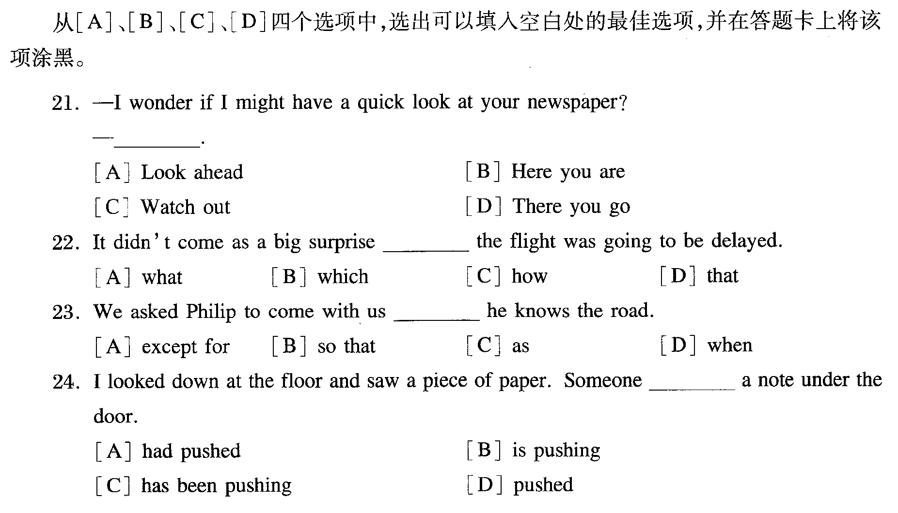
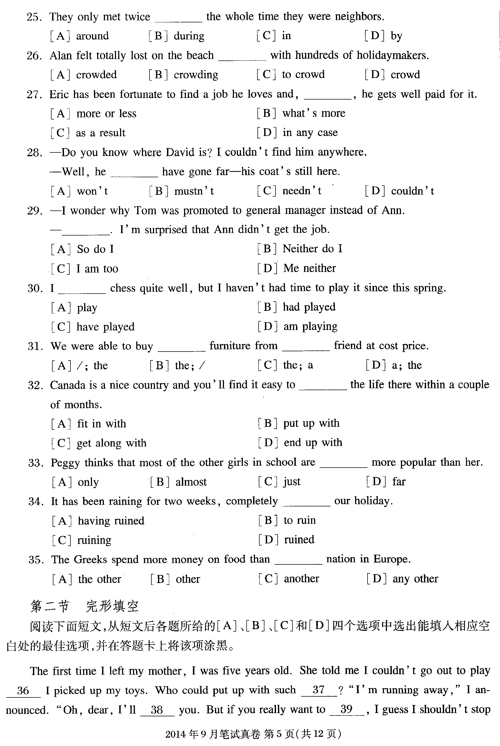
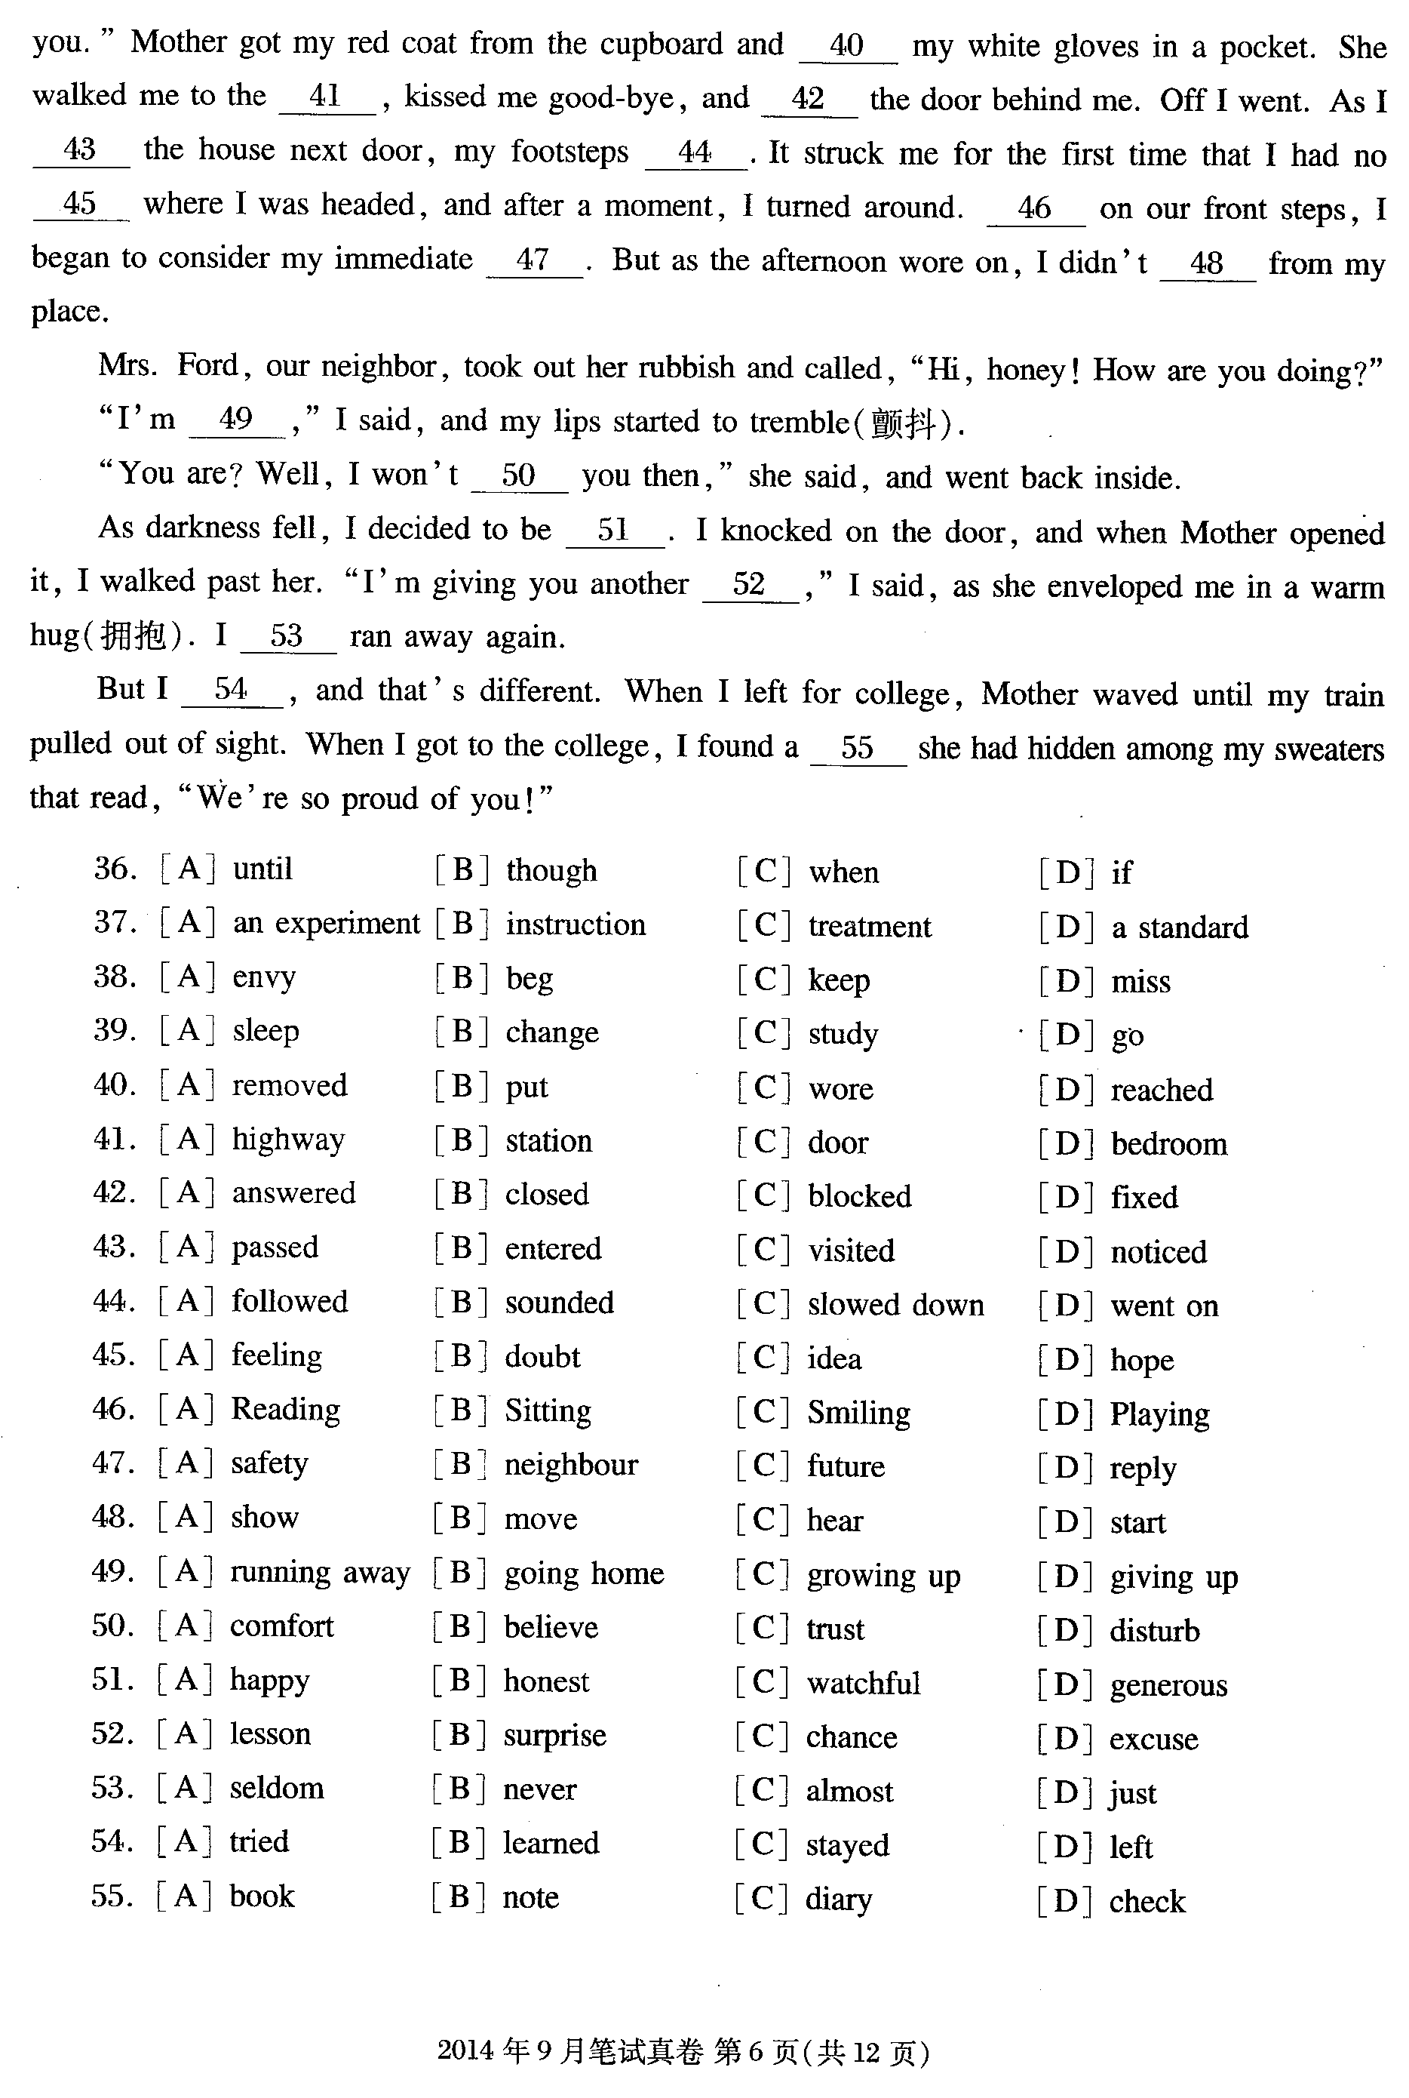
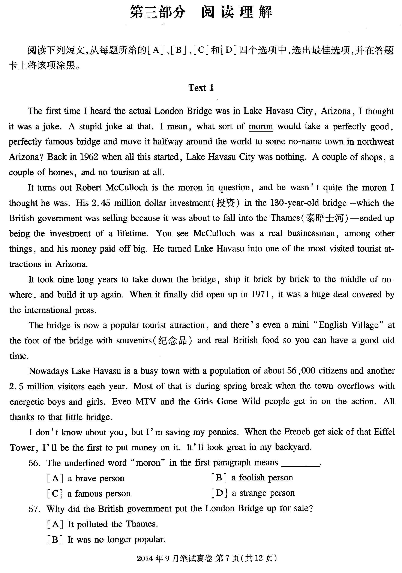
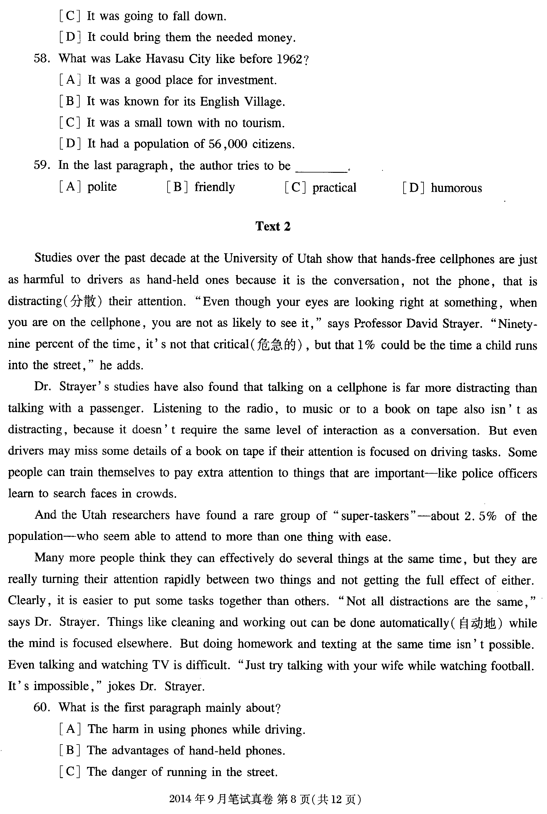
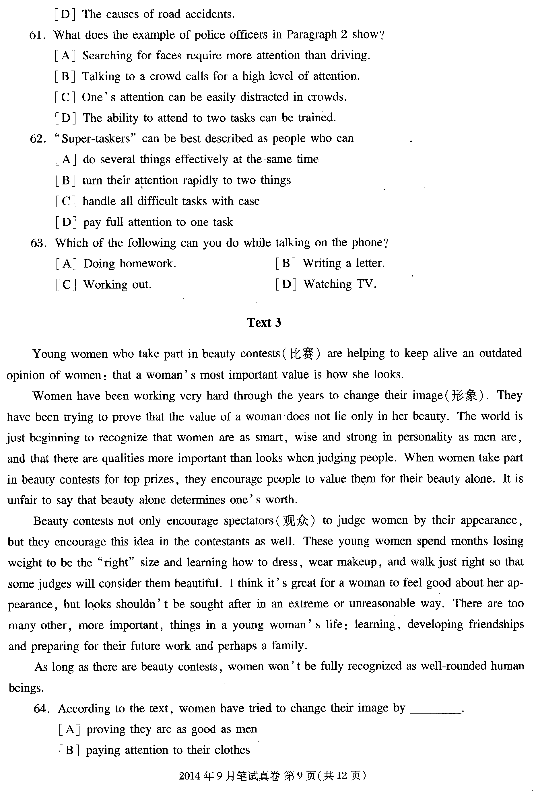
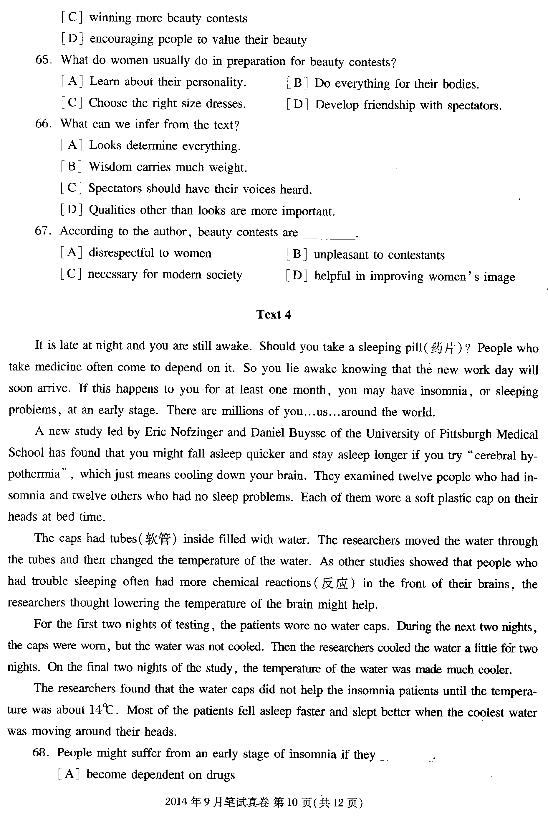
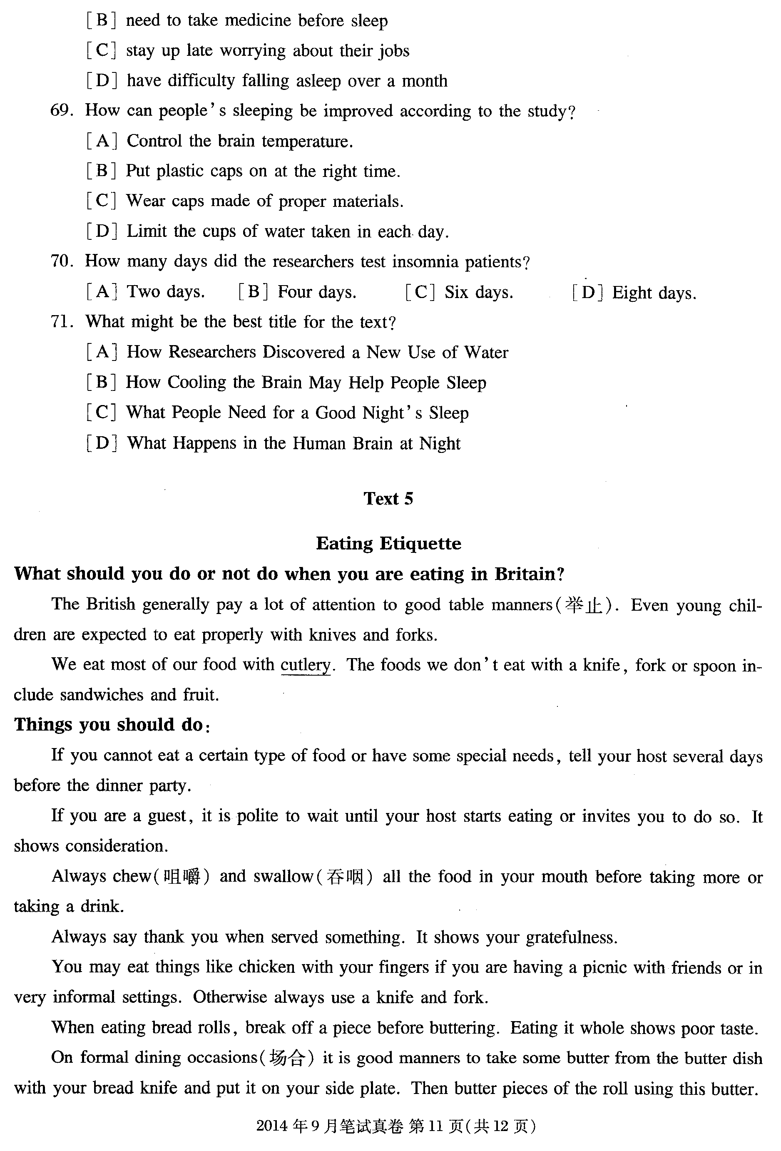
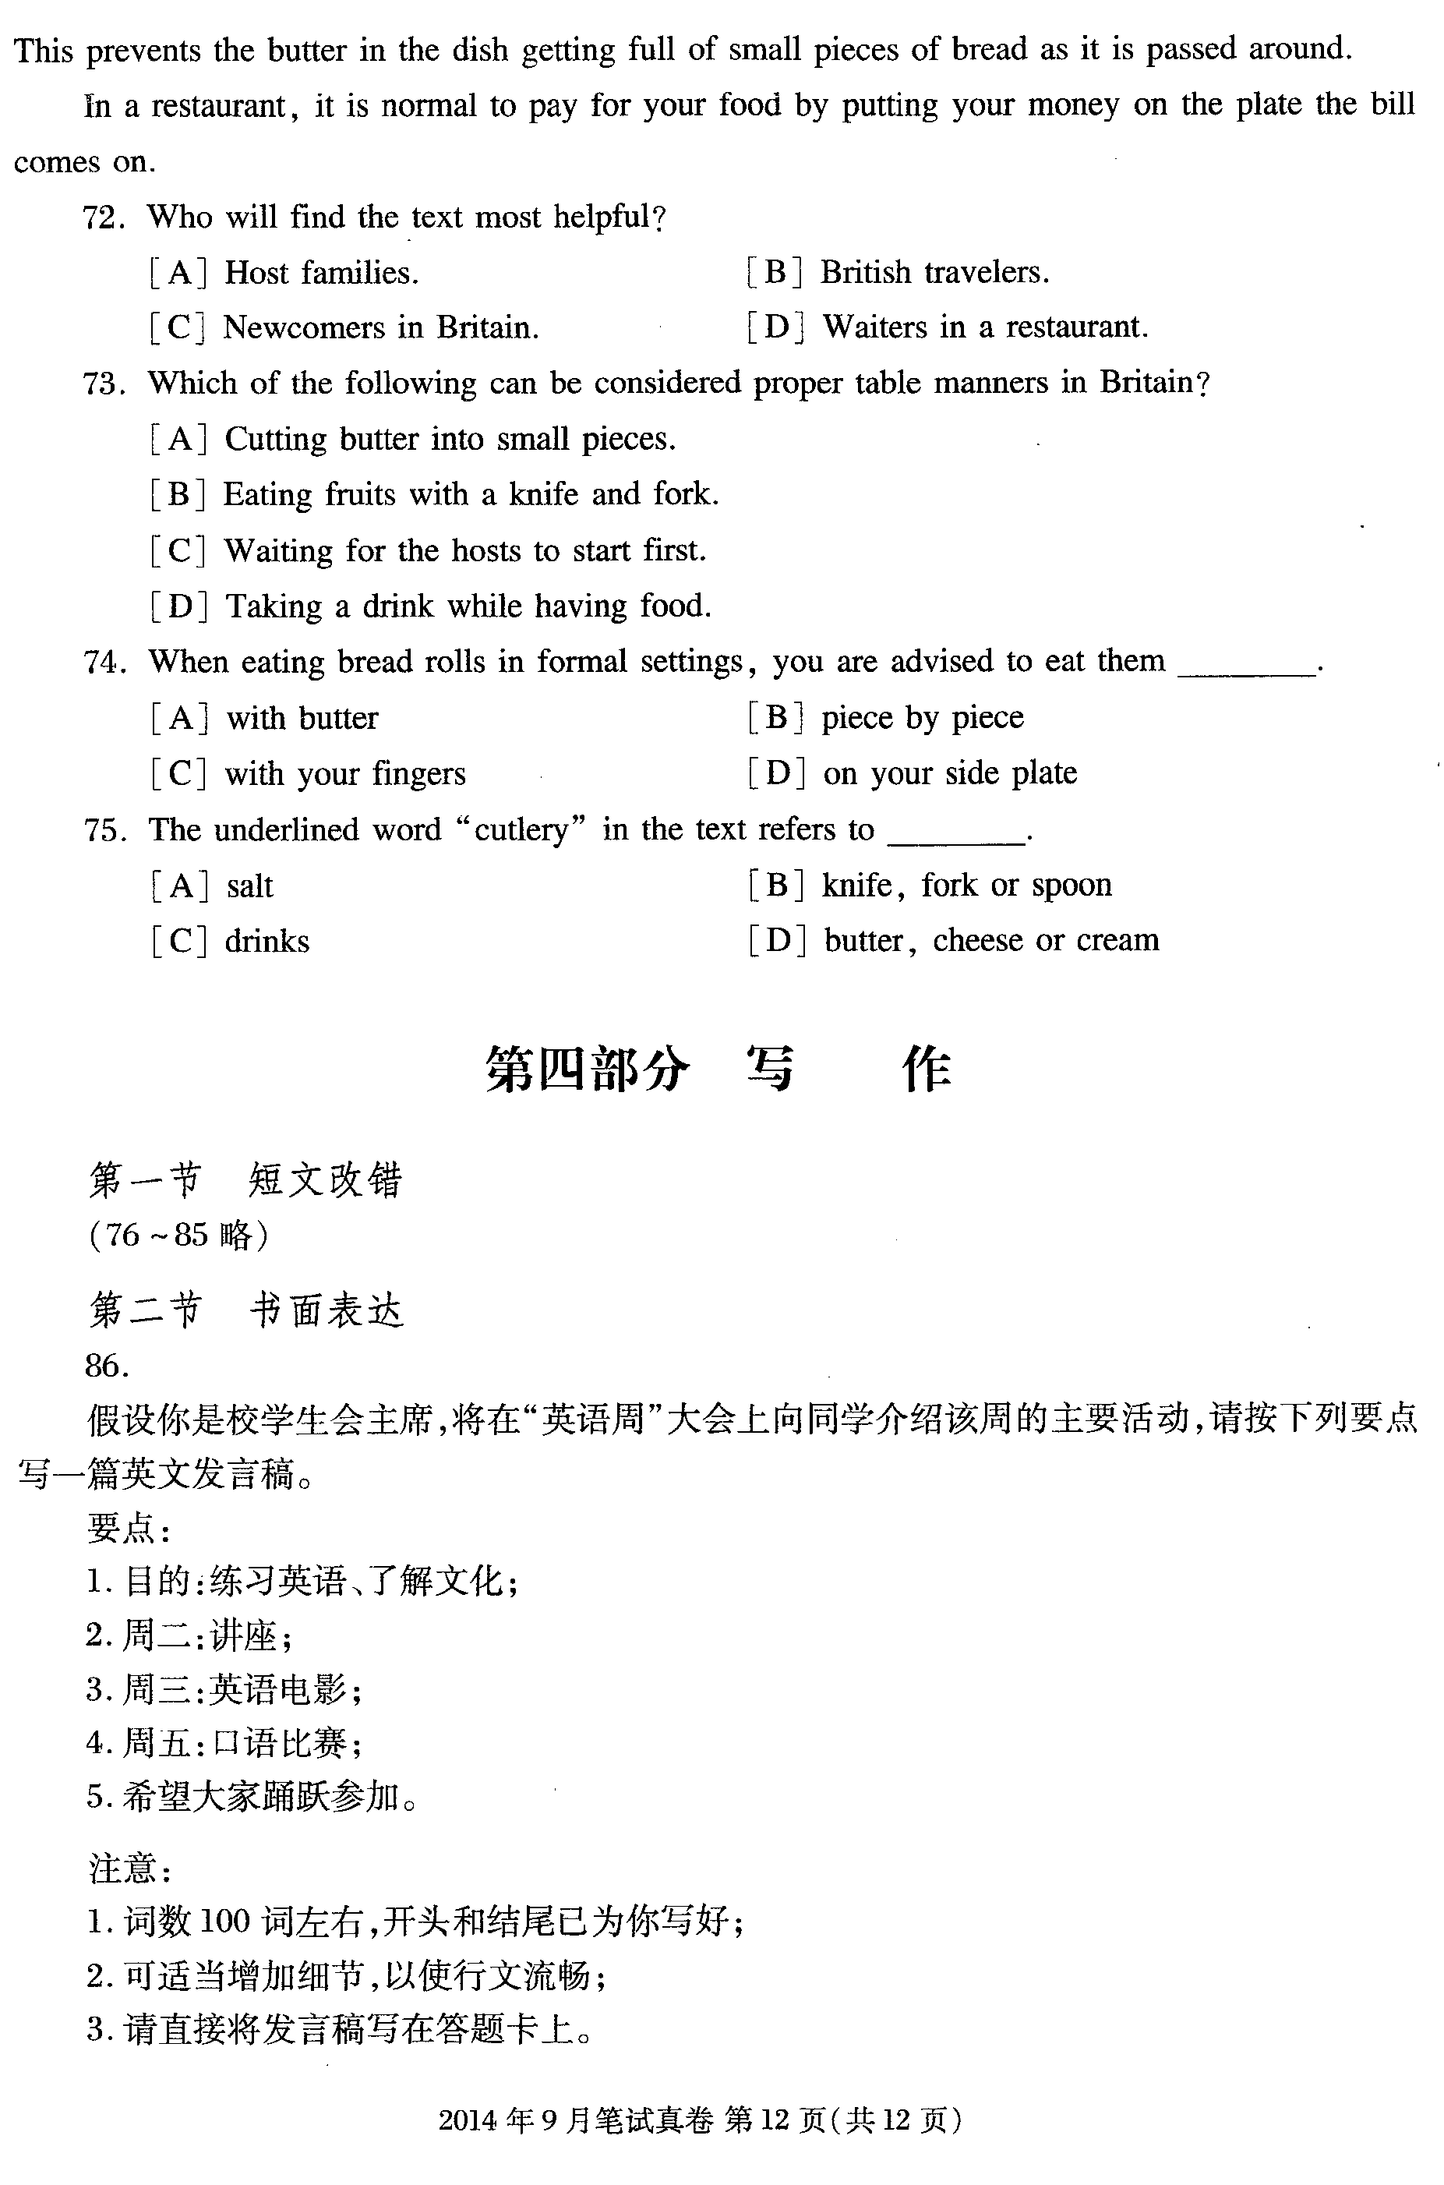

听力录音原文：

Text 1
W: Would it be all right if I left a bit early? I don’t feel very well today.
M: Yes, yes, by all means. The second part of the meeting is just free discussion.

Text 2

M: Do you have this shirt in other colors, ma’am?
W: Well, they come in white, yellow, red, and green. Will a white one do?
M: Yes, that’ll be nice. I’ll take one.

Text 3
W: Hi, Kent. Can you give me a lift? I’m late for work. My car’s broken down. It won’t start.
M: I’m sorry. I’m not going into town. But I can give you a lift to the bus station.

Text 4
M: I’m calling to ask if your hotel still serves Mexican food. I haven’t been there for years.
W: I’m afraid not, but you can easily find a Mexican restaurant close by.

Text 5

W: Hey, Bob. Would you please help me with these boxes?
M: Yes, if you promise to help me tidy up the house.
W: No problem. I’ll even do the dishes.

Text 6

M: Hi. Is Olivia there, please?
W: I’m sorry. She’s out for lunch. Do you want to leave a message?
M: Yes, this is Harris. Could you tell Olivia that I’ll wait for her at the box office of the cinema at 7:10?
W: Sure, Harris. You’ll wait for her at the box office at 10.
M: No, at 7:10.
W: Oh, sorry. At 7:10. I’ll tell Olivia.
M: Thank you!

Text 7

M: Look at this armchair. What do you think?
W: Oh, I’m not sure I like the design. It’s too heavy looking. Is it comfortable?
M: Try it.
W: Hmm. It’s really comfortable! And I’d like to have something this size. Our old armchair is way too small. This size is perfect.
M: What do you think of the color?
W: Well, green isn’t my favorite color, but it’s better than that terrible brown one we have now. It’s okay, I guess. But blue would be perfect.
M: How much is it?
W: Oh, no. It’s $999. That’s really too expensive. We can’t afford it right now.
M: I know. Why don’t we wait till next month for their mid-year sale? It might be cheaper then.
W: Hey, that’s a good idea!

Text 8
W: Well, I certainly have enjoyed my stay in Edinburgh, Peter. Thanks for all your help. And thanks to Jean as well for showing me around.
M: Well, we both enjoyed it, too. How long will you stay in York before you go back?
W: Two days. Look, when are you going to be in London again? You must bring Jean with you and we can all get together again.
M: Yes, I’ll do that. That’s your train, isn’t it?
W: Yes, I’d better go. OK. Thanks again. Bye!
M: Bye, Sue. Don’t forget to give my regards to John.
W: I won’t. Bye!

Text 9
M: Mom, I’m a little worried about college. I just don’t know what to study. I don’t know what my major should be.
W: That can be a difficult decision, John.
M: How can I decide?
W: Well, I’d start with your interests. It will help you if you study something that you are interested in. What do you like to read and learn about or do?
M: I guess I like dancing and helping people. Those are my interests, I guess.
W: What do you mean by helping people?
M: If people have problems, I like to help solve them. Or if people are hurt, I like to try to do things that make them feel better.
W: It sounds like you might be interested in medicine, then.

M: Uh, I don’t know…
W: Another thing I think you should consider is the possible jobs you might get and how much money you want to make.
M: How do I figure that out?
W: You can research different jobs at the library, and there are reports and data on how well different jobs pay.
M: I want to have a well-paid job so that I can have the money to travel.
W: Well, there you go! Income is going to influence you most in your choice of major. There is one other thing you should consider, too.
M: What’s that?
W: You know…scholarships, the money given to you for college. You might want to pick a major that will allow you to get a special scholarship. I know you’ll make the right decision.
M: Thanks, Mom.

Text 10
M: Welcome to London this December! There’s plenty going on this month. For example, on 1 December, London’s West End, the capital’s best shopping district, has its largest ever traffic-free day. More than a million visitors are expected to shop and enjoy various activities while Oxford Street and Regent Street are completely closed to cars and buses. Shoppers will be able to move around the streets, visiting our famous department stores, and having a bite at one of the many cafes and restaurants in the area. Trafalgar Square’s Christmas tree, a gift to London from Norway, will be lit at 6 p.m. on 6 December to the sounds of traditional Christmas songs. Then, every evening from 10 December until 23 December, 5 p.m. to 9 p.m., people will sing Christmas songs in this beautiful setting. Lastly, ring in the New Year with the capital’s largest fireworks show. Although the fireworks will be set off at the British Airways London Eye, they can be enjoyed from across London and will also be broadcast on television at the same time. Then, just a few hours later, come out and see London’s colorful New Year’s Day parade, when marching performers from around the world pass through the capital’s streets. Enjoy your time in our city.
答案：1-5 ACBCA 6-10 BBACA 11-15 BCCCB 16-20 ABAAC

